Time Tracking For Fisheries

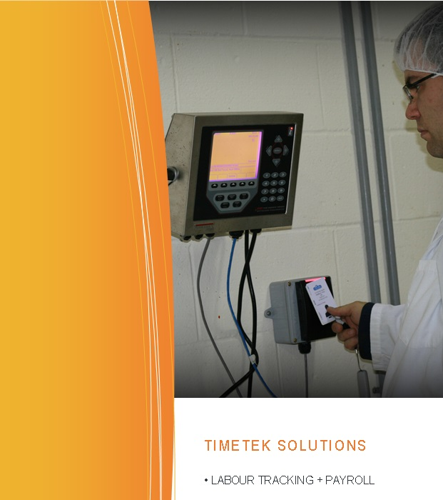Advatek Systems provides a comprehensive solution for seafood producers to automate the collection of employee hours. It works by assigning employees a badge that identifies them at the *time clock* – a specialized computer used for recording IN and OUT times.

One or more time clocks are connected to a Windows PC via a computer network, either wired (Ethernet cable) or wirelessly (Wi-Fi) . This computer (TimeTek SQL ADC Server) will collect the employee scan information and calculate the hours worked. It will include software with features to permit times to be edited and reports to be generated.

The time tracking system can be easily extended to provide additional features, such as department / work order tracking, where employees time is logged against a job function; door access control, which helps to secure and monitor the movement of employees within the plant facilities.

Here is a list of the components required for the system;

* Employee Badges (iClass RFID Proximity Cards)
* Time clock
* Network infrastructure
* Windows PC
* Time tracking software
* Optionally time card printer

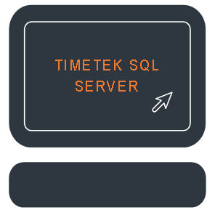Advatek can provide everything in this list. If cabling is required to extend or build the network infrastructure we will typically provide the cable and have the plant’s maintenance staff arrange to have this installed.

Time clocks come in several different models, each one tailored for the environment where it is installed. Our recommendation for a seafood production facility would be the **920 time clock**. It can withstand the harsh and wet conditions typical for the plant floor. It likely comes as no surprise that this model is also the most expensive. Therefore the **KDT Time clock** is an option as well, but must be located in an area away from high humidity, dirt and extreme temperatures. A final alternative is **Advatek Scanpad**, which is a stripped down solution with limited functionality. With this equipment employees only scan their badge; there are no buttons to press to select IN or OUT. Often this is paired with a receipt printer to give the employee feedback that their scan was received and to inform them of their hours worked and their status (in / out).

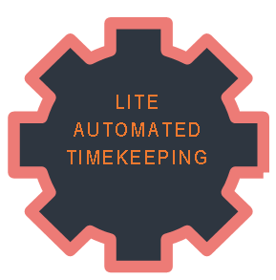There are two different options for the software system. Our recommendation for a seafood production facility is **TimeTek Windows**. This application offers a wide scope of features useful for the administration, such as ability to encode shift rules, department labour tracking, exception management and payroll export options. An alternative **Time Trakker Lite** is available with a more limited feature set, but it does provide the administrator with the basics required for timekeeping.

An important component is the Windows PC machine that the software and database system is installed on. Advatek recommends a single purpose PC (*stand-alone)* that acts as the time tracking server. This will be Windows 7 Pro, Windows 10 pro or Windows Server 2012 or later. This is a PC we can provide or can be purchased by the customer to meet our specifications. The computer specifications are easily met by a “modern” machine with the operating system pre-installed.

The term stand-alone single purpose PC means it acts as a server and does not have people working on it. By connecting to this server PC, multiple persons can work on the system at the same time from their own computers. This prevents someone from logging in to the machine on a regular basis and interfering with the operation of the system. However in smaller operations it makes fiscal sense to have a single PC in the office that the administrator uses for everything. In this scenario the necessary software can be installed on that one person’s computer, as long as it meets the specifications.

With the optional badge (card) printer you are able to print on each badge. Typically these are used to print a company logo, employee id number or name, or employee photo for security identification purposes.

When calculating the total cost of the system you will want to factor in the cost for installation services. The exact dollar amount here is determined by the hours Advatek spends on site, plus travel and trip expenses. As you can appreciate this will vary based on what needs to be done and what challenges are faced. Typically we see 1 or 2 days are required on site.

With a system support contract Advatek provides online and telephone support for the system. Typically this covers Advatek’s business hours of Monday to Friday 8:30am-5:00pm, and this contract is renewable every January.

See quotation #5135 for pricing of the various components.

Please note the following;

DELL PC quote can be provided on request

PC specifications:

Windows 10 64-bit system requirements

1GHz Processor, 4GB RAM, 500 GB HD

On site service rates

* $81.25 per hour between 8:30am-5pm mon-fri including travel time to and from Moncton
* Mileage billed at $0.60 per km

FOB Moncton Taxes Extra

Lead Time 3-4 Weeks