Human Resource Add-on For TimeTek

Advatek provides “HR” module to add human resource and employee management tools to the TimeTek time tracking software.

This module provides the following features to make it easier to track your workforce:

* Maintain a digital “HR” file on employees. Here memos are added that would store notes regarding the employee – supervisor comments, evaluations, instances of tardiness or misconduct, warnings issued, reasons for termination, etc. These could be called up at any time to review an employee’s work history.
* Store documents digitally, for example photos or scanned notes, to the HR file. These could be called up and viewed on-screen or re-printed.

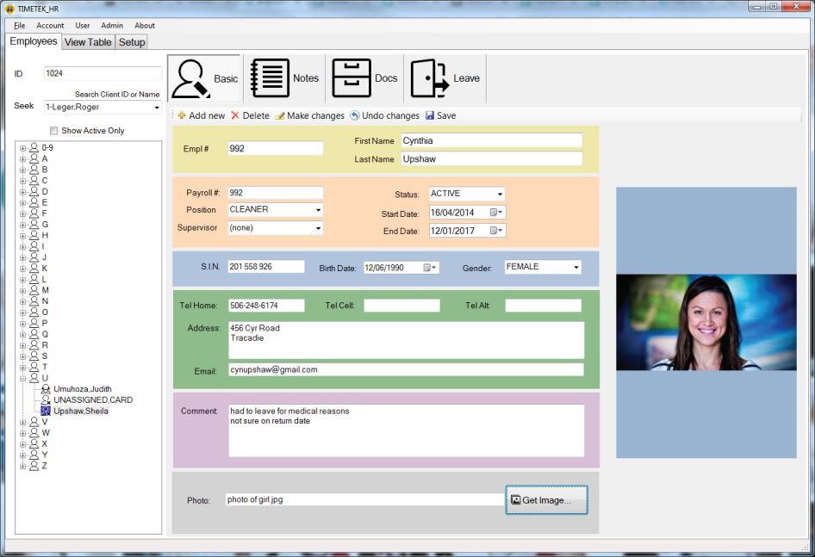



* 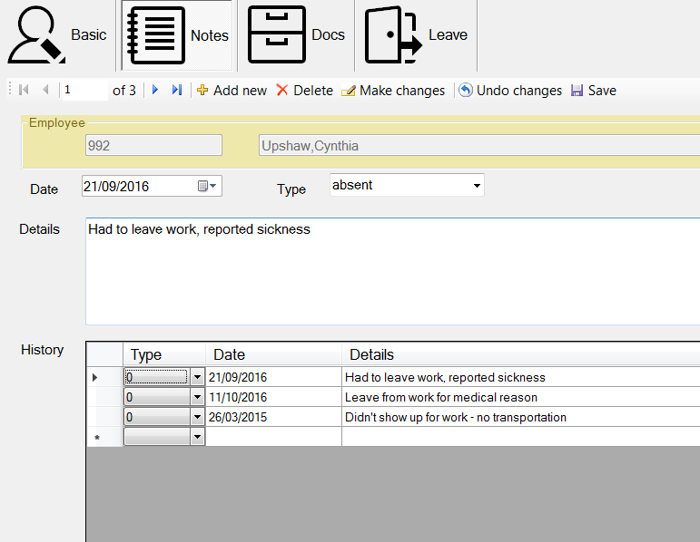Print employee badges that include photo id – employee photos can be imported from any camera, and stored and viewed from the employee properties. Badges can be printed directly inside the TimeWin program.
* Store more in depth information on each employee such as contact numbers and work history.
* 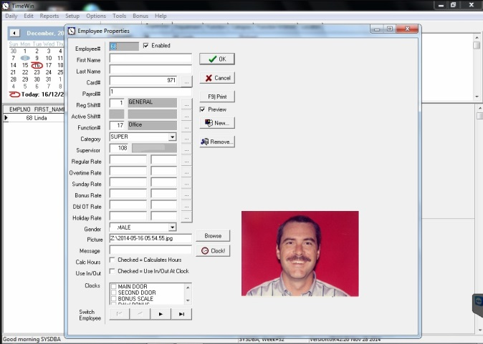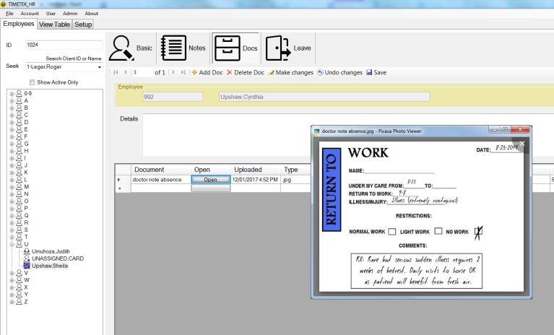 Record details on work terminations or work leaves, information required for EI.

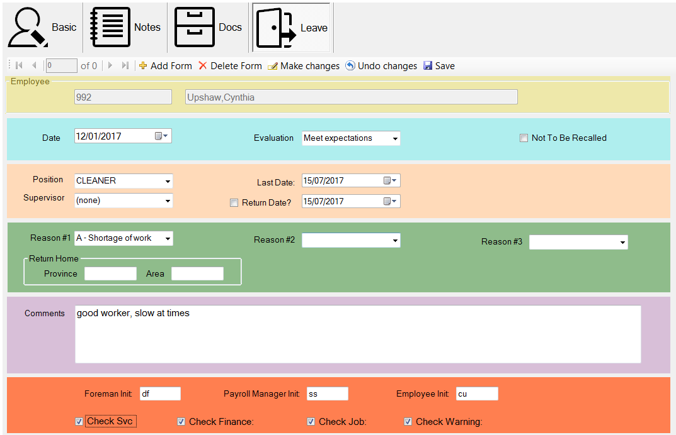

|  |  |
| --- | --- |
| Individual Components | Price |
| Human Resource Add-On | $1,620 |

Installation & Training Extra

* $93.75 per hour between 8am-5pm mon-fri
* $122.00 per hour outside these hours

FOB Moncton Taxes Extra Lead Time 3 –6 Weeks

Pricing valid for 30 days Terms net due in 30 days