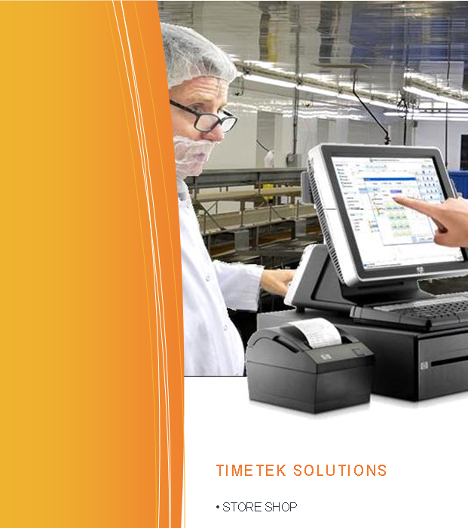Store/Supply Shop For Processors

Advatek provides “Store Shop”, a system that tracks the dispensing of workplace related items such as gloves and boots to employees.

The store shop area is equipped with a touchscreen kiosk computer terminal that works similar to a retail POS terminal.

It’s easy to use - a list of all the items that can be purchased, along with the cost to the employee, appear on the screen as buttons that can be selected.

When an employee has items they need they will first swipe their scan badge to authorize the purchase. Next the store clerk clicks off each item they provide, loading an on-screen “shopping cart”.

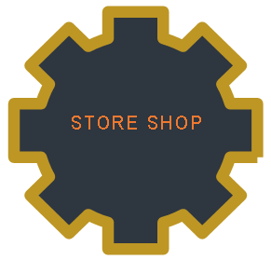

Once the clerk completes the order an optional receipt can be printed, and the total amount owed is recorded in TimeTek. It is shown on reports and can be deducted from the employee pay. In addition a report can be generated showing what is left in inventory, and notify when the stocks run low.

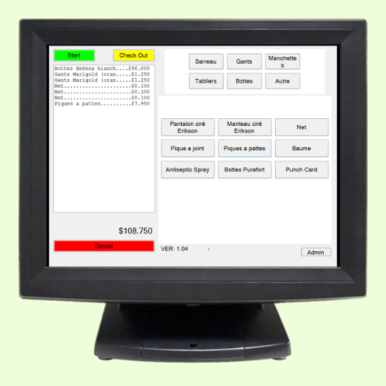

The Store Shop kiosk requires a connection to the building net

work and the TimeTek db server.

|  |  |  |
| --- | --- | --- |
| **Equipment** | **Quantity** | **Each** |
| Option#1: Stand Alone Kiosk Terminal with barcode or RF scan reader | 1 | $1,600 |
| Option#2: Touch monitor + card reader for PC  *Requires a PC* | 1 | $850 |
| Option#3: Card reader for PC  *Requires a PC* | 1 | $395 |
| Optional Receipt Printer | 1 | $495 |

|  |  |  |
| --- | --- | --- |
| **Software** | **Quantity** | **Each** |
| Store Shop with TimeTek interface | 1 | $1,500 |

Installation & Training Extra

* $81.25 per hour between 8am-5pm mon-fri
* $122.00 per hour outside these hours
* Mileage billed at $0.40 per km

FOB Moncton Taxes Extra

Lead Time 3-4 Weeks

Pricing valid for 30 days while USD to CAD exchange rate is 1.40 or less

Terms net due in 30 days, orders over $10,000.00 require a 30% down payment.