Piece Counting For Lobster/Crab

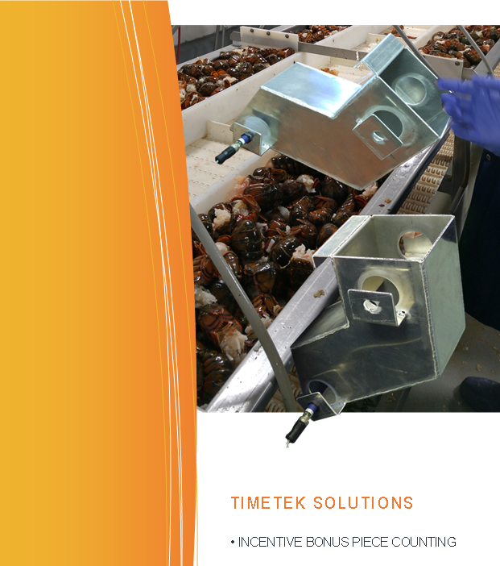Advatek Systems provides a comprehensive solution for seafood producers to implement employee incentive (bonus) systems.

It works by having employees scan in and out of work stalls, which are equipped with sensors that count of the number of pieces they produce.

By bringing together the counts and the time worked the system calculates each employees *through-put* (pieces per hour), and determines a bonus dollar amount that was earned.

The calculation can be different for every product they work on, as each product has parameters (“target pieces/hour” and “Bonus $/piece”) that are adjustable to allow the producer to customize the bonus payout for their plant and for the season.

Prices are grouped into sections;

* Bonus Controller
* Chute sensor equipment
* Bonus Tracking software
* Extras

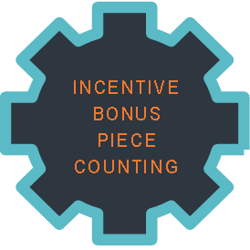The **Piece counter controller** handles up to a maximum of 24 stations (chutes).

The table with chutes will be in same room to be practical. Typically an employee swipes their badge IN and OUT at the controller where they select which station/chute they’ll be working at.

COST………………$7,200 each

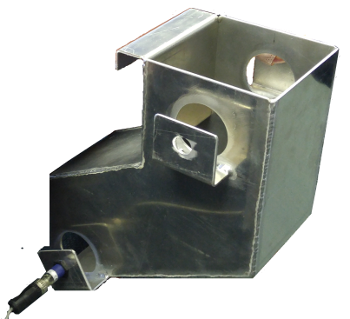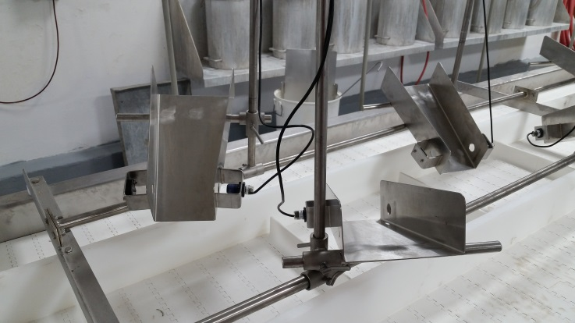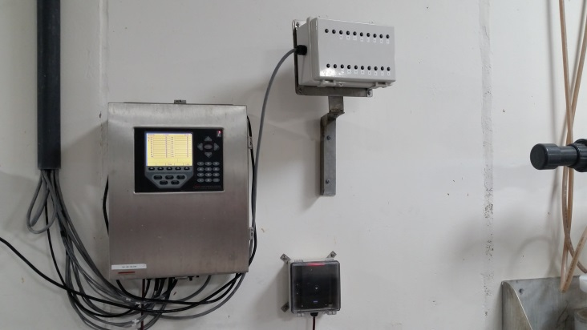

Chute **sensor equipment** is priced per unit, typically one or two may be used per chute.

COST……………..$205 each sensor

Stainless steel chutes can be provided, a price can be determined upon final design.

**Bonus Tracking** software pricing is for the add-on module as part of the TimeTek software.

COST ………………$3,250 one time

**Extras**

* Employee RF Scan Cards
  + $5.25 ea. minimum order of 100, ordered in batches of 100

Items not included are:

* *Chute, pricing available upon request*
* *On-site installation*
* *Cabling*
* *Taxes extra*

Installation & Training Extra

* $81.25 per hour between 8am-5pm mon-fri
* $122.00 per hour outside these hours
* Mileage billed at $0.40 per km

Estimate based on initial conversation

|  |  |  |  |
| --- | --- | --- | --- |
| **Equipment** | **Quantity** | **Each** | **Total** |
| Piece counter controller | 1 | $7,200 | $7,200 |
| Sensor equipment | 24 | $205 | $4,920 |
| Bonus Tracking software | 1 | $3,250 | $3,250 |
| **Subtotal** |  |  | $15,370 |

|  |  |  |  |
| --- | --- | --- | --- |
| **Extras** | **Quantity** | **Each** | **Total** |
| Computer system server | 1 | $1,500 | $1,500 |
| RFID badges | 300 | $5.25 | $1,575 |
| **Subtotal** |  |  | $3,075 |

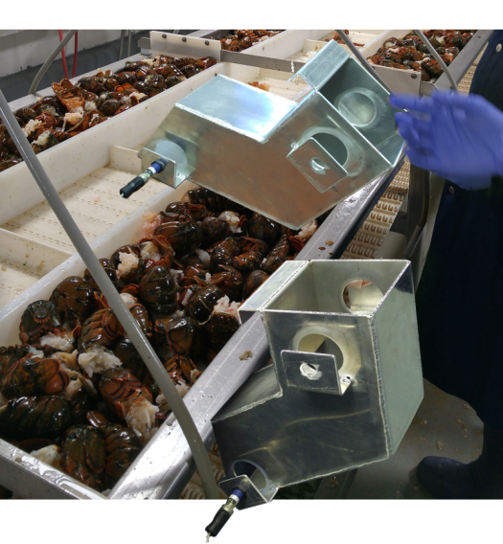

|  |  |  |  |
| --- | --- | --- | --- |
| **Installation** |  | **Each** |  |
| Cabling For Sensors |  | $.90/Foot |  |
| Cabling For Status LED box |  | $4.10/Foot |  |
| Service Technician |  | $75/Day |  |
| Software Systems Specialist |  | $93.75/Hr |  |

FOB Moncton Taxes Extra

Lead Time 3 – 5 Weeks

Pricing valid for 30 days while USD to CAD exchange rate is 1.40 or less

Terms net due in 30 days, orders over $10,000.00 require a 30% down payment.