Door Access System

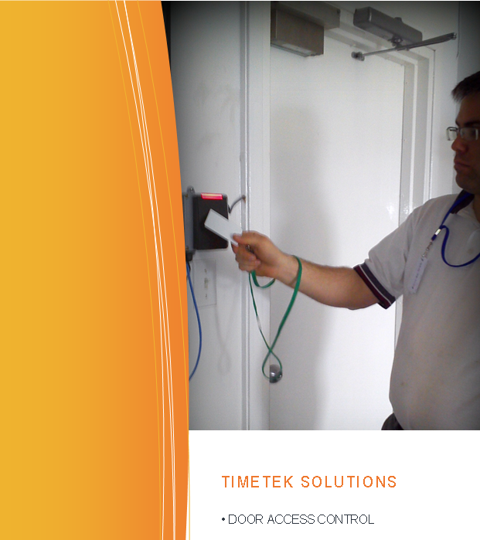Advatek Systems provides **TT/Access**, a door access control system that gives you control over who enters the premises.

It’s an automated systempreventing unauthorized persons from getting in while allowing employees to come and go as required. With the system in place employees pass their badge by the door scanner, and if privileges permit, the door is unlocked.

Each time the card is used the event is recorded, thereby creating a history of *who, when & where* that can be examined by administrators. If an employee quits, or attempts to enter at inappropriate times or locations, access is refused and the fact is logged in an exception report.

**TT/Access** can be used alone, or as part of a comprehensive labour tracking solution **TimeTek,** that tracks time for payroll as well as providing job function costing to better manage manpower expense**.**

The advantage here is the door controllers and time clocks accept the same cards/badges, avoiding the expense and hassle of managing two different sets of badges. Software setup is easier too because the employees are already entered in the **Timetek** system.

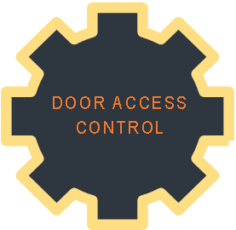

There are 3 parts included with a **TT/Access** system**:**

1. **Door controller** for each door to be covered.
2. **New or existing server PC** with **TT/Access** software loaded.
3. **Access badges (TimeTek** cards will be used).

Advatek Systems will install these components, connect them to the computer network, train the staff, and provide remote support afterwards.

**Please note that more is required to finalize the door access system.**

**Advatek Systems does not provide or install the following;**

* Door(s) and required electronic door locking mechanism. Electronic locks come in two types, *strikes* and *magnetic locks*. Mag locks require more hardware to satisfy safety regulations. You should consult with a locksmith regarding your options.
* 120 VAC power at the location of the door controllers.
* Computer network, network cables or conduit if desired.

During installation maintenance personnel is required to be present to perform any work required for mounting, such as drilling.

Supplies and installation times here are estimates only. Exact amounts will depend on the specifics of the job and the environment in which the system is installed.

Please check with your local fire service to ensure that all proper safety measures are followed.

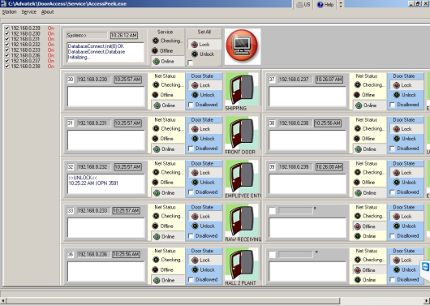

Quote # JLF-20160405-A

System Costs:

Door Access Controller **$780.00 CAD each**

* 1 Door Access Controller
* 1 Door Access Card Reader
* Every door requires the Door Access Controller

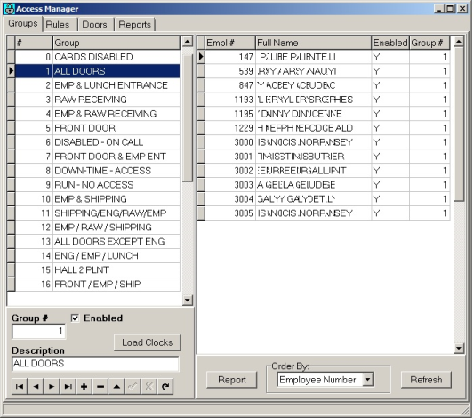Door Access Administration Software **$2,600.00 CAD one time**

* 1 Server License
* 1 User License
* Unlimited Door Access Users
* System Access Control Services
* Administration Software

Optional: If barcode badges are replaced with RF badges

Door Access Cards $5.25 CAD per Card

* Minimum order of 100 cards $525.00
* Provides the user access within the parameters of the rules

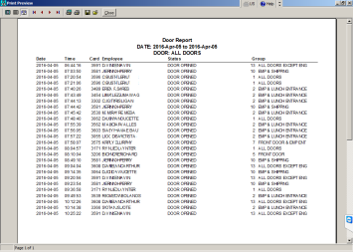

Installation & Training Extra

* $81.25 per hour between 8am-5pm mon-fri
* $122.00 per hour outside these hours
* Mileage billed at $0.40 per km
* Expect 2 days for up to 3 doors plus training

**Extra’s**

Temporary Open bypass $125.00 CAD each

* Temporarily opens the door allowing a person to exit
* Located on the inside of the building
* Normally only needed if a Mag Lock is installed

Emergency bypass and alert $180.00 CAD each

* Will permanently disable the lock allowing people to come and go
* Sounds a buzzer while active to alert management the bypass is active
* Normally only needed if a Mag Lock is installed to allow for escape in event of fire

FOB Moncton Taxes Extra

Lead Time 3 – 5 Weeks

Pricing valid for 30 days while USD to CAD exchange is better than 1.40

Terms net due in 30 days, orders over $10,000.00 require a 30% down payment.