Weight Data Collection Tracking / Bonus

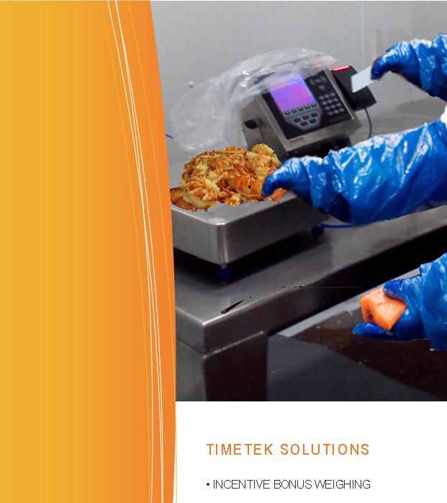Advatek Systems provides a comprehensive solution for seafood producers to collect production data on how much meat or product is being produced by the workforce.

It has everything you need to implement an employee incentive (bonus) system, as well as providing management with valuable real-time production data to track the labour cost per pound and cost per hour, by product and by worker.

It works by having employees scan an identification badge when weighing in the product they have produced.

The operator selects the current product using the keypad, and employees scan in and out of the bonus job function to accurately track the time worked.

By bringing together the net weight produced and the time worked the system calculates each employees rate of work in three key metrics: LBs-per-Hour, Dollar-per-LB, Dollar-per-Hour and determines a bonus dollar amount that was earned.

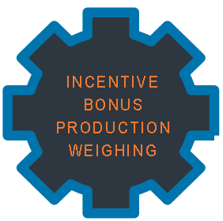The calculation can be different for every product they work on, as each product has parameters (“target LBs/hour” and “Bonus $/Lb”) that are adjustable to allow the producer to customize the bonus payout for their plant and for the season.

Prices are grouped into sections;

* Bonus Weight Indicator
* Bench scale
* Weight Tracking Bonus software
* Extras

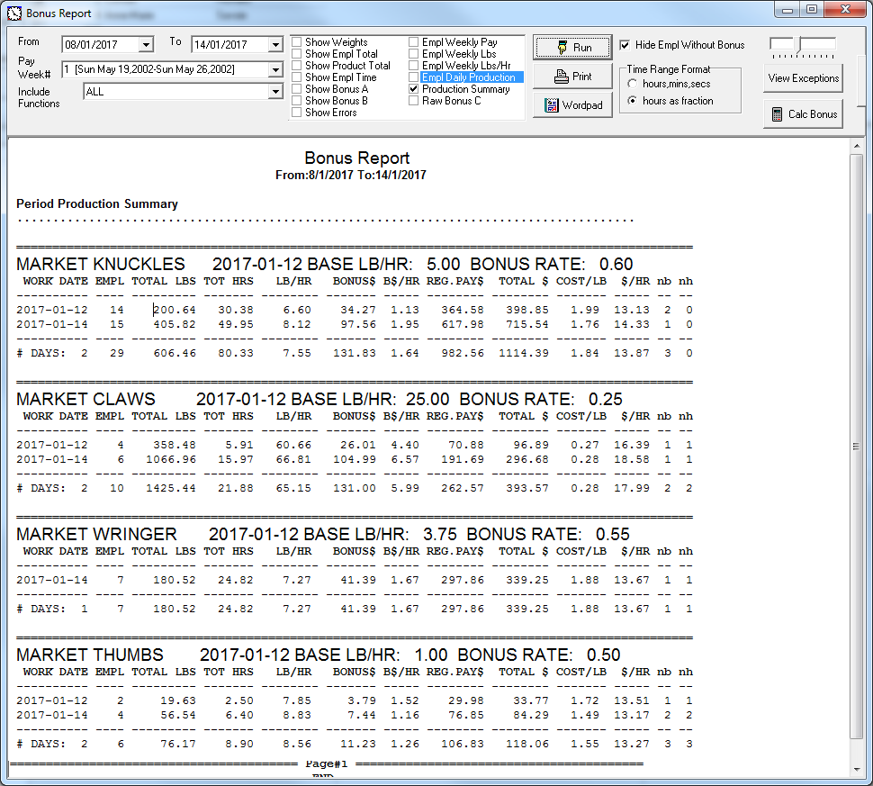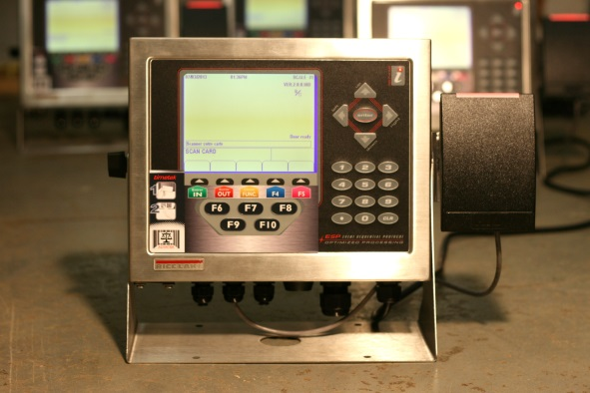

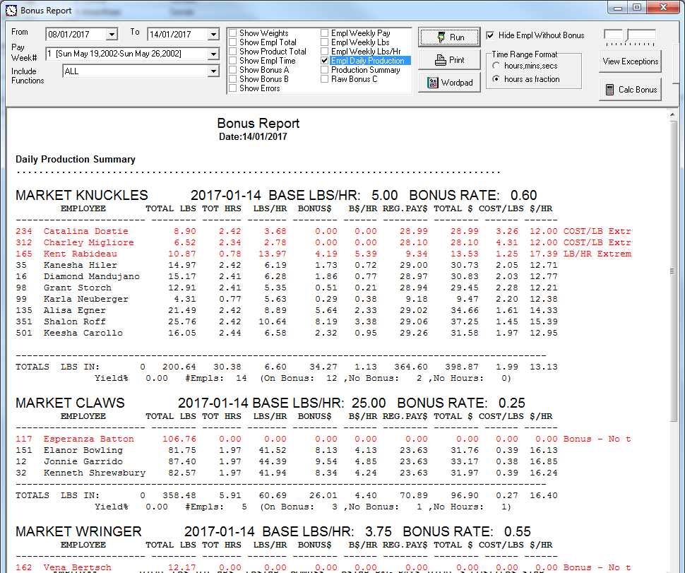

**Bonus Indicator**

COST………………$3,600 each*

*\*at the time of printing only, pricing will vary with exchange rate please call for latest pricing*

**Bench scale** will vary with model, exact specification

For example BSF 50 LB STAINLESS STEEL….$1,800*

**Weight Tracking Bonus** software pricing is for the add-on module as part of the TimeTek software.

COST ………………$3,250 one time

**Extras**

* Employee RF Scan Cards
  + $5.25 ea. minimum order of 100, ordered in batches of 100

Items not included are:

* *On-site installation*
* *Cabling*
* *Taxes extra*

Installation & Training Extra

* $93.75 per hour between 8am-5pm mon-fri
* $122.00 per hour outside these hours
* Mileage billed at $0.40 per km

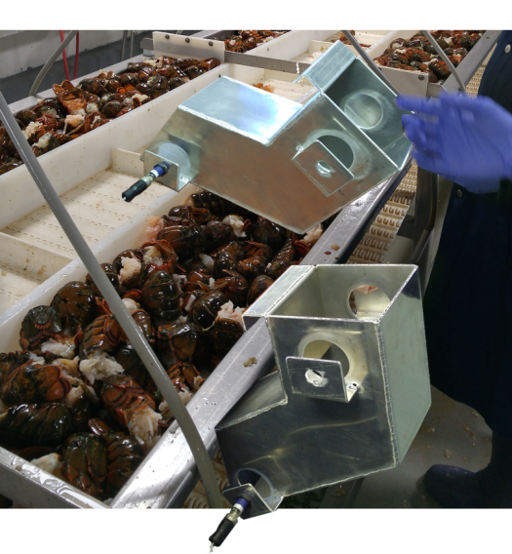

FOB Moncton Taxes Extra

Lead Time 3 – 5 Weeks

Pricing valid for 30 days while USD to CAD exchange rate is 1.40 or less

Terms net due in 30 days, orders over $10,000.00 require a 30% down payment.