As we move forward into phase Yellow we will continue to operate as if we are still in Phase Orange. This is in part due to the fact that as an essential service provider we travel inter-provincial and we feel this is the best method to help control the risk. This policy is in effect for all Advatek staff and contractors working on behalf of Advatek Systems Inc.

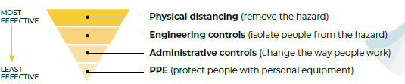

**Elevated Hygiene Controls:**

During a Pandemic it is important that all employees maintain a higher level of personal hygiene. Hand washing and use of hand sanitizers is encouraged. Hand Sanitizer & station sanitizer is provided for use. Remember to properly wash your hands after use of the washroom facilities and to clear the common surfaces.

**Office controls:**

As per directives, Advatek’s office is to have no more than 10 people in side at any one time. All staff will sanitize their work spaces at the start and end of the day. The first person in and last person out shall clean all door handles and common surfaces. In shared office space social distancing is to be maintained as such in the service office you will only be permitted 3 staff members at one time. Justin and Dan cannot be in at the same time.

**Desk phones:**

Personal assigned phones are to be cleaned at the start of the day. Shared phones cleaned between uses.

**Co Travel:**

As per directives co-travel inside NB is permitted if the passenger is seated in the rear passenger seat. The driver and passenger will sanitize all touched common surfaces before and after. Wearing of masks is also required. This is only suggested for short distance travel such as to take a tech to get their vehicle from the service shop, as going with a co-worker is lower risk than using a taxi.

**Shop and tool controls:**

All tools are too be cleaned before been placed back into the tool cabinets. This way we can treat the tool cabinet as clean zone. If you are to pick up tool from a desk it is to be sanitized prior to use. Techs who require to work in close proximity for a job must wear one of the provided masks

**Shipping and drop off & customer visit:**

Customers are not currently permitted to visit Advatek systems. The side man door will remain locked access to the building via back door only. Upon arrival all employees will sanitize their hands. Any customer drop offs are to be done in the roped off zone. Customer may enter and stay within the roped of zone if discussion with staff is required. Couriers are to drop off inside the roped of zone. Only 1 customer is permitted in the zone at any one time.

**Signatures:**

At this time and until further notice signatures for pick up, drop off or work orders is not required.

**Sickness:**

Should you feel ill you are **required** to stay home, if you are presenting with COVID-19 symptoms call 811 for guidance and inform your manager via e-mail. Even if you are tested and cleared if you are experiencing any flu like symptoms you are required to stay home.

A fever monitoring is as follows:

* Less than or equal to 37.4 C OK,
* Greater than 37.4 but less than 38C monitor extra times per day
* Equal to or Greater than 38 you have a fever stay home, call 811, notify your supervisor

**Awareness & Immunization**

Employees will be made aware of health issues relating to any pertinent disease to include prevention of illness, initial disease symptoms, preventing the spread of the disease, and when it is appropriate to return to work after illness. Disease containment plans and expectations should be shared with employees. Efforts will be made to communicate effectively with all employees. Should an immunization program become available all staff are asked to please take up the opportunity to get immunized.

**Covid-19 Symptoms:**

* Most common symptoms:
  + fever
  + dry cough
  + tiredness
* Less common symptoms:
  + aches and pains
  + sore throat
  + diarrhea
  + conjunctivitis
  + headache
  + loss of taste or smell
  + a rash on skin, or discoloration of fingers or toes
* Serious symptoms:
  + difficulty breathing or shortness of breath
  + chest pain or pressure
  + loss of speech or movement

**Reduction of office Staff & work from home:**

Depending on the pandemic severity level as dictated by the province Advatek will limit its staffing levels in the office. Those that can will be required to work from home. Those in the office will be required to maintain distancing. Should you be ill or required to isolate all efforts will be made to help the employee work from home if able. Staff are also encouraged to avoid work or pleasure in large crowded areas during a time of pandemic as instructed by the provincial health authorities.

COVID-19

Red / Orange - Max 5 office staff

Yellow – Max 10 office staff

**Critical Impact**

Should a sudden increase in illness start affecting the staff work from home will be enforce for all but 1 employee who will work from the office to allow for the answering of phone and shipping & receiving. Technicians will be asked to take work home as possible to work from home. All staff are setup on the company VPN and have cell phones to communicate. Should work need to be done at the office steps will be taken to ensure no contact between employees.

**Communications:**

All staff are asked to forward any question to their supervisor. Should they be approached by the media they are to forward the request to management. Management has an open door/communication policy for ease of communication. All communication to the customer will be handled by management. Should any illness break out at the company and we would have visited customers during the ‘infectious’ period customer will be notified by email.

**Service Work:**

While on site at a customer location staff will be required to maintain distancing as per the guidelines. If not possible then the wearing of gloves and masks is required. Along with the increased sanitization of common touch area. All techs coming back from out of province work are required to self-monitor this includes taking your temperature daily to ensure you are not running a fever.

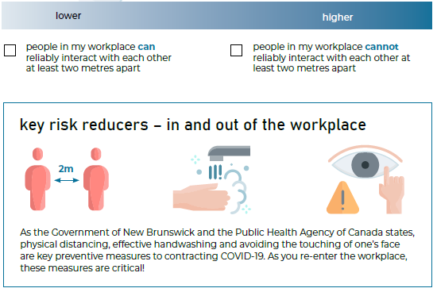

**Common Area’s & work surfaces:**

Areas such as the lunch area, microwave, fridge and the like are to be cleaned between uses. All work surfaces are to be cleaned twice a day with approved disinfectant.

**Plan & Review:**

This plan is to be reviewed yearly along with the workplace safety manual. Testing of the processes happens as part of daily work, such as VPN and working from home.

**Travel:**

All Advatek staff will be required to have with them all items as required in the **COVID-19 Check list**

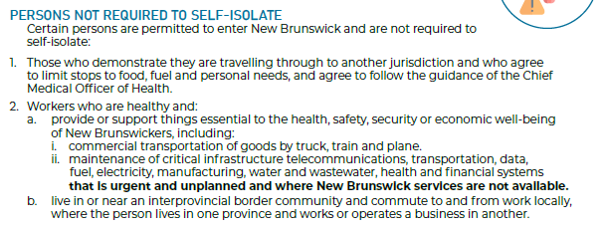

**Changes:**

Any changes will be sent by Jason Forster to the team via email, requiring a read receipt to be sent this will work as your conformation you have read the updates.

**Links:**

**PEI**

Complete the form in the link below

<https://www.princeedwardisland.ca/sites/default/files/forms/atlantic_travel_webform_en_fillable.pdf>

additional info: <https://www.princeedwardisland.ca/en/service/complete-pei-self-declaration-travel-form>

**NB**

Please fill in the form located at the link below

<https://www.pxw1.snb.ca/snb9000/product.aspx?productid=A001P783003&cs=1>

Questions can be emailed to: [TravelRegistration.EnregistrementVoyage@gnb.ca](mailto:TravelRegistration.EnregistrementVoyage@gnb.ca)

**NS**

Travel Info - <https://novascotia.ca/coronavirus/alerts-notices/#travel>

Working Info - <https://novascotia.ca/coronavirus/working-during-covid-19/>

**Documents:**

* COVID-19 Operational plan contains the current documents:
  + COVID-19 Check List-Fleet.docx
    - Check list for the non-commercial vehicles
  + COVID-19 Check List-Commercial.docx
    - Check list for the commercial vehicles
  + COVID-19 NB Advatek Travel Plan.docx
  + COVID-19 Clearance Form.pdf

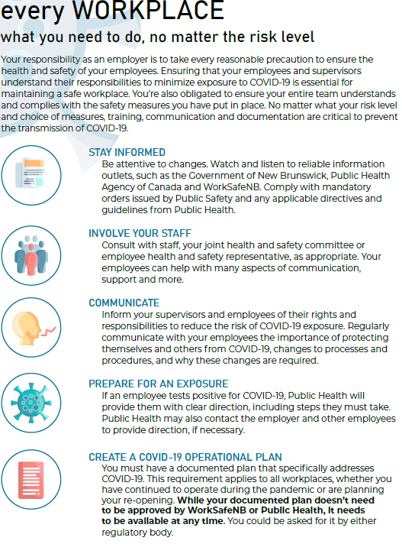

**Deficiencies and Improvements:**

Should any deficiencies be found or any way to improve the plan be suggested, it would then go into a review to see if we can implement this effectively and efficiently. Changes to the plan and procedure will be published into the company work safe policy.

**There are no exceptions and all staff will be held to account.**

This plan is been rolled into our standing safety program as a permanent addition for Pandemic response