Select the port which connects to the scale

2. After selecting, click on “OPEN.”
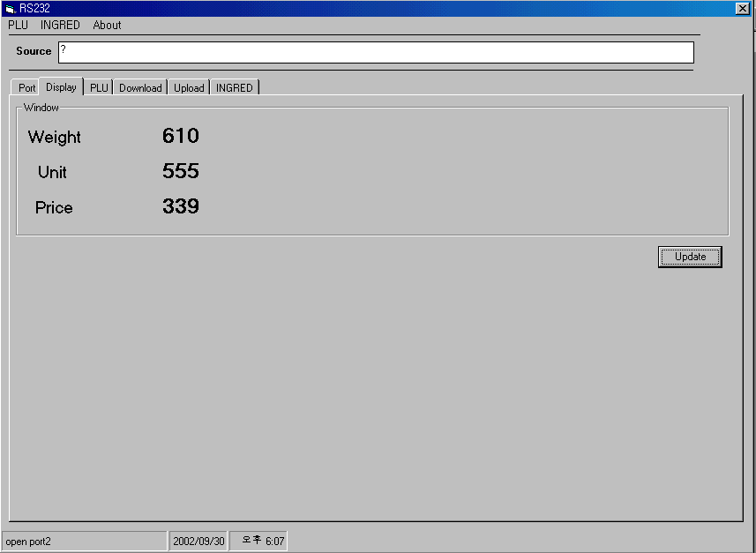
3. Check scale statue in Normal Mode. (Check for its connectivity)
4. Click “Update” to display updated data.
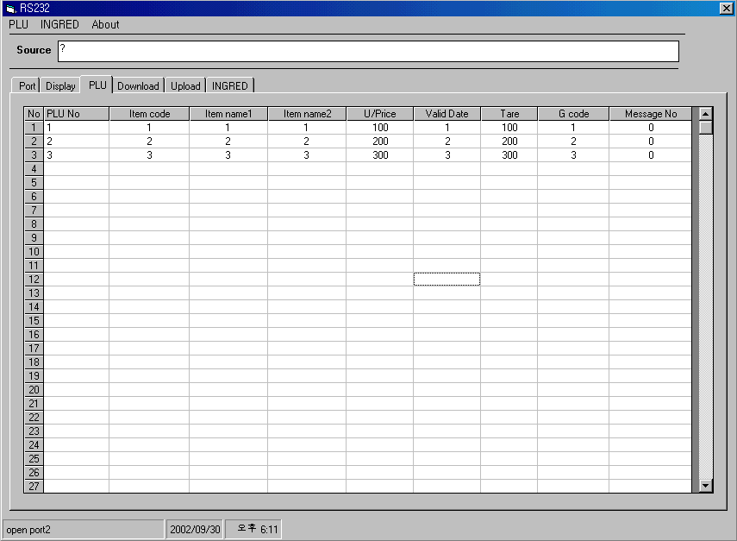
5. BYTE for each Heading:
PLU No : 2byte, Item Code : 4byte, Item Name 1 : 28byte , Item Name 2 : 28byte, Unit Price : 4byte, Valid Date : 2bytes, Tare weight : 2bytes, Group Code : 2bytes, Message No : 2byte

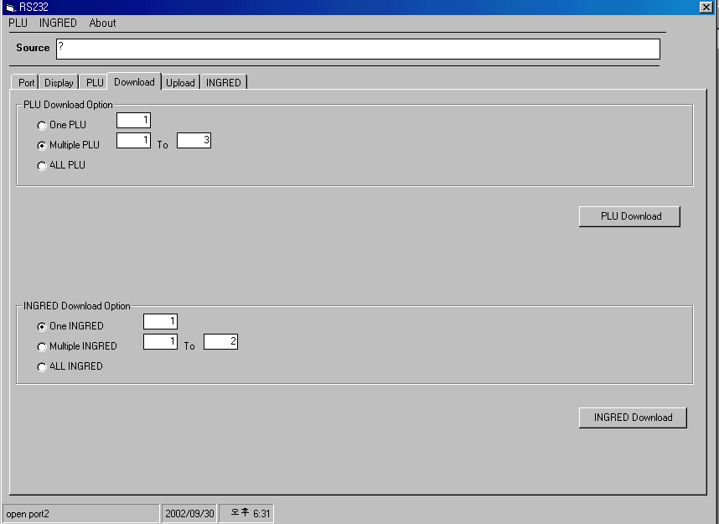
6-1.Select to send only one data from Loaded PLU data
6-2 Select to send multiple data from Loaded PLU data
6-3 Select to send all data from Loaded PLU data
7.Click “PLU download” to download PLU data to the scale.
8-1. Select to send only one data from loaded ingredient.
8-2. Select to send multiple data from loaded ingredient.
8-3. Select to send all data from loaded ingredient.

9. Click “ingredient download” to download ingredient data to the scale.
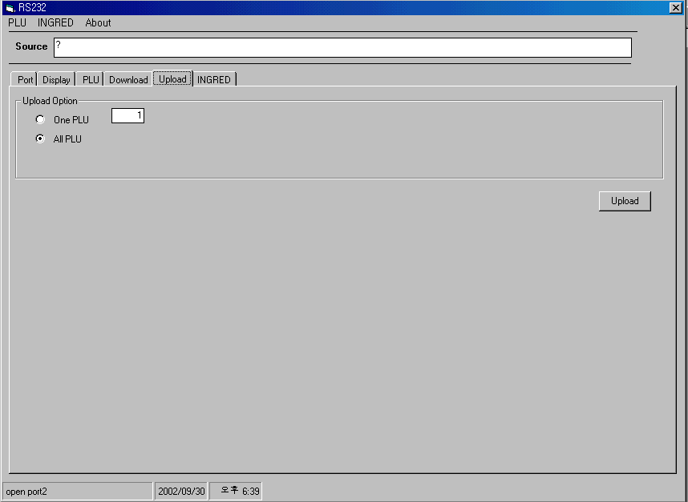
10. Select whether to send only one or all PLU data.
11. Click on “Upload” to upload data from the scale.
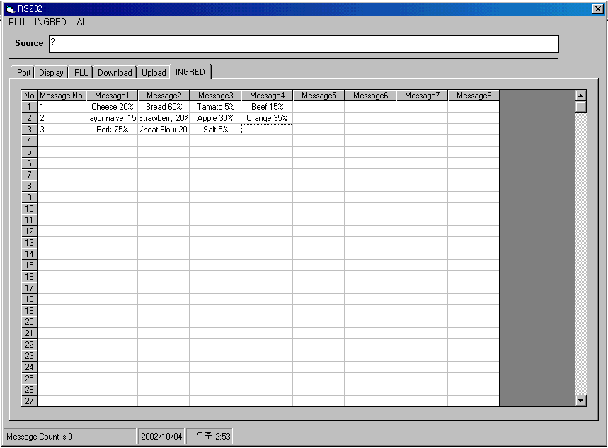
12. Message No : 2bytes, Message 1 ~ Message 8 : Each Char. String, 50bytes. (Ingredient only for 200 & 600 PLU)
200PLU : Message 8 Line
600PLU : Message 4 Line
Message Number : 200EA
In entering PLU, please key in Message No in the field of Message No.
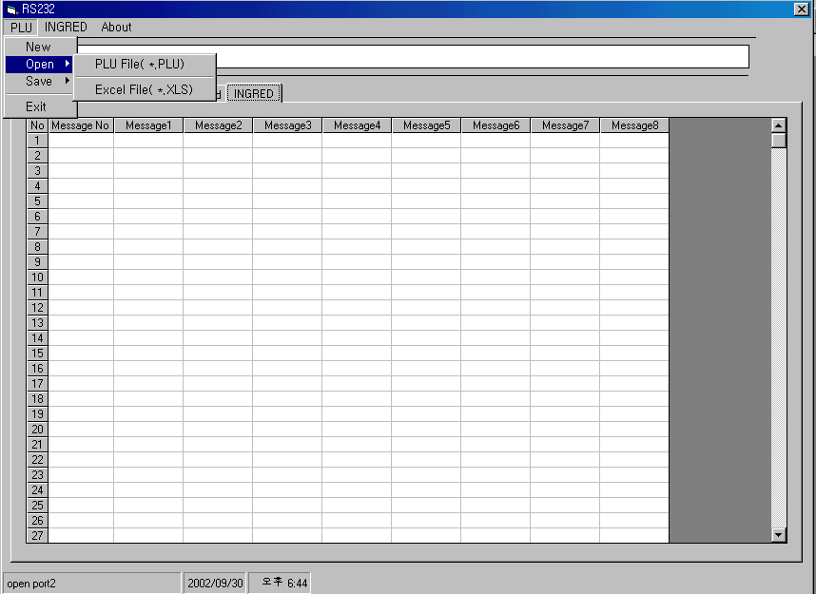
13. Open saved PLU data. (File format : *.PLU, *.xls)
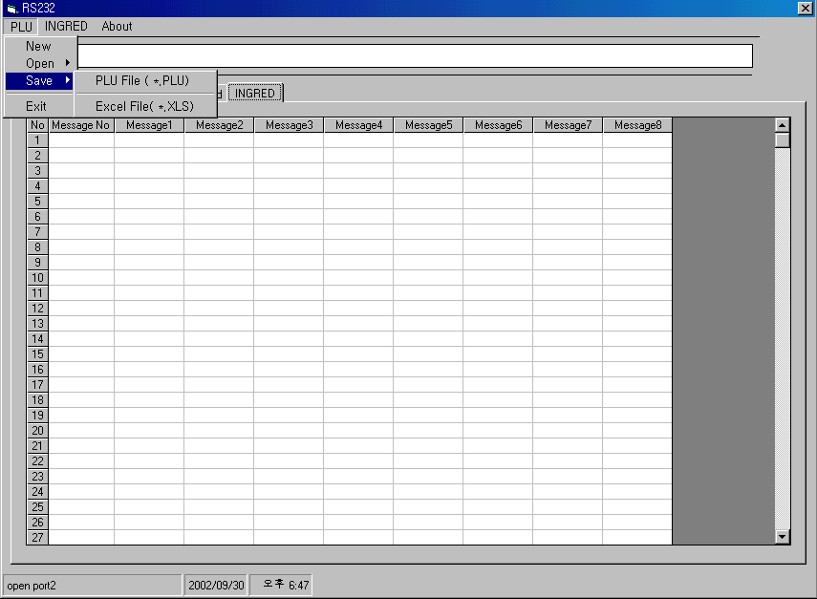
14. To save PLU data, select from *.PLU & *.xls.

Scale (25 Pin) – Male PC (9pin) - Male
Cable (Female) Cable (Female)
2 pin (TX) ------------------------------------- 2 pin (RX)
3 pin (RX) ------------------------------------- 3 pin (TX)
7 pin (GND ) ----------------------------------- 5 pin (GND)

