Vehicle Scale
Existing Foundation


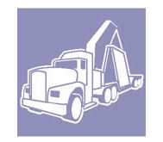


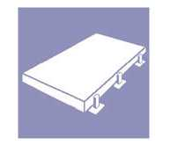
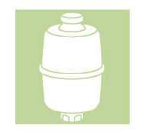

Use this form to provide data about an existing vehicle scale foundation.

Model 7461 / 7560 / 7562: Above-Ground Scale

A

F
D
Approach
Approach
E
C
G

B
Plan

H
I

Beam Slab Elevation

4"
4"
J₂
J₄
J₃
J₁
H
I

K
L

Variable Footer Elevation

Dimensions (Foundation Measurements – Not Existing Scale Measurements)

A |  | I
B |  | J1
C |  | J2
D |  | J3
E |  | J4
F |  | K
G |  | L
H
New Bumper Targets: Flush with end wall (embedded)
Surface mounted (not recommended)
Plate thickness (if not 3/4" each)

Customer: | Comments:
Site: | Comments:
Data taken by: | Comments:
Date: | Comments:

