RS-641L

DIRECT SUNLIGHT VISIBLE
LED DISPLAY

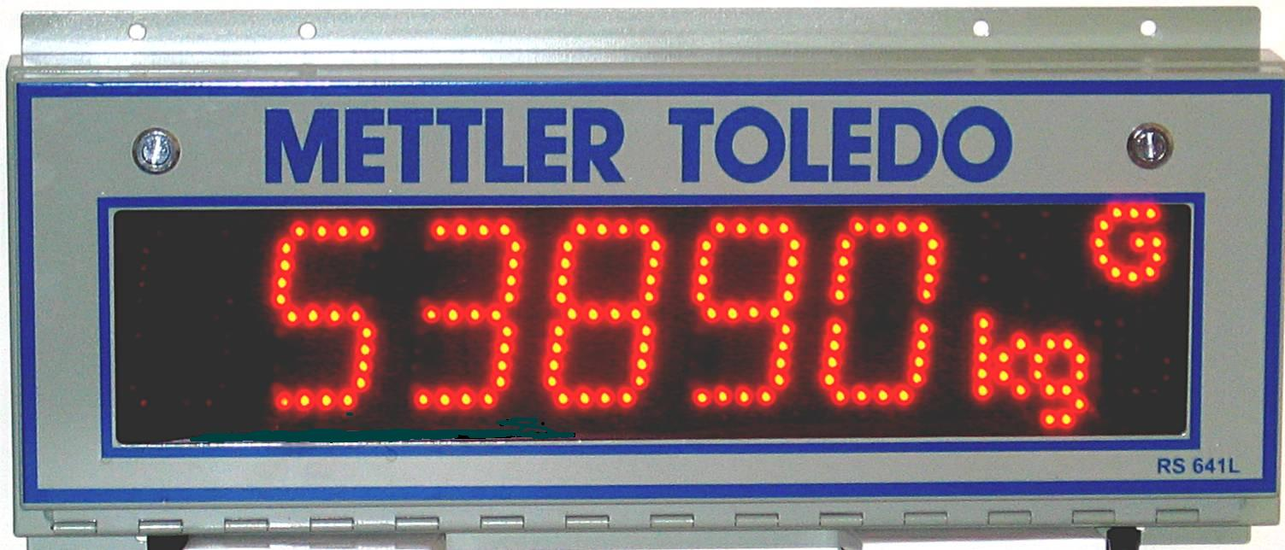

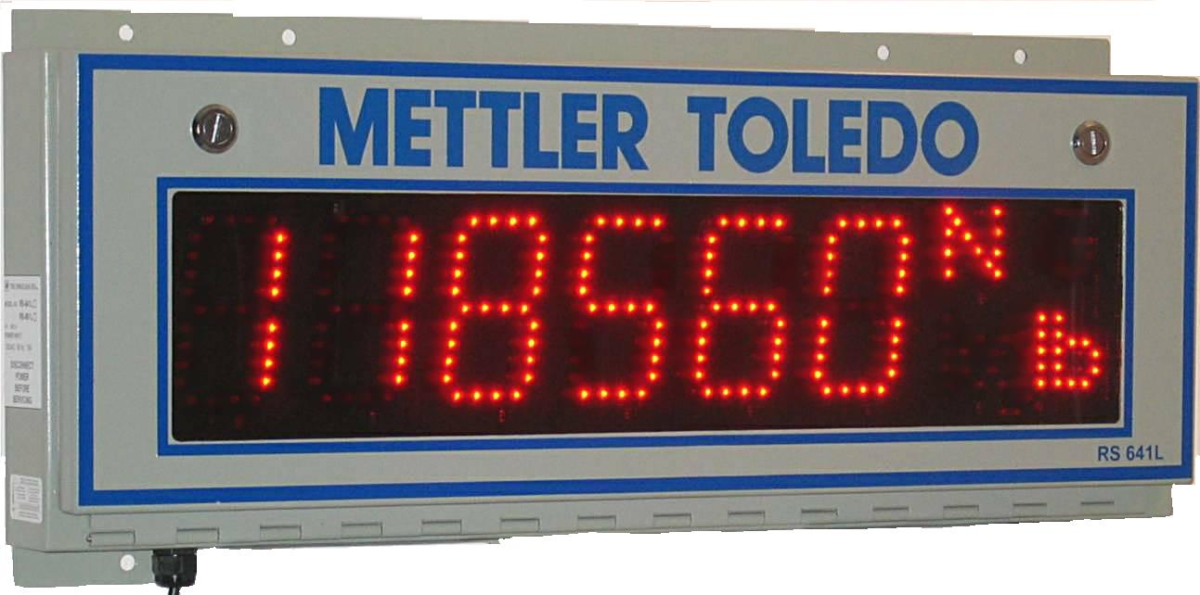

- Waterproof steel enclosure
- Choice of Red or Yellow led’s
- Readily identifiable lb,kg and G,N character display
- ¼ “ Bronze lens window
- RS_232, RS_485, 20ma Current Loop
- 4” or 6”digits of oval leds with approx 4000mcd
- Horizontal and vertical viewing angles 70° and 30°
- 16 Step intensity adjustment
- Field Technician’s friendly enclosure
- Quick swap board and Power Module facility
- Customer able to install wireless Remote Tx & Rx
- Electrical safety approval

