The Purolator DimWeigh application runs on a PDM graphic operator interface. This is a completely automated application that frees the operator to better serve their customers and expedite the shipping process.

The graphic display monitors the scale looking for stable weight above zero. When stable weight detected, the CNS810 is triggered and the dimensions are captured. The graphic display then displays the dimensions and calculates the DimWeight for ground and air shipments using the standard Purolator formulae. The measurement units can be either inches or centimeters. The weight is always in pounds. When the package is removed from the scale, the display is cleared.

Error messages are also be displayed when appropriate. The operator is allowed to make adjustments as needed. A package can also be rescanned if necessary by pressing a key on the display.

This is a transaction based system and therefore does not save the results of each measurement. The measurement results of each transaction can be passed to another device for data collection via the SER3 port on the CNS810.

Hardware.
Each system should include the following Mettler Toledo items:
64057511 CNS810 Static Dimensioner
61400747 Wall mount bracket for the CNS810
PS60xxxx 150 lb shipping Scale
64058237 PDM graphical operator interface
64060779 Custom application for the PDM

Refer to the manuals provided with the CNS810, the PDM and the Scale for additional information and details not contained in this document.

The PDM graphic display is provided complete with the application loaded and properly configured. The application also requires a PS60 or PS90 scale and a CNS810 dimensioner. The application will work with or without the CS2200 dimensions display.

All I/O cables are included. Each component comes with power supply or AC line cord. The scale includes a serial communications cable. The CNS810 and PDM both include Ethernet crossover cables. For direct connection of the CNS810 to a Local Area Network, a standard Ethernet patch cable of adequate length will be required.
Installation.
The wall mount bracket should be secured to the wall with the top no more than 55” above the scale platter. The bracket should be mounted directly to studs in the wall. Additional mounting holes may be added to the mounting bracket as required. Do not mount to bracket using dry wall anchors!

The CNS810 mounting hardware is installed in the bottom of the unit. Secure the CNS810 to the mounting bracket using the four screws and washers included. Remove the I/O access panel on the side of the CNS810. Note that all cables exit to the front and must be routed to the wall along the mounting bracket.

Do not apply AC Power to any of the devices until all the communications cables have been connected.

Refer to the installation instructions included with the PDM as needed. Mount the graphic display on the wall or counter in clear view of the operator. The 10 foot Ethernet crossover cable provided with the PDM will limit the distance from the CNS810. Make sure this cable can be properly routed to the CNS810 access panel.

Connect one end of the orange Ethernet Crossover cable to the NET2 port on the CNS810. Connect the other end of this cable to the Ethernet port on the PDM. A standard PS2 QWERTY keyboard may be required for configuration of the PDM. Attach the keyboard to the PDM keyboard port before power is applied.

If the CNS810 is being used in a standalone mode, attached the second orange Ethernet crossover cable to the NET1 port. This will connect direct to a local computer that will be used to calibrate and configure the CNS810. This computer will also be required to print an audit trail after the unit has been sealed. An alternate configuration would be to connect NET1 to the Local Area Network. This connection will require a standard patch cable (not provided) to connect the NET1 port to a network switch or hub at the site.

Connect the serial cable, provided with the PS60 scale, to the SER1 port on the CNS810.

A total of three AC outlets will be required for the system. One is use to power the CNS810, one for the scale and one for the PDM. Install the PDM power supply near the outlet and extend the low voltage cable to graphic display.
CNS810 DIMENSIONER
LAN or Computer with Printer
PS90 SCALE
PDM
NET1
SER1
NET2
Setup
Keyboard

Configuration.
Some of the components have been configured at the factory for this application. Verify the configuration of the PS60 scale, the CNS810 dimensioner and the PDM display as directed below.

PS60: Only a couple parameters are different from the default settings, but all critical settings will be listed.
- Set the Filter to Medium.
- Disable Alternate Units.
- Verify the serial port is set to 9600 baud, 7-bit character, Even parity, 1 stop bit.
- Set the Protocol to PROTO5.
- Set the GEO code as required.
- If the scale platter has been changed, it may be necessary to calibrate the scale.
- SAVE the settings.

CNS810: Log onto the web pages of the dimensioner for the following configuration steps. It may be necessary to disconnect the graphic display from the NET1 port if using this port for configuration.
- The software revision of the CNS810 must be 1.6.1 or later.
- Dimensions will be shown as configured in Package Reporting. If configuring for centimeters, the increment size must be 0.5. If configuring for inches, the increment size should be 0.2.
- NET2 port must be set for IP=192.168.2.101 and the SM=255.255.255.0. The NET1 port should be at IP=192.168.127.14 for standalone operation or consult the IT manager for a fixed IP address if attached to the Local Area Network. When connecting to a LAN, the Gateway address will also need to be configured.
- Under Advanced Settings/Hostem the following parameter settings are required. These setting have been pre-set at the factory.
  - Parameter host_location set to NET2.
  - Parameter gen_protocol set to CS800
  - Parameter heart_beat_timeout set to 1.
- Set the system clock. The CNS810 does not recognize daylight savings time, so select the standard time zone.
- Calibrate the CNS810. If a ball or roller top platter is used on the scale, it will be necessary to use a reference plane or box of known height for calibration. A reference plane of 24”x24” is recommended but a 16”x20” reference plane will be sufficient.

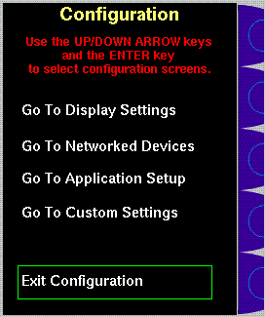
PDM: Attach a QWERTY keyboard to the PS2 keyboard input. Press and hold the “S” key on the QWERTY keyboard while applying power. The PDM will startup in the Configuration mode with four configuration screens options.

- The first three screens are exactly the same as the standard MT Default screens. Refer to the JXOI/PDM manual for details of these screens. The fourth screen allows customization of the application. Use the UP/DOWN arrow keys to select a configuration screen and then press the Enter key to go to that screen.
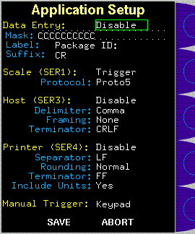
- The Application Setups should be configured as shown in the screen shot at the right. These settings enable automatic trigger via scale weight and manual trigger from the keypad. The data entry option is disabled. The host and printer outputs are disabled. The keypad must be enabled in Legal-for-Trade applications.
- The Custom Settings screen only has one parameter that allows custom configuration of the operation screens. In this application, this setting changes the screen layout and enables the Purolator Ground and Air DimWeight calculations. Set to “Custom” for the Purolator configuration.
- Select “Exit Configuration” to start the custom application. Press and hold the Mode Switch key on the PDM (key with green balance) to verify the application part number and revision (currently 64060779 Ver 0.4).

After verifying the configuration and operation, replace the access cover on the CNS810 to prevent dust from entering the dimensioner. Also, remove the QWERTY keyboard form the PDM.

Legal-for-Trade Sealing.
The CNS810 is approved by Measurement Canada for Catetory 3 sealing. When the system is sealed, an audit trail is created and maintained to show all configuration changes made to the system. During the certification process, the CNS810 will be sealed via the web pages and the inspector will request a hard copy printout of the Audit Trail. Either a PC with a printer must be attached to the NET1 port or the CNS810 must be on the Local Area Network to provide the printout. Follow the instructions in the CNS810 Owner’s Manual for sealing. Do NOT check the “lock root user account” box before sealing.

DimWeight Calculations.
The ground and air DimWeight calculations are completed each time the dimensions are taken. The results are held on the PDM until the package is removed from the scale. The formulae are as given below.

For dimensions given in inches, the Length, Width and Height are multiplied together to determine the volume of the package in cubic inches (V = L*W*H). The volume is rounded up to the next whole cubic inch. If the Weight is greater than the DimWeight calculation, the package is shipped by weight. Otherwise, the package is shipped by DimWeight.
Ground DimWeight = V / 1728 * 10.
Air DimWeight = V / 1728 * 15.

For dimensions given in centimeters, the Length, Width and Height are multiplied together to determine the volume of the package in cubic centimeters (V = L*W*H). The volume is rounded up to the next whole cubic centimeter. If the Weight is greater than the DimWeight calculation, the package is shipped by weight. Otherwise, the package is shipped by DimWeight.
Ground DimWeight = V / 27000 * 10.
Air DimWeight = V / 27000 * 15.

When packages are shipped by weight, the measured weight is rounded up to the next whole pound. The rounded weight is shown in the Ground and Air DimWeight boxes.

Potential Future Enhancements.
There are a few things that we can potentially do to enhance the application.
- The results of each measurement/calculation can be output on the SER3 serial port of the CNS810 for logging or data entry on shipping/manifest computer.
- We can add a keyboard for the entry of oversized and irregular shaped packages that we cannot measure.
- We can add a bar-code scanner to tie a tracking number to the data.

Operator Instructions.
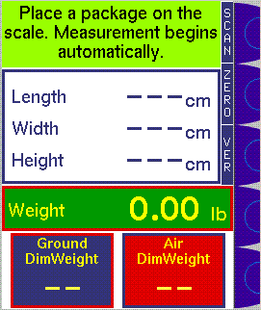
SCREEN LAYOUT. The PDM display is divided into panes that contain instructions, information and results of measurements and calculations. The top pane contains the instructions to guide the operator through the process. When problems are encountered, the operator will be offered possible solutions or instructed to refer to other panes for specific conditions. Normal instructions are presented on a green background. Error instructions are presented on a red background.

The second pane normally shows the results of the most recent measurement. The measurements remain on the screen until the scale returns to zero. When measurement error are encountered, this pane will provide details of the error condition that will help the operator resolve the condition. Errors will be shown on a yellow background.

The third pane shows the live weight on the scale at all times. If the scale is not ready for any reason, a status message will be shown on a yellow background. The scale weight is used to used to automatically trigger the CNS810 when it is above zero and stable. It is also used to clear the display when the scale returns to a stable zero. When the scale is unstable, a tilde (~) symbol will replace the weight reading.

The bottom pane contains two boxes that display the results of the DimWeight calculations. The blue box on the left contains the Ground DimWeight calculation. The red box on the right contains the Air DimWeight calculation. Always use the DimWeight results to determine shipping charges. If the package is being shipped by weight, both boxes will contain the scale weight rounded up to the next whole pound. If the packages are shipped by volume, the boxes will contain numbers greater than the displayed scale weight.

At the right side of the display there are five blue special function keys. The first blue key may be used to manually trigger the CNS810. The second key is used to verify the Zero calibration of the CNS810. The third key displays the software version of the CNS810 and the PDM. For normal operation these keys are required but they must be available for Weights & Measures inspection.

SYSTEM READY. The scale must be at zero when empty. If the empty scale is not at zero, press the zero key on the scale display.
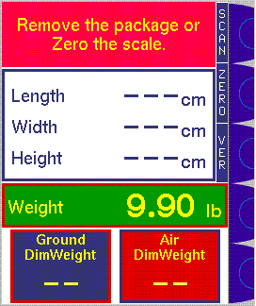
In the screen shot at the right, a package was on the scale at startup. The operator is instructed to “remove the package” to begin the measurement process.

When the system is ready, the screen on the previous page will be showing.

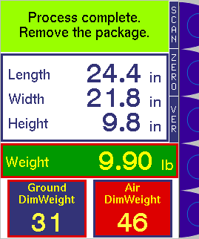
PROCEDURE. Place a package on the scale and move hands away from the package. Dimensioning begins immediately and will be completed in about 3 seconds. The process is complete when the dimensions are displayed.

Use the “Ground DimWeight” or “Air DimWeight” to determine shipping charges. Leave the package on the scale until the charges are determined.

Any time a package is on the scale, it can be re-dimensioned by pressing the “SCAN” key on the graphic display.

If the package is too large or not positioned properly, error messages will be displayed. Reposition the package if necessary. The package will be automatically re-measured in 10 seconds. Irregular packages and foreign objects (like hands) inside the measurement field will also generate errors.

