Kit Number: 64066426 Document Number: 64066503

Introduction
This kit is for an adjustable wall mount bracket to be used with the model CSN810 static dimensioner. The bracket is designed to mount on sheetrock that is at least 1/2” thick, supported by studs on 24” or less centers. Heavy duty dry wall anchors and wood screws are required.

Whenever a wooden stud is supporting the wall, a wood screw should be engaged. When the stud is located in an area of the mounting plate without a slot, a hole should be drilled in the plate.

Parts List
Included in this kit are:
- One back plate
- One left side and one right side support
- Two slide arms
- Eight M8 nuts, lock washers and flat washers

Tools Required
- A #3 (large) and #2 (medium) Phillips screwdriver
- A flat blade screwdriver
- An M10 wrench or socket
- A bubble level
- A tape measure
- A plum with at least 165cm (65”) of cord
- A stud finder
- Cordless drill with 4.8mm (3/16”) and 2.8mm (7/64”) bits

Anchors Required
The following items can be found at a local hardware store.
- Six #10 wood screws 2” long
- Six 3/16” Cobra DrillerToggle anchors or equivalent. Pull force must be greater than 100 lbs (45kg) when used in 1/2” drywall. Do not use plastic drywall anchors.
- Six 3/16” fender washers

Install the CSN810 Bracket
- The CSN810 must be mounted so that the laser exit window is approximately above the center of scale platter. Do NOT preassemble the bracket. The back plate will be used as a template during the installation.
- Locate the center of the scale along the wall. Measure 140cm (55in) up the wall from the top of the scale. Place a small horizontal mark on the wall. This will be the top of the mounting bracket.
- Place the mounting plate against the wall with the top of the bracket centered on the mark. Use a bubble level along the top of the bracket to position it properly. Mark the the four horizontal slots with a thin line at the top and bottom of each slot. Don’t mark the ends of the slots. Set the bracket aside.
- Locate any studs near or within the four slot marks. If the stud is within any of the slot marks, put a “+” mark in the center of the stud. If the stud is between the slots, put a “V” mark above the top of the bracket.
- In the center of the slots that do NOT have a “+” mark, install one of the drywall anchors (usually 2 or 4).
- Place the back plate of the bracket over the drywall anchors and insert the screws with flat washers.
- In the locations marked with a “+”, insert a wood screw with a flat washer. If any of the wood screws do not tighten, remove the bracket and install a drywall anchor near the wood screw location.
- Attach the Left and Right side supports to the mounting plate using two washers, two lockwashers and two M8 nuts on each side. Align the side supports with the top of the mounting plate and tighten the nuts.
- Install the two slide arms to the side supports using two washers, two lockwashers and two M8 nuts on each side. Push the arms to their shortest position (toward the wall). Leave the nuts finger tight at this point.
- Unpack the CSN810 and remove the four mounting screws in the bottom. Place the CSN810 on the bracket with the laser exit window away from the wall (access panel on the right side as you face the wall). Align the mounting holes with the slide arms and install the mounting screws. Tighten them.

Bracket Alignment
The wall mount bracket may require adjustments to properly position the center of the laser exit window above the scale.
- Place a mark on the plum cord 140cm (55”) from the bottom of the plum. A washer on a string can be substituted if a plum is not available.
- Hang the plum centered over the front edge of the CSN810 with the mark at the same level as the bottom of the CSN810. Tape the end of the string to the top cover of the CSN810 to hold it in place.
- With the scale in its normal operating position, adjust the side supports of the wall mount bracket up or down until the plum touches the top of the scale platter. Tighten the side support retaining nuts.
- Move the back plate of the wall bracket left or right to center the plum along the side of the scale. Tighten the screws holding the bracket to the wall.
- Gently lift the front of the CSN810 and pull it outward until the plum is approximately 7.5cm (3”) beyond the center of the scale. Tighten the slide arm retaining nuts. This positions the center of the laser exit window directly above the center of the scale.
- If only drywall anchors are supporting the bracket, add at least one wood screw to the back plate against the wall. Remove the CSN810 from the bracket. In the location(s) marked with a “V”, drill a 4.8mm (3/16in) hole in the mounting plate directly below the “V” approximately 25mm (1.0in) below the top of the plate. Install a wood screw in this location. Replace the CSN810.

Install the JXOI Base
- Loosen the JXOI mounting arm to free one of the ball ends. Attach the ball end to the large round plastic base.
- The JXOI can be mounted on a tabletop or the wall. Locate an appropriate mounting location. Make sure the Ethernet cable to the CNS810 is long enough to reach this location.
- For tabletop mounting use two or four wood screws. Drill pilot holes with a 2.8mm (7/64”) for easier installation.
- For wall mounting, use two wood screws into studs or two drywall anchors when studs cannot be found.
  - Use the stud finder to locate a stud in this area. Mark the spot that will be approximately the center of the display. Place the large plastic base over the spot with the mounting holes in a “+” orientation. The top hole should be over the marked spot. Install one wood screw with no washer in the top hole and another in the bottom. If either of the screws missed the stud, replace it with a drywall anchor as described below.
  - When a stud cannot be located, simply mark a spot that will be the approximate center of the display. Place the large plastic base against the wall with the mounting holes in a “+” orientation. The top hole should be over the marked spot. Use a wood screw to mark the top and bottom holes. Install drywall anchors in the marked locations. Attach the base with the anchor screws and no washers.

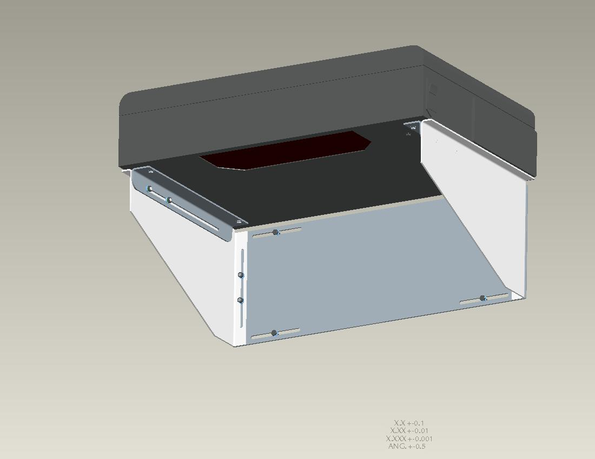
Slide Arm
Right Side
Support
Back Plate
140cm (55”) to top of scale
Left Side
Support

