
New Brunswick Power Coleson Cove Corporation

Mettler Toledo Inc. Unattended Scale

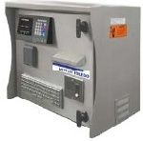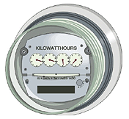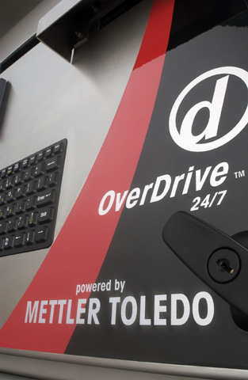

Phil Beatty
Mettler Toledo Unattended Scale operation

The following is an example of an operation using hardware and software controls and in use at your location, New Brunswick Power Coleson Cove Corporation.

INBOUND either empty or loaded.

- The traffic lights in both directions are red,

- A truck approaches the scale slowly, stops at sign and triggers the traffic loop detectors located in the approach to the scale. (Loops are located at both ends of the scale). This will send a command to Zero the scale.

- The Mettler Toledo System insures that the scale is at zero, if the scale cannot zero then the truck driver will be faced with a red light and must use the phone located by the Mettler Toledo Terminal to contact an on duty supervisor.

- If the scale zeroed, then the light facing the truck driver will turn green and the driver proceeds onto the scale.

- Once the truck is completely on the scale the traffic light will turn red, the truck is considered on the scale platform when the detector is no longer actuated and there is weight on the scale. The Terminal the driver will see on the first pass is marked SLAVE.

- The driver will be able to see the display from his cab and the weight, directly to the right of the weight will be the kg symbol, all weights are in kilograms and at the far right will be a X. When no motion or the motion is within range to weigh the X will turn to an * asterisk (star) symbol and the driver will now hold his badge in front of the badge reader, it can be up to three feet or more away but needs to be directly in front of the reader. The driver can just hold it out the window of his truck, no need to exit vehicle. The badge will look like the image on next page; you can hold it near the slot cut in badge. The illustration is not to size.

IMPORTANT

Wait for the * to appear before swiping badge
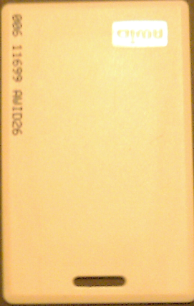

- After the badge is read the vehicle and account data will display in the window, nothing else needs to be done by the driver as all data has already been added in the computer. The driver will see the light in front of him turn from red to green, a message on the display screen says Transaction pass complete. The driver will drive off the scale at this time.

OUTBOUND either empty or loaded

- The traffic lights in both directions are red,

- A truck approaches the scale slowly, stops at sign and triggers the traffic loop detectors located in the approach to the scale. (Loops are located at both ends of the scale). This will send a command to Zero the scale.

- The Mettler Toledo System insures that the scale is at zero, if the scale cannot zero then the truck driver will be faced with a red light and must use the phone located by the Mettler Toledo Terminal to contact an on duty supervisor

- If the scale zeroed, then the light facing the truck driver will turn green and the driver proceeds onto the scale.

- Once the truck is completely on the scale the traffic light will turn red, the truck is considered on the scale platform when the detector is no longer actuated and there is weight on the scale. The Terminal the driver will see on the second pass is marked MASTER.

- The driver will be able to see the display from his cab and the weight, directly to the right of the weight will be the kg symbol, all weights are in kilograms and at the far right will be a X.

- When no motion or the motion is within range to weigh the X will turn to an * asterisk (star) symbol and the driver will now hold his badge in front of the badge reader, it can be up to three feet or more away but needs to be directly in front of the reader. The badge will look like the image as seen on the sheet for INBOUND weighing,

- After the badge is read the vehicle account data along with the first weight will be calculated and will display in the window, the driver will need to wait for his printed ticket. The driver will see the light in front of him turn from red to green, a message on the display screen says TRANSACTION COMPLETE PRINTING TICKET THANK YOU The driver will take his ticket and drive off the scale at this time.

Wait for your ticket

ERROR CODES - FLASHING LIGHTS - ETC.

- RED FLASHING LIGHTS – This may occur for a number of reasons, a truck may be on the scale when another truck approaches the loop and triggers the detectors. This will cause the traffic lights to flash and no transactions can happen. The display will show a message EXIT SCALE NOW. The vehicle on the loop must back off the loop and the truck that was on the scale must exit. When both vehicles exit the loops, the scale will re-set in ten seconds and the lights will return to a steady RED state and will return to normal weighing mode.

- RED FLASHING LIGHTS – Will not allow any transactions to happen, drivers should be aware of another truck on the scale and not drive on the loop until the truck has cleared the scale.

- GREEN LIGHT STAYS ON – When the light turns green and a truck enters scale there may be an occasion that motion or another fault will not allow the light to turn red. If this happens driving off the scale should re-set the loops and lights, try entering scale again. If problem persist contact supervisor using phone located by the Mettler Toledo Unattended Terminal.

- You may also see other error messages such as Invalid transaction, your weight may be the same on both directions, should not happen, contact supervisor.

- You may see other error messages, such as wrong grad size, this may be a malfunction of the scale or associated equipment, contact supervisor.

- If the capacity of the scale is exceeded you will see down pointing arrows approximately 15, where the weigh data was, no weight will be visible.

- This message should never be seen as you would have in excess of 73,000 kg of weight. This would be illegal to travel on the highway with. If you should see this message please call the supervisor, do not proceed with load.

NOTE:
This is a new system in use for collecting data and making your scaling experience more accurate and saving time from manual weighments. We would appreciate feedback on any ERROR MESSAGES you may see, how they happened, etc. With your help we will be able to provide you with changes to make your job more productive, please send in feedback.

METTLER TOLEDO has provided Weight & Measures with complete data on the system; they have inspected and certified the scale as an accurate weighing device for use in trade applications. You can be assured that your weights are accurate. If you notice anything out of the ordinary please contact the on-duty supervisor.

NB Power Coleson Cove Corporation Computer Operators Guide

Mettler Toledo Overdrive Tech Support Line is provided by:
Mettler Toledo Vehicle Systems
Lexington, Ky
859-266-6600

Local Support by:
Mettler Toledo Inc.
Moncton, NB
1-800-523-5123 Jean Claude Hachey or Phil Beatty 24 hour, seven days per week support, on-site or phone support.

IP Addresses

Computer IP 111.111.111.110
Master UADT 111.111.111.111
Slave UADT 111.111.111.112
Master NetGear Print Server 111.111.111.2
Slave NetGear Print Server 111.111.111.1

Computer Specs.
Dell Dimension 4600
CPU 3 Gig Pentium 4
RAM: 512 Meg
OS” Windows XP Professional

Overdrive Login:

Username: Supervisor
Password:

Training Summary:

  - Account ID - Table is used to designate who the driver is transporting for.

  - Vehicle ID - is the vehicle license or ID on truck.

  - Product - is the commodity that is being shipped or received.

  - Operation - S is Ship, R is Receive. If either is picked then the system will determine if the transaction is S or R.

  - In order to run a transaction, you must provide a Vehicle, an Account and Product. These fields are highlighted with a yellow colour; you will find most of the fields that are yellow require information.

All information is entered into the table using the Data Setup area of Overdrive to add information to the account table, bring up the account table or to enter items into the Vehicle table, select Vehicle table.

  - In order to backup your data in the Overdrive Database just copy the SybaseDB folder from: C:\ProgramFiles\MettlerToledo\Overdrive\sybaseDB to a CD-RW or to your preferred backup device. You should do this weekly.

BADGE CONFIGURATION

In order to setup a Badge into the system, you first must have the Vehicle set up in the database. Next you need to shut down the UADT via the virtual Scale Indicator, (seen on your computer screen).

The Virtual Scale displays current information from the scales attached to the system. It allows the operator to view the activity on the scale; the virtual scale automatically starts when you log on to overdrive. Check the always on top box.

The shutdown button is a virtual push button located in the lower right hand coroner of the virtual scale Indicator, after swiping the badges turn it back on. When you push the button in the Unattended Station Screen will read UNATTENDED CLOSED,
Otherwise the message will read WELCOME TO OVERDRIVE.

Click the shutdown button, click on the Badge table to bring up the Badge entry screen.

Make sure that Jag Scale is checked and then have someone scan the Badge at one of the UADT terminals located at the Scale.
When the Badge is scanned you will see the Hexadecimal number for the card show up in the Badge Id Field, next select Vehicle for the Table selection and pick the Vehicle you want to associate with the Badge under the field selection box.

Next hit the table save button and the information will be saved to the database. See Info below:

Optional Proximity Card Reader badges can be setup within the Overdrive Data Setup. When a Badge is held in front of the Badge Reader the badge number is automatically inserted in the “Badge ID” field.

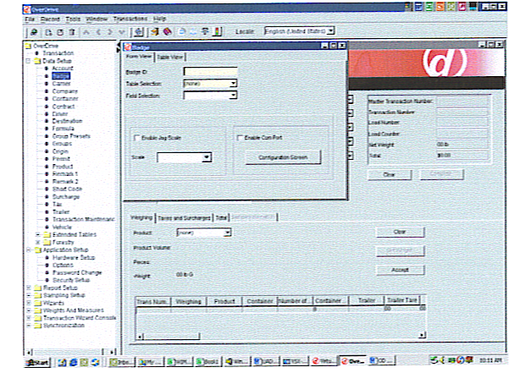

Remember whenever you add a new Vehicle to the system you must assign that Vehicle to the transaction wizard so it will ask the correct questions out at the UADT terminal at the scale.

NOTE: The driver will see the information for a split second but does not need to respond to any prompts. This can be changed in the future if you need your driver to make different selections.

Tickets:

Different tickets or info on the tickets can be changed, this would be a custom change so try to determine exactly what your needs will be. We can make changes and send ticket back by email and assist you in installing it.

Your Present Ticket:

Coleson Cove Corporation

In 1/19/2005 1:52:04 PM

Out 1/19/2005 2:14:21 PM

Transaction 249

Vehicle ID Toledo Test

Account ID Toledo

Product ID Weights

Gross Weight: 5000 kg

Tare Weight: 100 kg

Net Weight: 4900 kg

Thank You

REPORTS:

Different reports can be created but again these are custom reports that need to be created using Crystal Report Writer. Again try to determine exactly what you need as these are done off-site or can be done on-site if you purchase Crystal Report Writer.
Present Reports used are designed to provide you with daily and weekly Net Weights of different products,

SUPPLIES:

You should carry in stock thermal rolls of paper used for the ticket printer. A spare Load Cell, A spare Cable and two pieces of “T” Belting to keep debris falling into the scale ends.

Thermal Roll part # TRF80-152 Minimum order 4 rolls $21.65 roll

Load Cell Part # A15475900A $2024.15

Twenty six foot cable TA000088-026 $ 426.96

“T” Belting 11 foot $ 88.00

Spare Cards can be ordered for the Badge Reader as needed, order in Quantities of 50, part # of card - AWID proximity card.

Warranty:

Your scale has a full five year warranty but must have a paid service contract with at least two full visits per year to retain the warranty. We will provide you with the details shortly and set up a schedule to carry out the maintenance required.

-


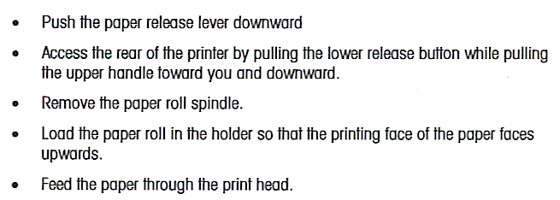

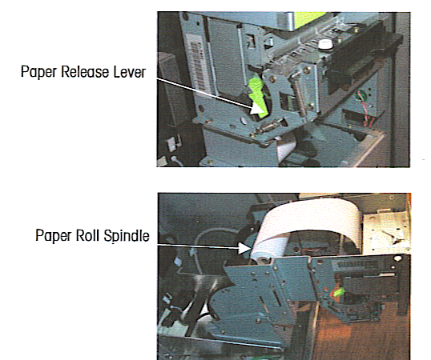

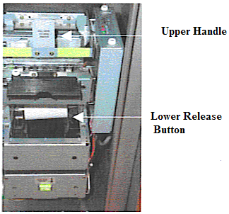



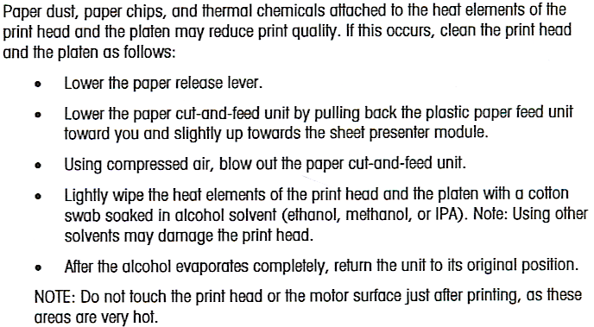



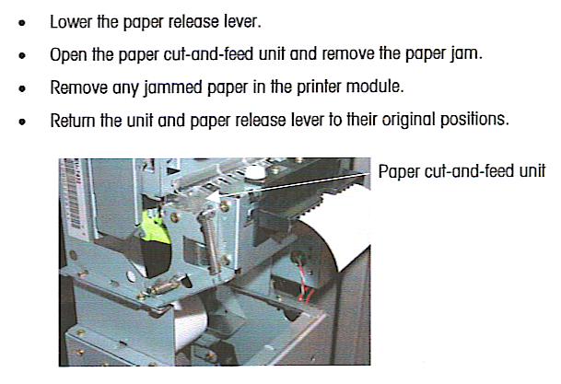

Equipment List

UADT 2111110-5452727-5KF
UADT 3111110-5452726-5KF
JAGXTREME-5452133-5KF
JAGXTREME-5452132-5KF
7562-1131183-1KF

