Procedure for viewing APC 100 scanner PC at Sameday Right-O-Way

The APC 100 decoder PC can be accessed by two different methods:

Method 1: A VGA monitor, keyboard and mouse can be brought to the system and plugged directly into the bottom of the APC 100. The monitor plugs into the VGA jack, the keyboard plugs into the purple jack and the mouse plugs into the green jack. This procedure is normally only used when the PC cannot be accessed remotely.

Method 2: The Accu-sort APC 100 decoder PC is accessed remotely through VNC from the Interweigh PC. This procedure is used as a more convenient way to access the APC100 than method 1.

Overview: The Interweigh PC is set-up with TCP/IP address 192.168.0.1, Subnet 255.255.255.0. The APC 100 is set-up with TCP/IP address 192.168.0.2, Subnet 255.255.255.0. The two PC’s are connected with a cross-over ethernet cable. The APC 100 runs VNC as a service under Windows NT 4. The Interweigh PC uses VNC-Viewer to access the APC 100.

Step 1: Press the View Scan PC button on the System Status tab of the SDReweigh application.

When prompted for the password, enter accusort

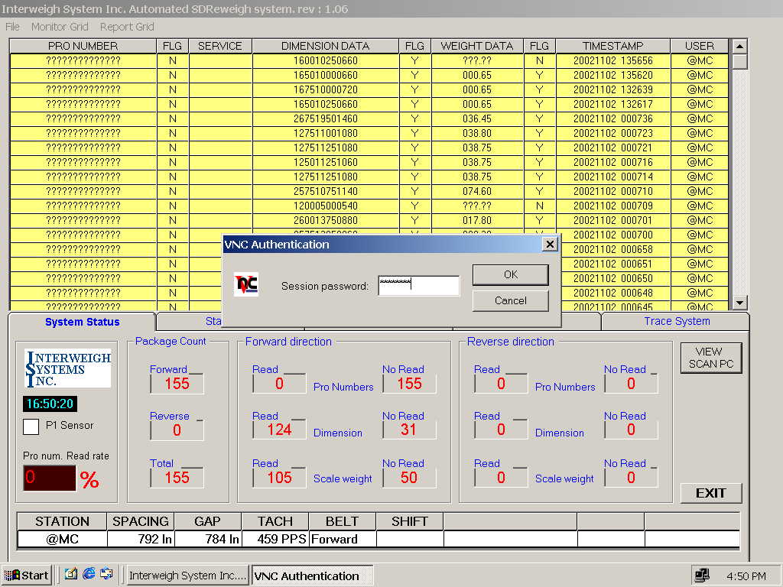

Step 2: Right click on the apc100 button on the task bar. Click on Full screen.
You are now able to see the full APC 100 screen. Use CTRL-ESC to get back to the Interweigh task bar. Use ALT-TAB to switch between SDReweigh and APC 100.

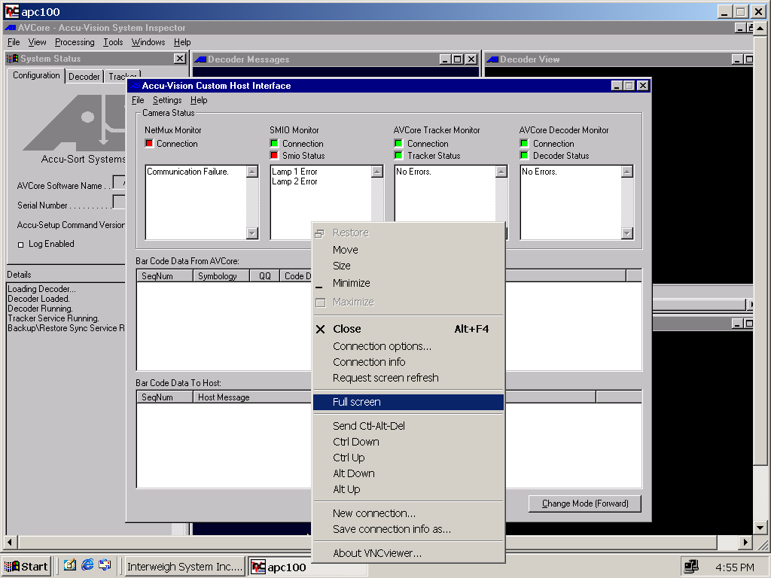

Step 3: If the task bar is missing from the APC 100 display, click on AVCore, go to the View menu and
click on Restore Desk Top.

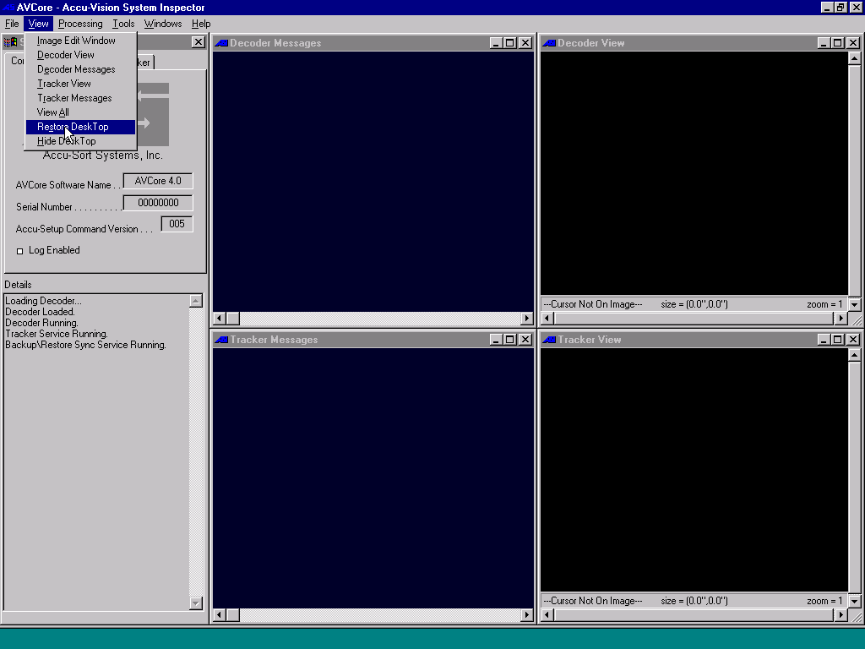 Hidden Task Bar

Step 4: When your session is complete, you must close the VNC Viewer.
Press CTRL-ESC and right click on apc100. Click on Close

