

OPERATING PROCEDURES

AUTOMATED REWEIGH CUBING SYSTEM

For

SAMEDAY RIGHT-O-WAY

Confidential Document:

This document is the property of Interweigh Systems Inc. 51 Bentley Street, Markham, Ontario L3R 3L1 and is produced for the Operation instruction of employees of Sameday Right-O-Way only.
Upon receipt of this document Sameday Right-O-Way agrees to keep this document for its own internal use and will not distribute or copy this document to anyone other than those for internal use.
This document should be reviewed and updated to match the current version of the Interweigh ARC Reweigh software, as identified in the footer on each page.
Index: Page No.

Confidential Document Statement……………………………………. 1

Index…………………………………………………………………… 2

Introduction to ARC…………………………………………………… 3

Startup Procedures…………………………………………………….. 4

Passwords .……………………………………………………………. 4

SDReweigh ARC System screens .…………………………………… 5

Reports Screen ………………………………………………………… 5

System Status …………………….…………………………………… 7

Stats Data ……………………………………………………………… 9

Setup Parameters ……………………………………………………… 10

Log files ……………………………………………………………….. 12

Trace System ………………………………………………………….. 13

Accu-sort manuals for the following devices were provided at the time of installation

1. DM-3000 Multi-dimensioning unit

- AV-3700 High-Speed Barcode Reader

3. APC-100 Decoder PC

Introduction ARC:

The Automated Reweigh Cubing System (ARC) is the integration of three separate pieces of equipment to automatically capture each shipping carton’s, PIN, dimension and weight, while in-motion as part of Sameday’s conveyors. Please note the system works in both directions. The system tracks and marries the data from each device and then formulates and writes the data to a flat file resident in the Interweigh PC. The Interweigh PC is on Sameday’s Network, thus facilitating Sameday taking the data from the flat file to its back end billing system.

Scanning:
Top scanning is provided by Accu-Sort through its AV-3700 High-Speed Bar Code Reader system. It is comprised of a single top AV-3700 Reader and the APC-100 Decoder PC to accommodate singulated cube-shaped box sizes up to 36” in length and PIN label positions on the top (only) of the package . In addition to the various PINs being used by Sameday and its customers, the Av-3700 system also read the various Service Level barcodes, such as, 9:00 AM, AM and PM. Each shipping carton passed through the AV-3700 system is programmed for only one PIN and one Service Level barcode. Any multiple reads are identified as 14 exclamation marks (!!!!!). No Read errors are identified as 14 question marks (????) The data is transmitted via RS-232 communication to the Interweigh ARC System’s PC.

Dimensioning:
Each carton’s dimensions are obtained from the DM-3000 dimensioning system supplied by Accu-Sort. The carton’s measurements are obtained through a combination of a tachometer measuring the movement of the conveyor and a CCD camera detecting a sweeping laser beam as the package passes under the DM-3000 equipment. The dimensioner is Legal for Trade approved for this systems as indicated on the marking plate attached to the device. The carton’s length (0.25” increments), width (0.25” increments) and height (0.20” increments) is transmitted via RS-232 communications to the Interweigh ARC System’s PC. Like the scanning equipment above the equipment is designed for singulated freight with a minimum spacing of 3” between packages.

Weigh Scale:
Each carton’s weight is obtained from the ISI-5436-CS In-Motion Carton Scale, supplied by Interweigh Systems Inc. The scale is sandwiched between two in-feed conveyors, forming the ARC System’s conveyors. Both in-feed/out-feed conveyors are the ISI-3636 IF conveyor supplied by Interweigh, and are required to ensure all cartons are spaced properly and travelling at the correct speed as they enter the scale and each of the three devices. The In-motion Scale’s weight is displayed on the digital indicator located above the Interweigh ARC System’s main control cabinet and transmits each weight to the Interweigh ARC System’s PC, via RS-232 communications.

Reverse Direction:
The system operates in both forward direction (usually PM shift) and in reverse direction (usually AM shift). The direction of the conveyors is tied to Sameday’s main conveyor panel and starts/stops along with the other conveyors controlled from that panel.
The ARC System’s conveyors run at 240 ft/min in both directions. Depending on the direction at the time, the conveyor before the scale is the in-feed and the one after the scale is the out-feed. The in-feed conveyor provides the separation of the packages as they enter the ARC system coming from Sameday’s conveyor, to ensure only one package is on the scale at a time. The out-feed conveyor takes the cartons away from the scale at the same speed to prevent the package from effecting the weighing of the next carton. Both these conveyors reverse rolls in the reverse direction. The scale operates in either direction.

Interweigh ARC System’s Main Controller Cabinet:

The ACR System’s main controller cabinet is Model ISI-ARC-3200-CS and is supplied by Interweigh Systems Inc. It contains the ARC system’s PC and connections to each of the system’s three devices (scan, cube & weight) and the ARC system’s electronics. It is from this Main Controller cabinet that the ARC system is started.

The following Operating Instructions will guide you in this task.

The main program for the ARC system is called ‘SDReweigh’ and is accessible from either the icon on the desktop or via ‘Start - Programs – SDReweigh’. If re-starting the ARC PC the program can only be accessed after passing through Sameday’s logon process.

Startup Procedures:

We have made the assumption that each Operator will have the basic skills to use a PC and will not cover those basic instructions. Re-booting the PC, automatically activates the logon process (procedures by Sameday). Once logon is completed the SDReweigh program will automatically start.

Passwords:
Each Interweigh ARC System PC has been setup by Sameday’s System Administrator to logon to the network. Refer to their procedures for any passwords.
There are three passwords associated with the SDReweigh program.
- The most used password is associated with the Interweigh ARC System PC is for closing the ‘Reweigh’ application. The password is ‘isi’ (lower case) and is prompted when closing the program.
- The second password is to approve changes in the ‘Setup Parameters’ screen. The password has been given to Management (only) and once entered will stay active for 5 minutes to allow other changes. Changes to the setup should be performed by qualified personnel only as you could effect the operation of the system. Each use of the password is recorded in the Trace Log along with the changes made.
- The third password is for authorized Service Technicians only. Changes made under this password are also recorded in the Trace Log for record purposes. This password is not known by Sameday.

SDReweigh:

If SDReweigh does not open automatically upon startup, select the ‘SDReweigh’ program from the Startup folder in the Start menu. The following is SDReweigh’s five screen:

SDReweigh ARC System screens:

Report Screen:

The SDReweigh program has a large ‘Report’ window for viewing each carton’s acceptance or rejection as it passed through the system. The ‘Y’ flag indicates the acceptance of each carton’s ‘Pro number’, ‘Dimension data’ and ‘Weight data’. The ‘N’ flag indicates its rejection. If a service-level barcode is also read, by the scanner, it is displayed in the ‘Service’ field.
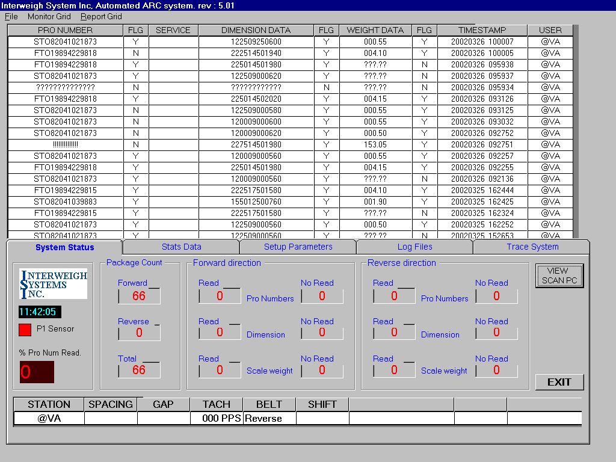All ‘Y’ accepted Pro numbers require one (only) good Pro number read by the scanner. No scan reads are identified with 14 ‘Question Marks’ (????) and multiple scan reads are identified with 14 ‘exclamation marks’ (!!!!).

All ‘Y’ accepted Dimensions are reported in a 12-digit number, with each of the 3 dimensions 4-digits long (length=4, width=4, height =4). Each of the 4-digit dimensions is a 2-decimal measurement in inches, example 2225 = 22.25”.

All ‘Y’ accepted Weights are reported as a 5-digit number to 2-decimal places and is in pounds, example 004.10 = 4.10 lbs.

In addition, the date and time is reported for each carton as it is processed. This is displayed in the Time Stamp column as an 8-digit number for the date (YYYYMMDD) and a 6-digit number for the time (HHMMSS).

The ‘User’ column indicates the station ID for the depot that captured this data.

There are 5 tabs that allow you to view various functions of the system. These are as follows:

System Status:

This screen is displayed above and provides the user with the current status of the system and what has been processed today. The following is an overview of this tab.

Time: This is the current time of the PC, which is a 24-hour clock.

P1 Sensor: This is the Interweigh photo-sensor located at the middle of the line. It is used for the package count and triggering the scale to weigh. It flashes ‘Red’ when blocked and ‘white’ when unblocked. When the SDReweigh program is first started the P1 indicator is ‘black’ and only activates with the first trip of the photo-sensor.
% Pro
Num Read: This is the percentage of good scan reads vs. packages counted and indicated the effectiveness of the system.

Package
Count: This is the physical count by the system of packages processed both in the Forward and Reverse direction for one day.

Forward
Direction: This is the physical count of accepted (Read) and rejected (No Read) items from each of the three devices (scan, cube & scale) in the forward direction.

Reverse
Direction: This is the physical count of accepted (Read) and rejected (No Read) items for each of the three devices (scan, cube & scale) in the reverse direction.

Station: This is the station ID number assigned by Sameday.

Spacing: This is the distance measured from leading edge to leading edge of each package processed through the system. If the spacing drops below 540 (54.0”) that means there was two packages on the scale at the same time. The system will not use the weight of the leading package in those cases. The spacing value is set in the ‘Setup Parameters’.

Gap: This is the distance measured from the trailing edge of the lead package to the leading edge of the trailing package as they are being processed. If the space drops below 120, that means there was two packages on the scale at the same time. The system will not use the weight from either package.

Tach: This is the number of tachometer pulses/second, which translates into belt speed in feet per minute. The value is around 480 PPS which is in 1/10” increments or 48”/second or 240 ft/min.

Belt: This indicates the status of the belt's movement as either ‘Stop, Forward or Reverse’.

Shift: This indicated which shift is currently being processed. AM = midnight + 1 second till noon. PM = noon + 1 second till midnight.

View
Scan PC: This button connects the Accu-sort APC-100 controller to the Interweigh system’s monitor and allows management or service to view that system’s information. Refer to the Accu-sort manuals for information on the APC-100. Upon finishing with the APC –100 connection close the connection. Please note there is a 10-minute timer on the viewing and the connection will automatically close.

Exit: This is the only avenue to close the SDReweigh program. Click on ‘Exit’. A second window appears for you to enter a password. The password is ‘isi’ (lower case). Click on done and the application will close.

Stats Data:

This screen displays the overall statistical data for one whole day including both shifts. It includes the total box count, accepted (Read) and rejected (No Read) counts for each of the three devices in both Forward and Reverse and the overall read rate from the scanners (Prod No. Read).
The screen displays the data from previous day’s production and allows the operator to scroll down to view previous days activity.
The data from today is pass to this screen at midnight.
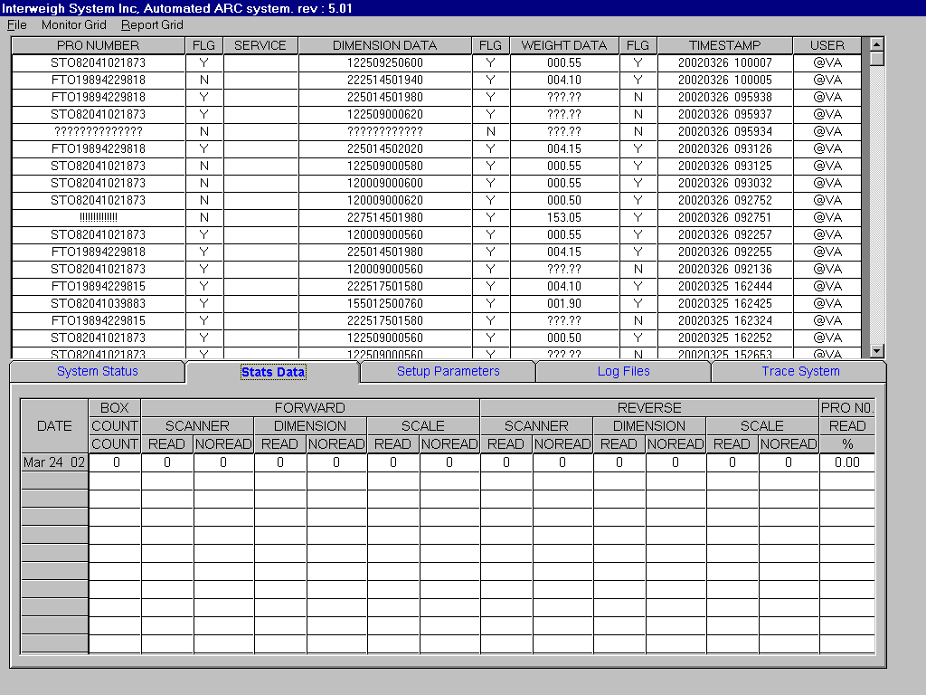

Setup Parameters:

This screen allows for the setup of the system’s parameters and requires a manager’s password to accept any changes. Please note that changes should be made by qualified personnel only, as they can effect the accuracy of the system. The following items are provided.
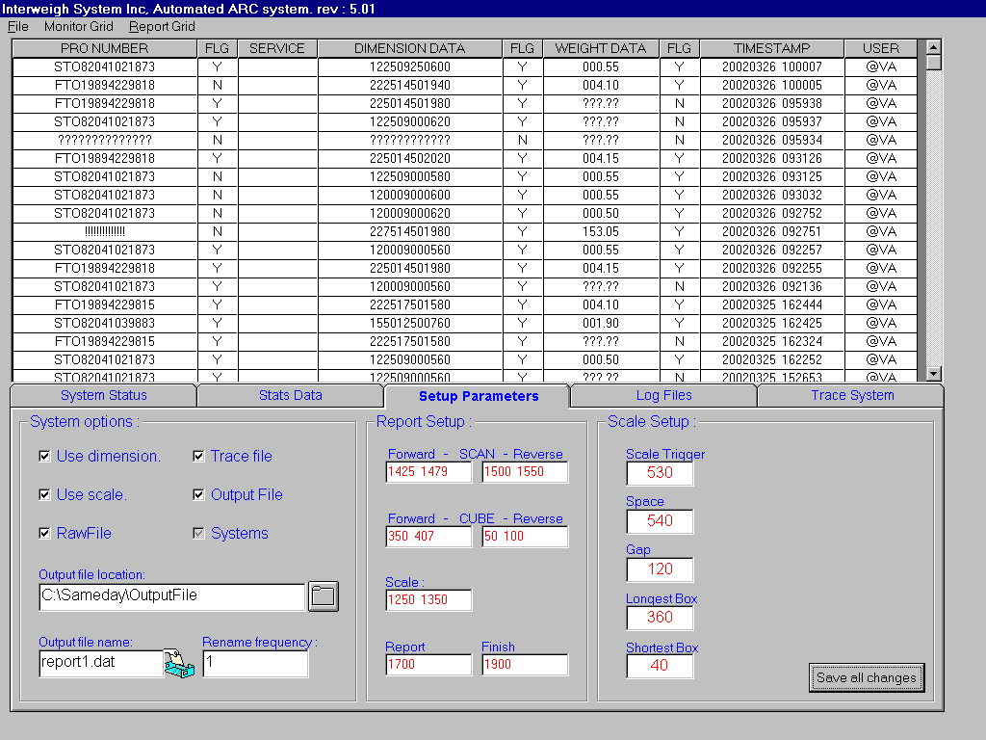

System
Options: This section allows Management to select which devices and/or reports are to be included in the system. For the cuber’s and scale’s data to be used their box must be ticked. The reports can be turned ‘On/Off’ by ticking the box next to them. Note the Raw and Trace files are used for servicing. The ‘Output file’ is the file that the system writes the collected data to and should only be turned off for servicing.

Output file
Location: This allows Management to position the ‘Output file’ in whatever directory they choose.

Output file
Name: This allows Management to name the Output file to whatever name they choose.

Rename
Frequency: This is the frequency in minutes that the system will rename the system’s internal data collection file to the name of the ‘Output file’ for Sameday to then retrieve that file for processing.

Report
Setup: The numeric values in this section are to be set by qualified service personnel only. These values determine when data is to be used and any incorrect setting will create inaccurate data collection.

Scale Setup: The numeric values in this section are to be set by qualified service personnel only. These values determine the operation of the scale and the weight data collected. Any incorrect setting will create inaccurate data collection.

Save All
Changes: Any changes to the Setup Parameters require the changes to be saved before they take effect. Changes saved, take effect immediately and can be made while the system is in use.
Upon Clicking the ‘Save all changes’ button, another window appears for a password to be entered. The password is recorded in the Trace Log file to indicate when and who made the changes. Please note there is a Password for Sameday’s management and a password for service technicians.

Log Files:
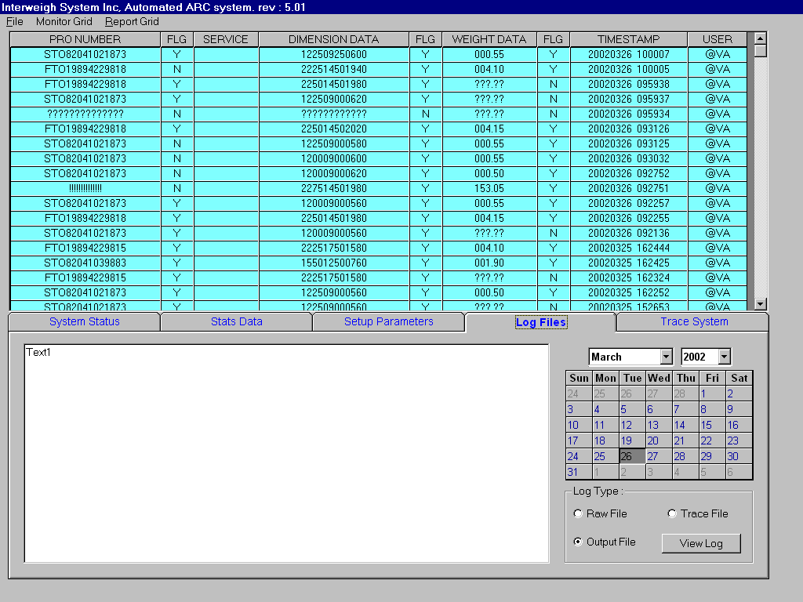

The Log file screen allows for the viewing of the three log files ( Raw, Trace & Output) directly from the main program, without having to close that program. Select the date and file required and Click on the ‘View Log’ button. The data will be viewed in the window.
The Raw file is primarily for service use and reports each carton's data collected.
The Trace file is primarily for service use and reports each activity of the system while collecting the data for each carton.
The Output file is for both the Service Technician's and Sameday’s use and reports the data collected in the string format requested by Sameday.
Note that when viewing any of the three files for the current day’s production only a ‘snapshot’ of the file will be displayed. This is not an online view of the files.
Data can be viewed back in time 3 months.

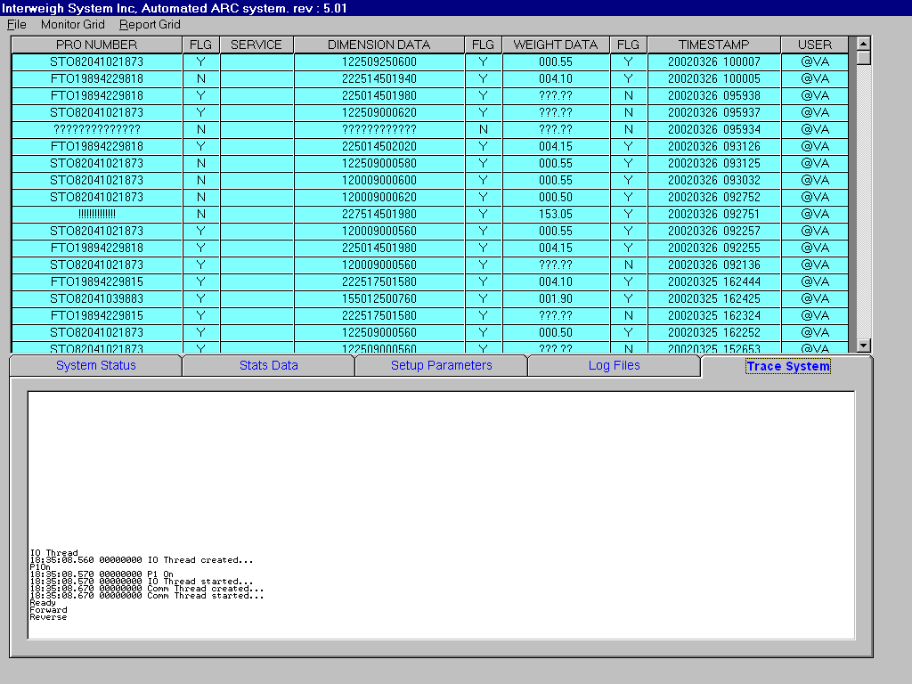Trace System:

The Trace System screen displays the system’s data collection processes for each carton and is viewed in a real time basis. This screen is primarily for service use. The data viewed on this screen is written to the Trace file and can be viewed there if previous data is required.

