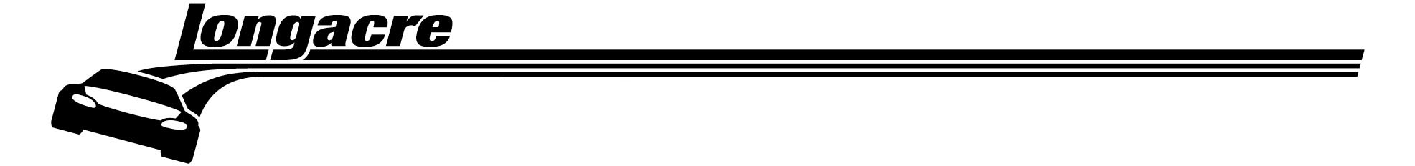
Longacre Racing Products, Inc.
e-mail: sales@longacreracing.com
16892 146th ST SE, Monroe, WA 98272

Phone 360-453-2030 Fax 360-453-2031 Orders 800 423 3110

72606 Calibration Instructions

- Set up scales where you can place an 800 lb. (363 kg) test weight on 1 pad. (100 lbs can also be used)

- Turn scales on. Plug in charger. Plug cables into all 4 pads.

- Allow control box to warm up for a couple minutes and then zero all pads.

- To enter calibration mode, press “hidden” button (under the “C” in “Computerscales”) and LF button at the same time. Then press the LR button.

- Gently place the test weight(s) on one scale pad. Allow the weight to stabilize for a few seconds.

- To calibrate, press LR button.

- The display on the channel being calibrated will change to 800 (100 if using 100 lbs).

- Repeat for the other 3 channels.

- To exit calibration mode, press the “hidden” button and LF button at the same time. Repeat.

If there are any questions, please contact the Longacre service department at 360-453-2051.

