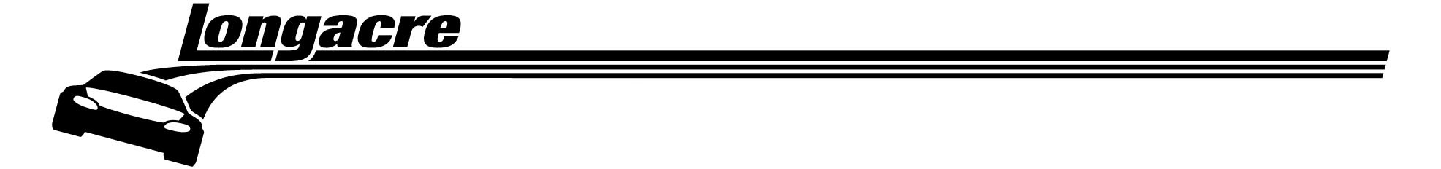
Longacre Racing Products, Inc.
e-mail: sales@longacreracing.com
16892 146th St. SE, Monroe WA 98272

Phone 360-453-2030 Fax 360 453 2031 Orders 800 423 3110

72585/586/587/588 Calibration Instructions

- Set up scales where you can place an 800 lb. (363 kg) test weight on each pad. The scale can be calibrated with a 100 lb. weight if 800 lbs are not available.

- Turn scales on. Plug in charger. Plug cables into pads.

- Allow control box to warm up for a couple minutes and then zero all pads.

- To enter calibration mode, press “hidden” button (under the “C” or “O” in “Computerscales”), RF, and RR buttons at the same time.

- Gently place the test weight(s) on one scale pad. Allow the weight to stabilize for a few seconds.

- To calibrate, press the “hidden” button and RF button at the same time.

- The display on the channel being calibrated will change to 800.

- Repeat for the other 3 channels.

- To exit calibration mode, press the “hidden” button and RR button at the same time.

