SW-1S/1C/1W SERVICE MANUAL
(Revision 0.1 / 2008.06.17)

< Table of Contents >

1. Introduction 3
1.1. Preface 3
1.2. Precaution 3
1.3. Specifications 4
1.4. Key 5
1.5. Dimension 5
1.6. Sealing Method 6
2. Calibration 7
2.1. General Calibration 7
2.1.1. C4 Setting 8
2.1.1.1. C4-1 Setting 8
2.1.1.2. C4-3 Setting 8
2.1.2. SPAN Calibration Setting (C-3) 9
2.1.3. Gravity Constant Value Setting (C-9) 9
2.1.4. Calibration factor Setting (C-10) 9
2.1.5. Displaying Real A/D Value (C-5) 10
2.1.6. Percent Calibration (C-7) 11
2.1.7. Battery Calibration (C-8) 11
3. The Schematics and Diagram 12
3.1. System Block Diagram 12
3.2. Circuit Diagram 13
3.2.1. Main PCB 13
3.2.2. Power Part (Main PCB) 14
3.2.3. Rear Display PCB 15
4. Exploded View 16
5. Load Cell drawing 17
6. Part Location 18
6.1. Main PCB (Top) 18
6.2. Main PCB (Bottom) 19
6.3. Rear Display PCB (Top) 20
7. Error Messages & Solution 21
8. Part List 22

Introduction

Preface
Thank you for purchasing of our CAS scale.
This scale has been designed with CAS reliability, under rigid quality control
and with outstanding performance.
WE hope that your departments enjoy with high quality of CAS product.
This manual will help you with proper operations and care of the SW-1S/1C/1W series.
Please keep it handy for the future references.

Precaution
- Make sure that you plug your scale into the proper power outlet.
- Place the scale on a flat and stable surface.
- Plug into a power outlet 30 minutes before operations.
- Keep the scale away from strong EMI noises may cause incorrect weight readings.
- This scale must be installed in a dry and liquid free environment.
- Do not subject the scale to sudden temperature changes.
- Do not subject the platter to sudden shocks.
- If the scale is not properly level, please adjust the 4 legs at the bottom of the scale (turn legs clockwise or counterclockwise) so as to center the bubble of the leveling gauge inside the indicated circle.

Specifications
 |  | SW-1S/1C/1W-02 | SW-1S/1C/1W-05 | SW-1S/1C/1W-10 | SW-1S/1C/1W-20 | SW-1S/1C/1W-30
Resolution | Capacity / e | Dual Interval  1 kg / 0.0005 kg  2 kg / 0.001 kg | Dual Interval  2.5 kg / 0.001 kg  5 kg / 0.002 kg | Dual Interval  4 kg / 0.002 kg  10 kg / 0.005 kg | Dual Interval  10 kg / 0.005 kg  20 kg / 0.01 kg | Dual Interval  15 kg / 0.005 kg  30 kg/ 0.01kg
Resolution | Internal | 1 / 60,000 | 1 / 60,000 | 1 / 60,000 | 1 / 60,000 | 1/60,000
Resolution | External | 1 / 2,000 | 1 / 2,500 | 1 / 2,000 | 1 / 2,000 | 1 / 3,000
Resolution | Max. Tare | - 0.9995 kg | - 2.449 kg | - 3.998 kg | - 9.995 kg | - 14.995 kg
Display |  | 110 x 35[mm]/43" x 13.8" 5 digit LCD
Indicators |  | STABLE, ZERO, TARE, g, kg, lb, oz, Low Battery  HI / OK / LO & PCS (SW-1C only)
Keys |  | ZERO, TARE, HOLD(Hold Ver.), UNIT(Unit Ver.), MODE(SW1C), POWER
Functions |  | Weighing, WaterProof level IP66(SW-1W only)  Hold(Hold Ver.), Unit Conversion(Unit Ver.),  Counting-Counting SampleRange :  10~100,200,300,400,500 (SW-1C only)  Weight Comparison Function : hi, ok, low(SW-1C only)  Sleep Mode Function
Dimension |  | 260(W) x 287(D) x 137(H)[mm] / 102(W) x 113(D) x 54(H)[inch]  278(W) x 317(D) x 141(H)[mm] / 109(W) x 125(D) x 56(H)[inch]  (SW-1W : WaterProof Type)
Platter Size |  | 230(W) x 190(D)[mm] / 90.55(W) x 74.80(D)[inch]  247(W) x 195(D)[mm] / 97.24(W) x 76.77(D)[inch]  (SW-1W : WaterProof Type)
Weight |  | 2.8kg  3.7kg(SW-1W : WaterProof Type)
Power |  | 1.5V x 6 units (D size Battery) or 9V Adapter
Op.Temperature |  | -10°C ~ +40°C / 14°F ~ 104°F
Options |  | 9V Adapter 300mA, Rear Display, Stainless Tray (SW-1S, SW-1C)
Minimum Voltage  Level The Battery |  | About 5.5V
Operation time |  | Approx. 500hours (Manganese battery)/  1000hours (Alkaline at 20°C /68°F)

Key
Key | Function
ZERO (-O-)  [Set] | To set zero point  To do [SET] key in the SETUP mode.
TARE | To input or cancel the tare (the weight of container).
HOLD | To make the weight of item stable. This weight is average value.
POWER | To turn on or off.

Dimension

SW-1S/1C
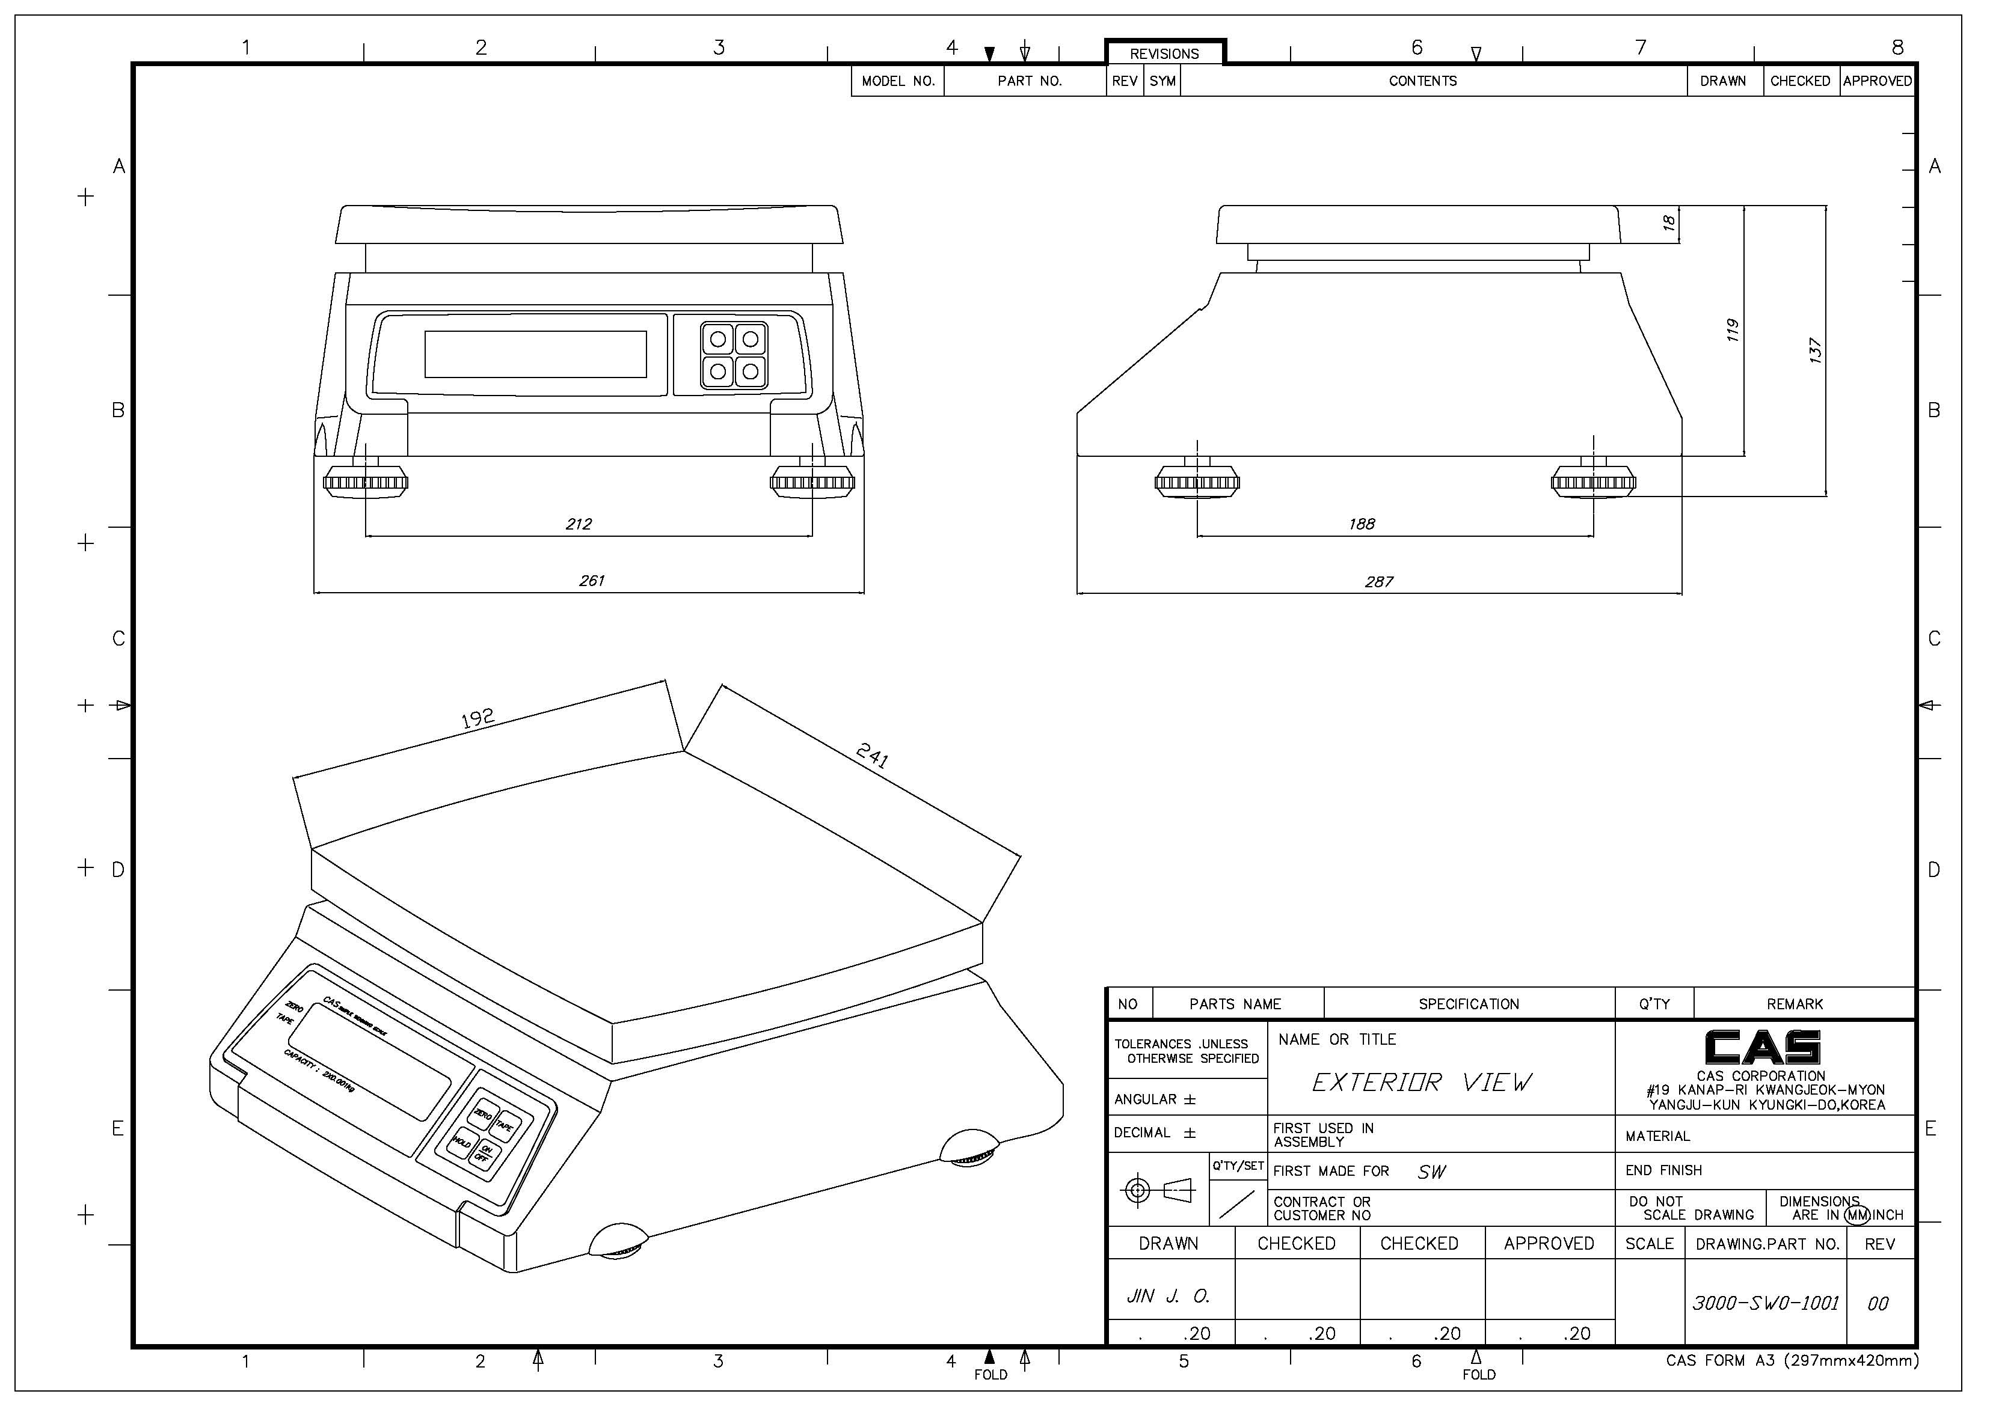

SW-1W

Sealing Method
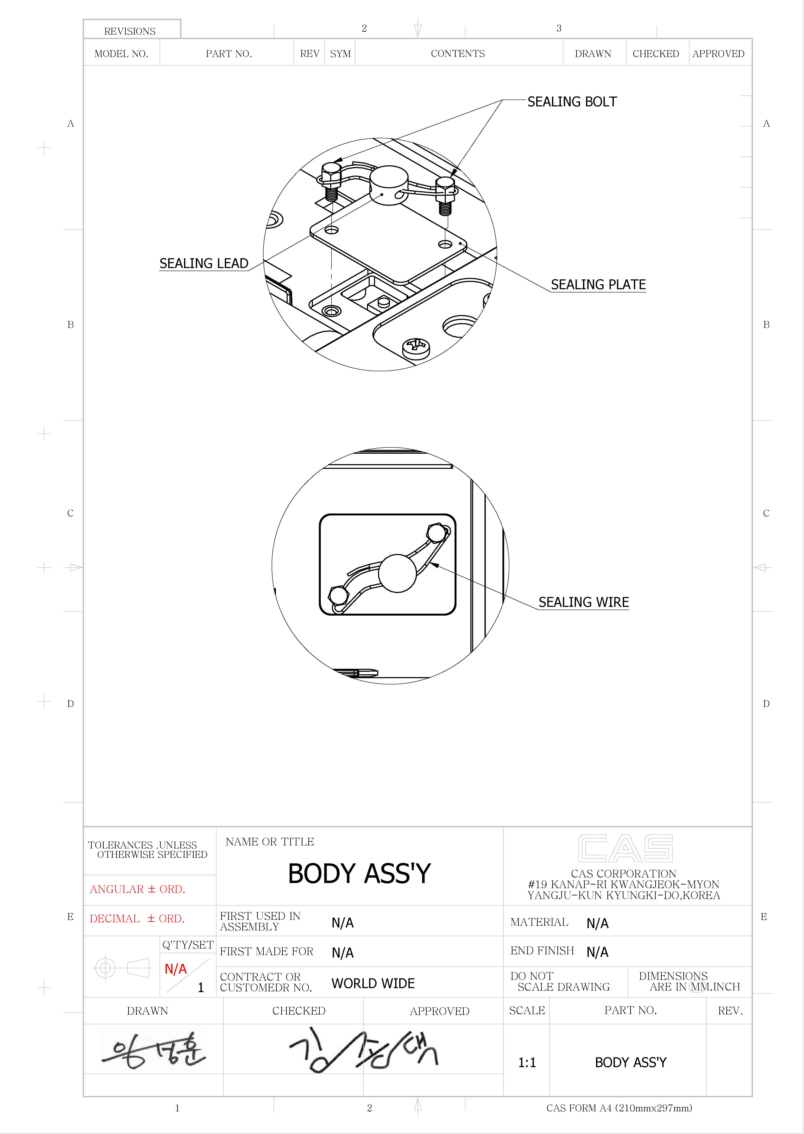
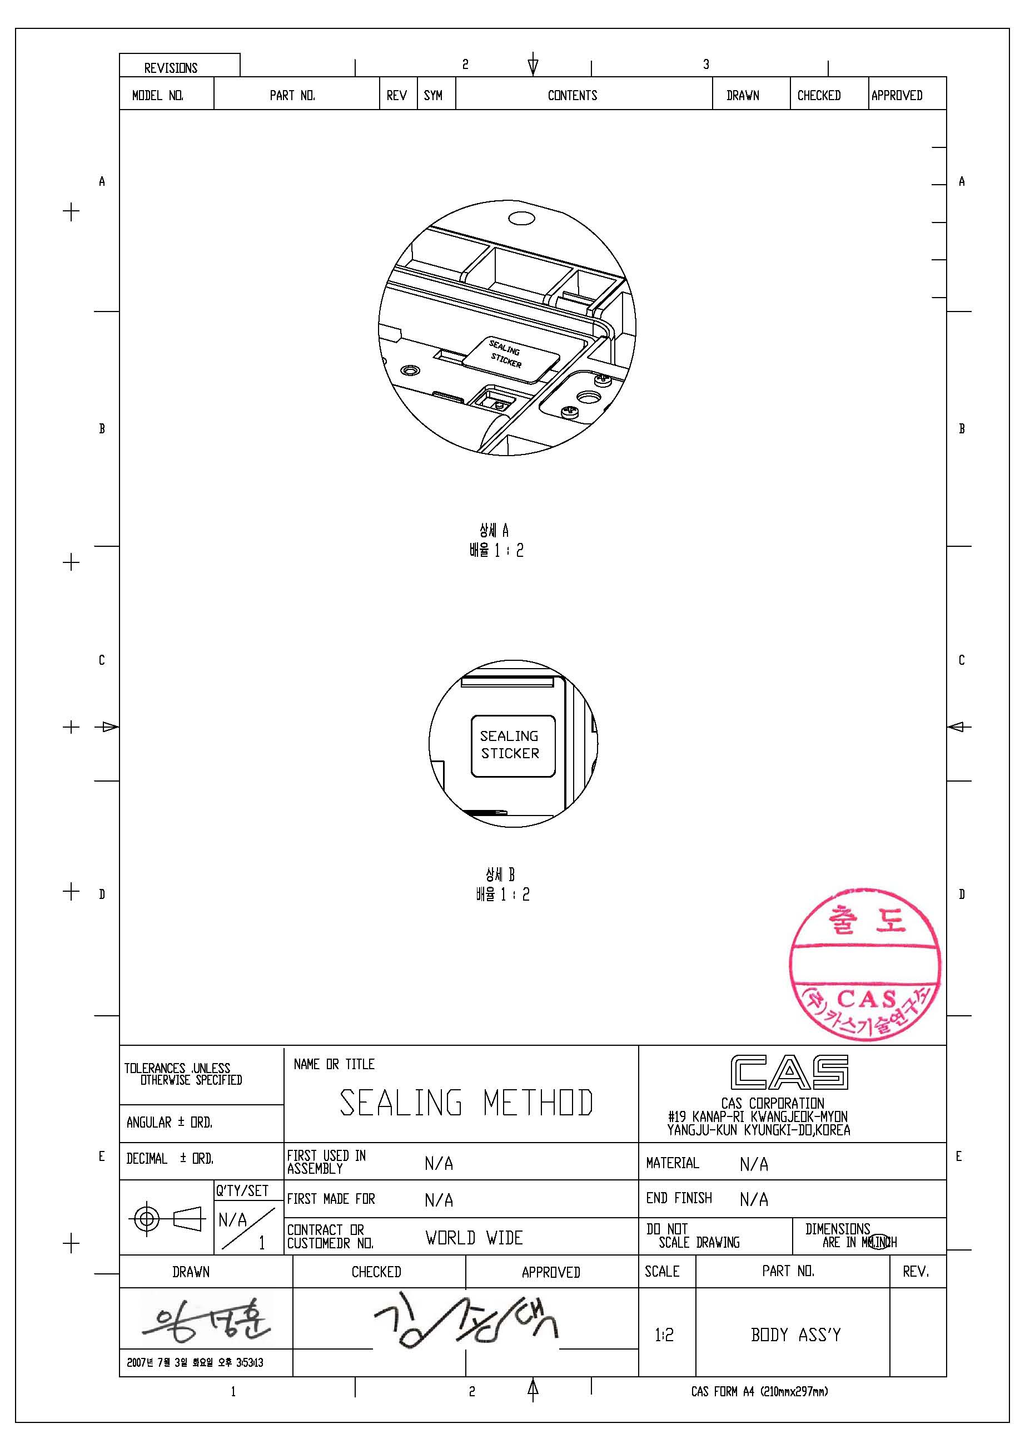

Calibration

General Calibration
Pressing and holding calibration switch press [POWER] key to go to calibration mode.
User can move to other mode by using [ZERO] key in the calibration mode.
User also moves to other sub-modes for each mode by using [TARE] key.
Please simply follow below procedure to move to other mode.
- Calibration Mode: Pressing and holding “Calibration Switch” press [POWER] key.
- It displays “CAL-0” after “CAL”, and it blinks the version of scale three times.
- Selecting menu: press [TARE].
- ENTER(Setting) : [TARE] key
MODE | Function
CAL 1 | Display normalized AD
CAL 2 | Display Keypad infomation-
CAL 3 | Weight Setting Mode  “UnLoad” → [TARE] →  “MIDD” → [TARE] after loading for 1/3 weight →  “FULL” → [TARE] after loading for Full weight →  “MIDD” → [TARE] after loading for 1/3 weight → “END”
CAL 4 | Option Setting ( Refer to Table 1)
CAL 5 | Display filtered Raw AD
CAL 7 | % Calibration
CAL 8 | Battery calibration
CAL 9 | Gravity constant
CAL 10 | Set calibration factor  “Unit” → [TARE] → select 0, 1 (0:kg, 1: lb) → [TARE]  “CAPA” → [TARE] → select capacity → [TARE]  “MCAPA” → [TARE] → select mid-capacity → [TARE]  “W-dP” → [TARE] → Select Decimal Point → [TARE]  “ 1 d ” → [TARE] → Select division → [TARE]  “Dual” → [TARE] → Enable dual interval (0:disable, 1:enable) → [TARE]  “tare” → [TARE] → Enable custom tare (0:disable, 1:enable) → [TARE]
CAL 11 | Set nation(00 : OIML , 01 : NTEP , 02: KOREA)
< Modes >

C4 Setting

C4-1 Setting
BIT 6~7 | Initial Zero range | 3 | 5%
BIT 6~7 | Initial Zero range | 2 | 10%
BIT 6~7 | Initial Zero range | 1 | 3%
BIT 6~7 | Initial Zero range | 0 | 2%
BIT5 | Last digit enable | 0 | Disable
BIT5 | Last digit enable | 1 | Enable
BIT4 | Key zero percent | 0 | ±3% key zero percent
BIT4 | Key zero percent | 1 | ±2% key zero percent
BIT 2~3 | Successive tare | 3 | (+), (-) All Direction successive Tare
BIT 2~3 | Successive tare | 2 | (+) Direction successive Tare
BIT 2~3 | Successive tare | 1 | (-) Direction successive Tare
BIT 2~3 | Successive tare | 0 | One Time tare
BIT0~1 | Zero mark type | 0 | Gross zero indication
BIT0~1 | Zero mark type | 1 | Net zero indication
BIT0~1 | Zero mark type | 2 | Both(gross and net) zero indication

C4-3 Setting
BIT7 | Dot Type | 0 | "." dot
BIT7 | Dot Type | 1 | "," comma
BIT6 | Use Preset tare | 0 | Don't use
BIT6 | Use Preset tare | 1 | Use
BIT5 | Use Back light | 0 | Don't use
BIT5 | Use Back light | 1 | Use
BIT4 | Use Head message | 0 | Don't use
BIT4 | Use Head message | 1 | Use
BIT3 | Use gram | 0 | Don't use
BIT3 | Use gram | 1 | Use
BIT2 | Use oz | 0 | Don't use
BIT2 | Use oz | 1 | Use
BIT1 | Use lb | 0 | Don't use
BIT1 | Use lb | 1 | Use
BIT0 | Use Kg | 0 | Don't use
BIT0 | Use Kg | 1 | Use

SPAN Calibration Setting (C-3)
- Pressing and holding “Calibration Switch” press [POWER] key.
After “CAL” message blinks three times and shows the version of scale, it displays “CAL 1” message.
- Press [ZERO] to display “CAL-3”.
- Press [TARE] key and then it displays “zero ” message.
- Press [TARE] key and then it displays “midup” message
- Load middle weight (ex:1/3 full capacity) on the platform
- Press [TARE] key and then it displays “span ” message
- Load full weight on the platform
- Press [TARE] key and then it displays “middn” message
- Load middle weight (ex:1/3 full capacity) on the platform
- Press [TARE] key and then it display “CAL 3” message

Gravity Constant Value Setting (C-9)
Current gravitational Acceleration value is set to 9.7994 m/s² .
- Pressing and holding “Calibration Switch” press [POWER] key.
After “CAL” message blinks three times and shows the version of scale, it displays “CAL-1” message.
- Press [ZERO] to display “C-9”.
- Press [TARE] key, and then “ G-1“ message and “9.7994” will be shown. The first digit,”9” will blink.
- Input a gravitational acceleration value by using [ZERO] key.
- Press [TARE] key, and then “G-2“ message blinks.“9.7994” will be shown. The first digit,”9” will blink.
- Input a gravitational acceleration value by using [ZERO] key.
- Press [TARE] key to save the gravitational acceleration value, and “C-9 ” message will be shown.

Calibration factor Setting (C-10)
- Pressing and holding “Calibration Switch” press [POWER] key.
- After “CAL” message blinks three times and shows the version of scale, it displays “CAL-1” message.
- Press [ZERO] to display “C-10”.
- Press [TARE] key, and then “UNIT “ message and “0” will be shown. The first digit,”0”
will blink. It means calibration unit is “kg” (0 : kg, 1 : lb)
- Input a calibration unit by using [ZERO] key.
- Press [TARE] key, and then “CAPA“ message blinks.“0015” will be shown. The first digit,”0” will blink. It means a full-capability is “15 (calibration unit, kg or lb)”
- Input a capability by using [ZERO] key.
- Press [TARE] key, and then “MCAPA“ message blinks.“0005” will be shown. The first digit,”0” will blink. It means a mid-capability is “05 (calibration unit, kg or lb)”
- Input a capability by using [ZERO] key.
(10)Press [TARE] key, and then “W-dP “ message blinks.“3” will be shown. The first digit,”3” will blink. It means a weight decimal point is “3 (will display 0.000)”
(11)Input a weight decimal point by using [ZERO] key.
(12) Press [TARE] key, and then “1d “ message blinks.“0.005” will be shown. The third digit,”0” will blink. It means a division is “0.005 (calibration unit, kg or lb)”
(13) Input a division by using [ZERO] key.
(14) Press [TARE] key, and then “dual “ message blinks.“1” will be shown. The third digit,”1” will blink. It means a dual interval is disable. (0 : disable, 1 : enable)”
(15) Input a dual interval enable by using [ZERO] key.
(16) Press [TARE] key to save the calibration factor, and “C-10 ” message will be shown.

Displaying Real A/D Value (C-5)
Display Raw AD

Percent Calibration (C-7)
(1) Pressing and holding “Calibration Switch” press [POWER] key.
After “CAL” message blinks three times and shows the version of scale, it displays “CAL 1” message.
(2) Press [ZERO] to display “CAL-7”.
(3) Press [TARE] key and then it displays “per 0 ” message. Select the percent value using the
[numeric] key. You can choose 10~90 percent. (Last digit of percent must be 0.)
(4) Press [TARE] key and then it displays “zero” message
(5) Press [TARE] key and then it displays “pspan ” message
(6) Load choice percentage weight of full weight on the platform
(7) Press [TARE] key and then it displays “CAL 7” message

Battery Calibration (C-8)
(1) Pressing and holding “Calibration Switch” press [POWER] key.
After “CAL” message blinks three times and shows the version of scale, it displays “CAL 1” message.
(2) Press [ZERO] to display “CAL-8”.
(3) Press [TARE] key and then it displays voltage of battery.
(4) Change the jumper-pin of main PCB, ‘BAT’ to ‘+5V’.
(5) Press [ZERO] key two times and then Press [-] key two times.
And then it display ‘500’
(6) Change the jumper-pin of main PCB, ‘+5V’ to ‘BAT’.
(7) You can see the calibrated voltage of battery.

The Schematics and Diagram

System Block Diagram

Circuit Diagram

Main PCB

Rear Display PCB

Exploded View

SW-1S/1C
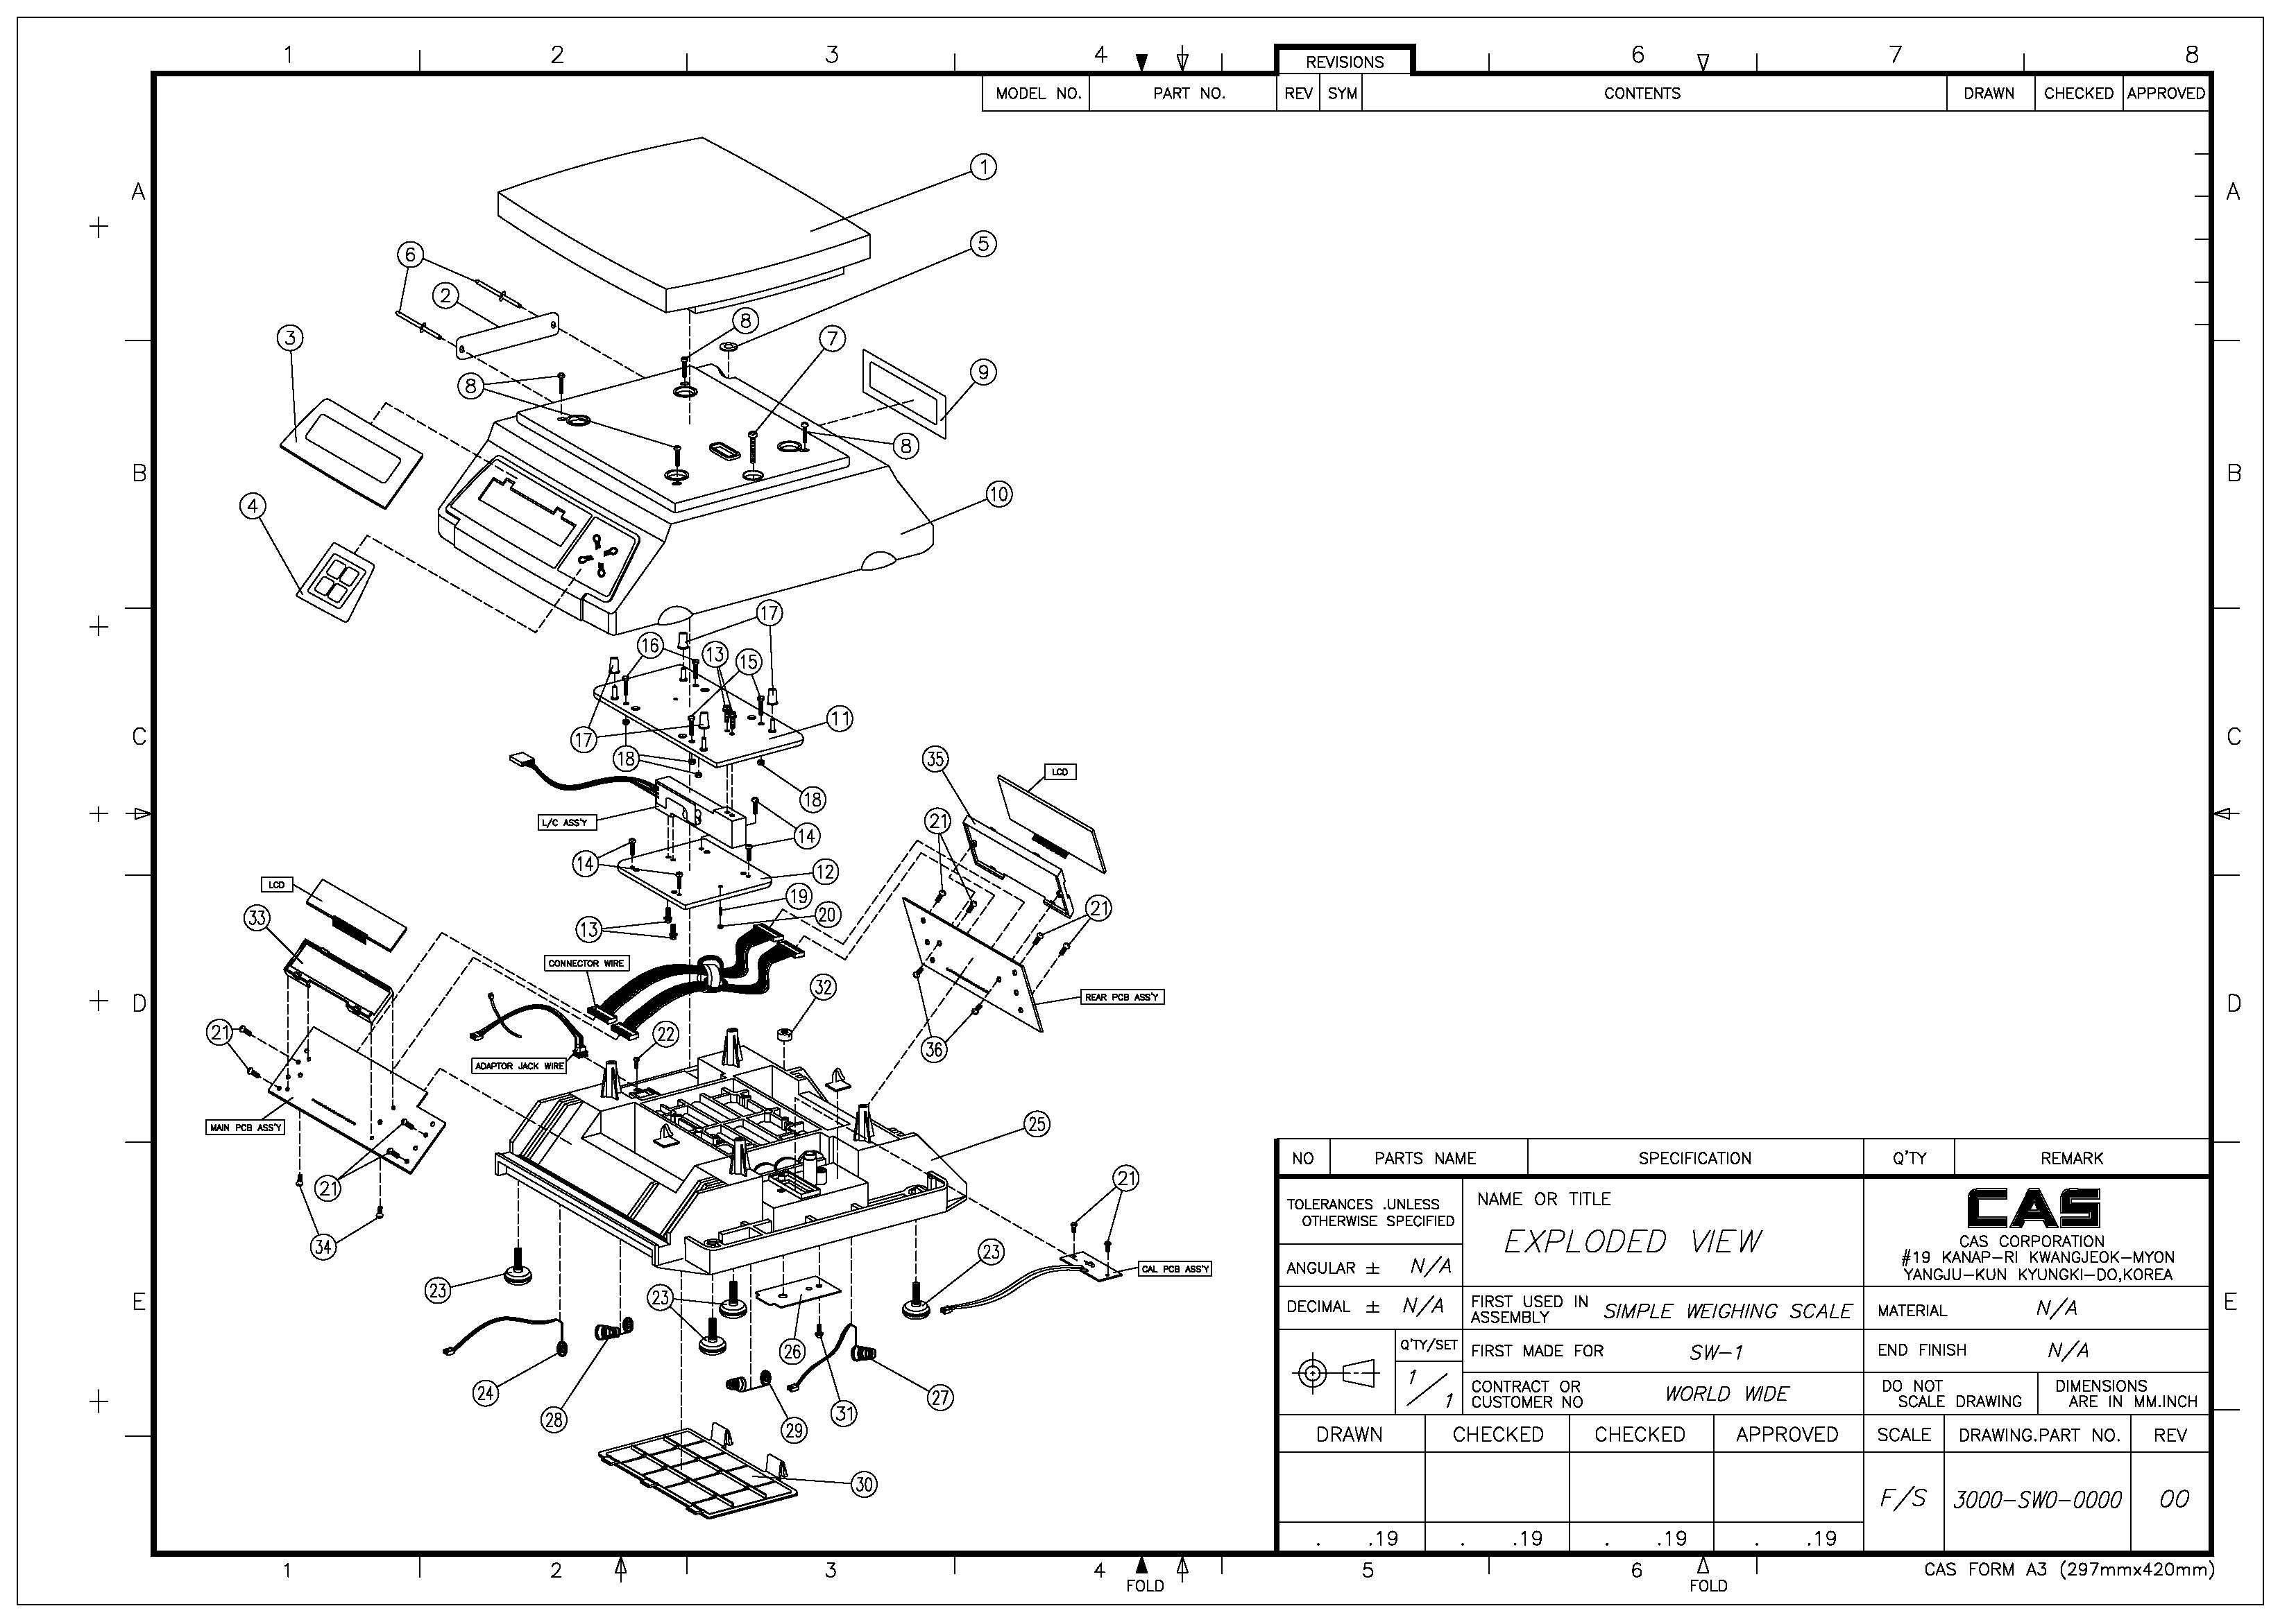

SW-1W

Load Cell drawing

Part Location

Main PCB (Top)
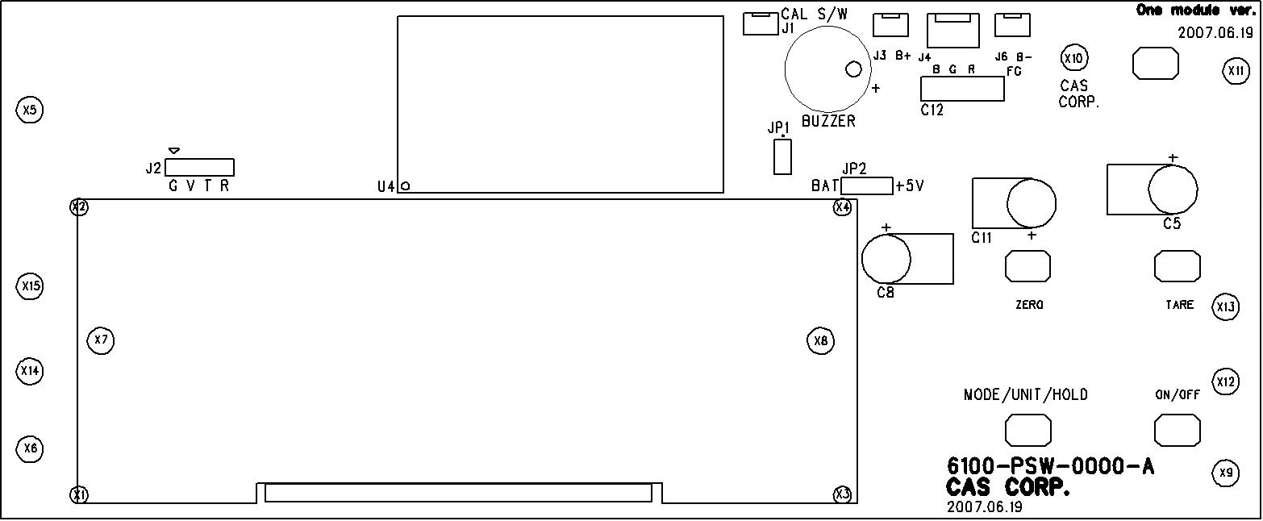

Main PCB (Bottom)
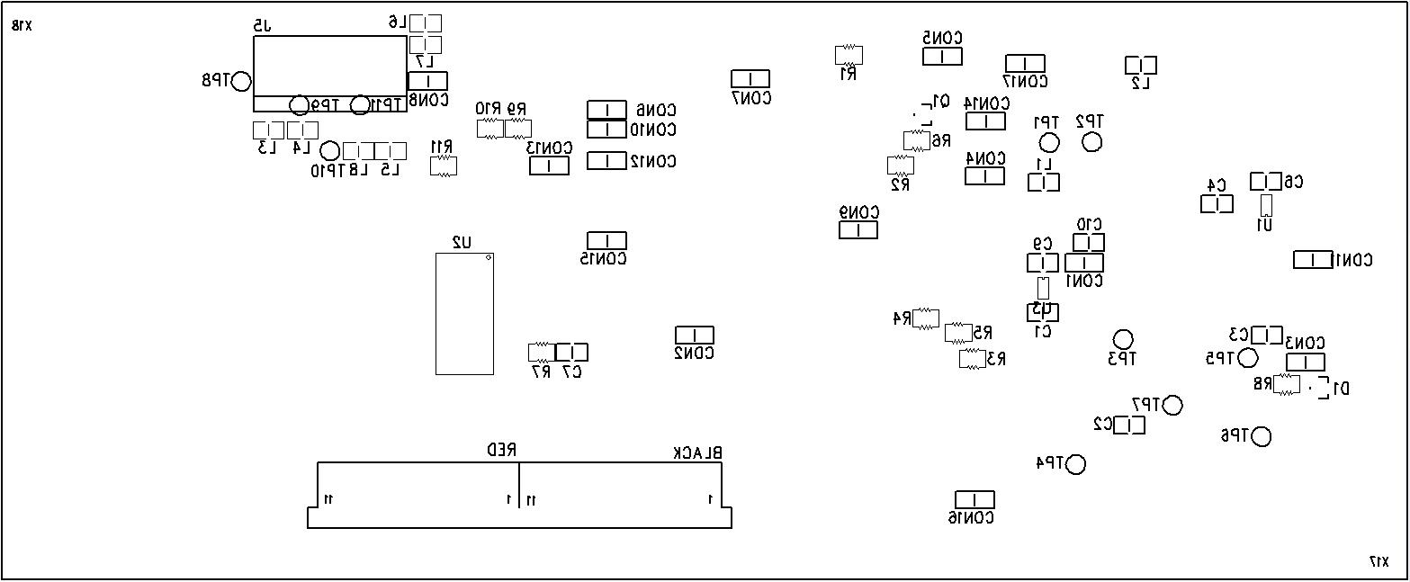

Rear Display PCB (Top)
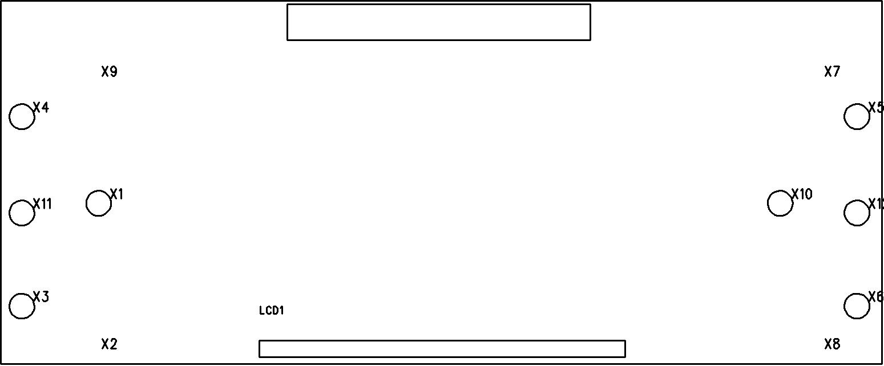

Error Messages & Solution
Error Message  on Display | Description | Solution
"Err 0" | The "Err 0" occurs when scale is not stable. | Remove unstable facts.
"Err 1" | The "Err 1" occurs when a current zero point has shifted from the last span calibration. | Please call your CAS dealer.
"Err 2" | The "Err 2" is not a real error. Only it prompts return CAL switch to the normal position. | Please call your CAS dealer.
"Err 3" | The "Err 3" is an overload error. | Please remove the weight.
"Err 9" | The "Err 9" is no weight error. When scale is in counting mode, you must load the weight.  If you have no weight on your scale, you can see this error message. | Please load the weight on your tray.
“Err 11” | The "Err 11" means a writing error of the internal nonvolatile memory. To recognize this error, be sure to check the voltage on the circuit and do calibration procedures. | If it still has "Err 11", replace the digital module.
“Err 12” | The "Err 12" warns that the scale has lost the parameters for weighing regulations or has lost the factors for a digital span calculation. | Enter each condition codes again.  Please try a span calibration again if still not fixed.
“Err 14” | The "Err 14" means calibration range is not correct. | Please call your CAS dealer.

Part List

SW-1S/1C/1W (Electronic part)
 | 1.1 MAIN PCB ASS'Y [140SW5EMAPUN0101]
No | Part Name | Specification | Part Number | Q'ty | Remark
 | MAIN PCB ASS'Y |  | 140SW5EMAPUN0101 | 1 | MAIN PCB ASS'Y
1 | PCB-MAIN | 6100-PSW-0000-A(SW-1S) | 6100PSW0000A | 1 | MAIN PCB
2 | ONE MODULE | ONE MODULE | 6PA0A0000000 | 1 | U4(ONE MODULE NO OPTION)
3 | IC(REGULATOR) | XC6204C502MR(5.0V) | 6220IS0C5020 | 1 | U1
4 | IC(REGULATOR) | XC6204C332MR(3.3V) | 6220IS0C3320 | 1 | U3
5 | IC(LCD DRIVER) | HOLTEX HT1621B | 6224I0016210 | 1 | U2
6 | TRANSISTOR CHIP | KTA1504 SY | 6281I0015040 | 1 | Q1
7 | DIODE-CHIP | KDS184 | 6294ICP01840 | 1 | D1
8 | RESISTOR-CHIP 1/10W | WR06X0000JT(0Ω) | 6527ID00000A | 17 | CON1~17
9 | RESISTOR-CHIP 1/10W | RR1220P-100D(10Ω) | 6527ID001000 | 1 | R11
10 | RESISTOR-CHIP 1/10W | RR1220P-222D(2.2K) | 6527ID300220 | 1 | R7
11 | RESISTOR-CHIP 1/10W | RR1220P-104D(100K) | 6527ID310000 | 4 | R1,2,8,9
12 | RESISTOR-CHIP 1/10W | RR1220P-102D(1K) | 6527ID300100 | 1 | R10
13 | RESISTOR-CHIP 1/10W | RR1220P-101D(100) | 6527ID010000 | 5 | R3,4,5,6
14 | INDUCTANCE | HB-1M2012-102JT(TP2,LP2,DBB) | 6670T0001020 | 8 | L1,2,3,4,5,6,7,8
15 | CONDENSER-CERAMIC | 0.01uF/3KV | 6710CAP0103B | 1 | C12
16 | CONDENSER-ELECTRIC | 330uF/25V | 6704C2503300 | 1 | C11
17 | CONDENSER-ELECTRIC | 100uF/16V | 6704C1601000 | 2 | C5,8
18 | CONDENSER-CHIP | CL21F 102KBNC | 6712CHP01020 | 3 | C1,2,3
19 | CONDENSER-CHIP | CL21F 104KBNC | 6712CHP01040 | 5 | C4,6,7,9,10
20 | CONNECTOR(WAFER) | LAL0640-02 (LAW250-02) | 7809CAL00020 | 3 | J1,3,6
21 | CONNECTOR(WAFER) | LAL0640-03 (LAW250-03) | 7809CAL00030 | 1 | J4
22 | CONNECTOR(WAFER) | LAL0640-11 (LAW250-11) | 7809CAL00110 | 2 | LCD_CON
23 | PIEZO BUZZER | APR,ADR(CHINA) | 7002Z0000000 | 1 | BUZZER
24 | TACT S/W | KPT-1105B(DJTA-1102C) | 7600STA1105B | 4 | ZERO,TARE,HOLD,ON/OFF KEY
25 | JUMPER | 10PIN | 7821CJM00100 | 1 | JP1(2PIN),JP2(3PIN),J2(4PIN)
26 | BRACKET-LCD | DTE 101754AJP 1(SW) | 2000A0000660 | 1 | LCD1
27 | LCD | 114.8*44.8*BLACK(SW-1) | 7212D0040920 | 1
28 | GROUND WIRE | 100mm(DB-Ⅱ) | 7860GND01000 | 1 | FG
 | 1.2 REAR DISPLAY PCB ASS'Y [140SW1MDIPUN0104]
No | Part Name | Specification | Part Number | Q'ty | Remark
 | REAR DISPLAY PCB ASS'Y | SW-1S | 140SW1MDIPUN0104 | 1 | REAR DISPLAY PCB ASS'Y
1 | BRACKET-LCD | DTE 101754AJP 1(SW) | 2000A0000660 | 1
2 | PCB-DISPLAY | 6110-PSW-1130-0(SW) | 6110PSW11300 | 1
3 | LCD | DTE 101754AJP 1(SW) | 7212D0040920 | 1 | LCD
4 | FLAT CABLE CONNECTOR | (10+11)P*350mm(CORE,SW양면) | 7850W0021350 | 1
 | 1.3 CAL PCB ASS'Y [140SW6ECAPUN0101]
No | Part Name | Specification | Part Number | Q'ty | Remark
 | CAL PCB ASS'Y | SW-WR | 140SW6ECAPUN0101 | 1 | CAL PCB ASS'Y
1 | PCB-CAL | 6151-PSW-0000-0(SW1-S/1C) | 6151PSW00000 | 1
2 | TACT S/W | 11902(DJTA-1102) | 7600STA19020 | 1
3 | CONNECTOR WIRE | 2P*140m/m(SW) | 7840W000214B | 1

SW-1S/1C (Mechanical part)
1.1 BODY ASS'Y [140SW4SBODUN0103]
SW-1S | 반제품 | 140SW4SBODUN0103 | BODY ASS'Y | SW-1S | Q'ty
BODY ASS'Y | 자재 | 1590A000006A | BATTERY SPRING B | ø0.9*ø16*50*19-SUS(SW-1) | 1
BODY ASS'Y | 자재 | 1590A000007B | BATTERY SPRING C | ø0.9*ø16*37*8 | 1
BODY ASS'Y | 자재 | 1590A000014A | BATTERY SPRING A | ø0.9*ø16*50*19(SW-1) | 1
BODY ASS'Y | 자재 | 1590A0000240 | BATTERY SPRING D | ø0.9*ø16*37*26-SWP(SW-1) | 1
BODY ASS'Y | 자재 | 7840W000219B | CONNECTOR WIRE | 2P*190mm SW-WP (+)BATTERY WIRE | 1
BODY ASS'Y | 자재 | 7840W0002230 | CONNECTOR WIRE | 2P*230mm SW-WP (-)BATTERY WIRE | 1
BODY ASS'Y | 자재 | 7840W0003230 | CONNECTOR WIRE | 3P*230mm-303(EP,SW) | 1
1.2 C/T BOX ASS'Y [140SW4MCTBUN0103]
SW-1S | 반제품 | 140SW4MCTBUN0103 | C/T BOX ASS'Y | SW-1S
C/T BOX ASS'Y | 자재 | 7510P0911220 | ADAPTOR | 110/220V9V/300mA(EP,PW) | 1
C/T BOX ASS'Y | 자재 | 7520P0001500 | BATTERY-MN | R20-1.5V-D(TP,SW) | 6
C/T BOX ASS'Y | 자재 | 9002SW300330 | MANUAL | SW-1S1C1W(영문) | 1
C/T BOX ASS'Y | 자재 | 9100SW00133B | C/T BOX | SW-1(360*297*215, 영문) | 1
C/T BOX ASS'Y | 자재 | 9100SW004300 | C/T BOX | 615*375*435(SW-1/4) | 0.25
C/T BOX ASS'Y | 자재 | 9203AS000070 | STYROFOAM BOX | 352.5*191*146(SW-1) | 1
C/T BOX ASS'Y | 자재 | 9203AS000080 | STYROFOAM BOX | 352.5*191*146(SW-1) | 1
C/T BOX ASS'Y | 자재 | 9300A0000020 | POLY BAG | 90*150*0.05T(FUSE) | 1
C/T BOX ASS'Y | 자재 | 9301A0000030 | POLY BAG | 170*250*0.05T(MANUAL) | 1
C/T BOX ASS'Y | 자재 | 9302A000005B | POLY BAG | 270*350*0.04T(MW,PW)(SET)HD | 1
C/T BOX ASS'Y | 자재 | 9305A000001B | POLY BAG | 500*650*0.04T(S2000)(SET,HD) | 1
C/T BOX ASS'Y | 자재 | 9400A0000460 | SILICAGEL | 10g | 2
C/T BOX ASS'Y | 자재 | 9900A0000010 | 봉인납 | 수출용 | 1
C/T BOX ASS'Y | 자재 | 9900A0000020 | SEALING WIRE | 300M/ROLL | 0.001
1.3 BODY ASS'Y [140SW4MBODUN0103]
SW-1S | 반제품 | 140SW4MBODUN0103 | BODY ASS'Y | SW-1S
BODY ASS'Y | 자재 | 1000A0000790 | SEALING PLATE | 29*69.8*1T(SW-Ⅰ) | 1
BODY ASS'Y | 자재 | 1260A0000090 | BOLT-SEALING | M4*40(NI)SW-1 | 1
BODY ASS'Y | 자재 | 1502A0004060 | SCREW-MACHINE(PH) | M4*6 | 1
BODY ASS'Y | 자재 | 1510A0003060 | SCREW-TAPPING(PH)-1 | M3*6 | 3
BODY ASS'Y | 자재 | 1510A0003080 | SCREW-TAPPING(PH)-1 | M3*8 | 4
BODY ASS'Y | 자재 | 1510A0004120 | SCREW-TAPPING(PH)-1 | M4*12 | 4
BODY ASS'Y | 자재 | 1510A0004200 | SCREW-TAPPING(PH)-1 | M4*20 | 4
BODY ASS'Y | 자재 | 2040-103-0013-0 | BATTERY COVER | SW Violet (비난연) | 1
BODY ASS'Y | 자재 | 2040-103-0012-0 | BODY | SW Violet (비난연) | 1
BODY ASS'Y | 자재 | 2008A000001B | FOOT | PVCø40*42(SW-1) | 4
BODY ASS'Y | 자재 | 2022A0000041 | WATER LEVEL GAGE | ø14.9*8(S-2000)상보 | 1
BODY ASS'Y | 자재 | 7642S0000600 | METAL CLAMP | 6N | 5
1.4 L/C BRACKET ASS'Y [140SW4MLCBUN0103]
SW-1S | 반제품 | 140SW4MLCBUN0103 | BRACKET ASS'Y | SW-1S
L/C BRACKET ASS'Y | 자재 | 1030A000039A | BRACKET-L/C LOWER | SPC 120*100*4T(SW-1) | 1
L/C BRACKET ASS'Y | 자재 | 1030A000040B | BRACKET L/C-TOP | SPC160*110*3.2T(SW-5,10K) | 1
L/C BRACKET ASS'Y | 자재 | 1130A0000020 | BOLT-LIMIT | M5*33.8(Zn황)(SW-10,20,30) | 2
L/C BRACKET ASS'Y | 자재 | 1130A0000030 | BOLT-LIMIT | M5*34.9(Zn백)(SW-2,5,10) | 2
L/C BRACKET ASS'Y | 자재 | 1510A0004120 | SCREW-TAPPING(PH)-1 | M4*12 | 4
L/C BRACKET ASS'Y | 자재 | 1530MSU05150 | BOLT-WRENCH | M5*15-SUS | 4
L/C BRACKET ASS'Y | 자재 | 1532A0004120 | BOLT-WRENCH(ST) | M4*12(SP 30K,60lb 2EA) | 1
L/C BRACKET ASS'Y | 자재 | 1540A0005000 | NUT(HEX) | M5*0.8 | 4
L/C BRACKET ASS'Y | 자재 | 1540MSU04000 | NUT(HEX) | M4*07-SUS | 1
L/C BRACKET ASS'Y | 자재 | 1552MSU05000 | WASHER(OTO) | ø5-SUS | 4
L/C BRACKET ASS'Y | 자재 | 2600A000051A | TRAY RUBBER B | NBRø17.4*21(SW2,5,10K)BLACK | 4
1.5 UPPER CASE ASS'Y [140SW4MUPCUN0103]
SW-1S | 반제품 | 140SW4MUPCUN0103 | UPPER CASE ASS'Y | SW-1S
UPPER CASE ASS'Y | 자재 | 1510A0004200 | SCREW-TAPPING(PH)-1 | M4*20 | 4
UPPER CASE ASS'Y | 자재 | 1563A0003080 | RIVET | @3.2*8 | 2
UPPER CASE ASS'Y | 자재 | 1810SW000332 | SPEC PLATE | SW-1(영공)(SW,SW-II 공용) | 1
UPPER CASE ASS'Y | 자재 | 2040-103-0014-0 | UPPER CASE | SW Violet (비난연) | 1
UPPER CASE ASS'Y | 자재 | 2040-103-0015-0 | TRAY | SW Violet (비난연) | 1
UPPER CASE ASS'Y | 자재 | 2000A0000750 | DISPLAY COVER | ABS750 124.7*53.7*3.5(SW)(R) | 1
UPPER CASE ASS'Y | 자재 | 2010A0000080 | WATER LEVEL GAGE COVER | ø24.8*0.5T(LP-1,Ⅱ,SW) | 1
UPPER CASE ASS'Y | 자재 | 2050SWA10222 | DISPLAY COVER | SW-1(10kg)유럽공용 심볼 | 1
UPPER CASE ASS'Y | 자재 | 2200SW000220 | KEY BOARD PAD | SW-1(S)(HOLD)유럽공용심볼 | 1
UPPER CASE ASS'Y | 자재 | 2632A0000160 | DISPLAY COVER TAPE | 124*53(SW-1) | 1
1.6 SW-5L [LLBSW0153G000000]
SW | 자재 | 9800A0000040 | LOCKING PAINT | 접착제(200G)(녹색) | 0.002
SW | 자재 | 8ZSW0KK00500 | LOAD CELL | SW-5L(CHINA) | 1
SW | 자재 | 9800A000001A | 순간본드 | ALTECO-EE(20g) | 0.002
SW | 자재 | 9800A0000030 | BOND | #575 180ml | 0.002

SW-1W (Mechanical part)
1.1 BODY ASS'Y
SW-1W | 반제품 |  | BODY ASS'Y | SW-1W | Q'ty
BODY ASS'Y |  | 1000A0002270 | CONNECTOR RUBBER PLATE | SW-1W(39.6*29.6*1.2t) | 1
BODY ASS'Y |  | 1005A0001150 | SEALING WASHER | ø5*10 (SW-WATERPROOF) | 8
BODY ASS'Y |  | 1030A0002030 | SEALING PLATE | 35.2*26*1t DB-II | 1
BODY ASS'Y |  | 1265A0000010 | BOLT-SEALING | M3*9(황동,HEAD 3mm포함) | 2
BODY ASS'Y |  | 1502MSU05120 | SCREW-MACHINE(PH) | M5*0.8*12-SUS | 8
BODY ASS'Y |  | 1510A0003060 | SCREW-TAPPING(PH)-1 | M3*6 | 2
BODY ASS'Y |  | 1510A0003080 | SCREW-TAPPING(PH)-1 | M3*8 | 8
BODY ASS'Y |  | 1510A0004060 | SCREW-TAPPING(PH)-1 | M4*6 | 1
BODY ASS'Y |  | 1510MSU04120 | SCREW-TAPPING(PH)-1 | M4*12-SUS | 6
BODY ASS'Y |  | 1561MSU05000 | E-RING | ø5*ø11*0.6-SUS | 1
BODY ASS'Y |  | 2040-103-0016-0 | BODY | SW-1W Violet (비난연) | 1
BODY ASS'Y |  | 2040-103-0017-0 | BATTERY COVER | SW-1W Violet (비난연) | 1
BODY ASS'Y |  | 2040-103-0020-0 | BATTERY COVER BOLT | SW-1W Violet (비난연) | 1
BODY ASS'Y |  | 2040-103-0021-0 | BATTERY COVER GUIDE | SW-1W Violet (비난연) | 1
BODY ASS'Y |  | 2008A000001B | FOOT | PVCø40*42(SW-1) | 4
BODY ASS'Y |  | 2022A0000041 | WATER LEVEL GAGE | ø14.9*8(S-2000)상보 | 1
BODY ASS'Y |  | 2600A000084A | BATTERY COVER GASKET | SW-WATERPROOF (150.2*187.8*4) | 1
BODY ASS'Y |  | 2600A0000850 | CONNECTOR RUBBER | SW-WATERPROOF (39.5*45.5*15) | 1
BODY ASS'Y |  | 2630A0000030 | O-RING | P5(HBB) | 8
1.2 C/T BOX ASS'Y
SW-1W | 반제품 |  | C/T BOX ASS'Y | SW-1W
C/T BOX ASS'Y | 자재 | 7510P0911220 | ADAPTOR | 110/220V9V/300mA(EP,PW) | 1
C/T BOX ASS'Y | 자재 | 7520P0001500 | BATTERY-MN | R20-1.5V-D(TP,SW) | 6
C/T BOX ASS'Y |  | 9100SW00133B | C/T BOX | SW-1(360*297*215, 영문) | 1
C/T BOX ASS'Y |  | 9100SW004300 | C/T BOX | 615*375*435(SW-1/4) | 0.25
C/T BOX ASS'Y |  | 9203AS000200 | STYROFOAM BOX | SW-WATERPROOF(R) 352.5*146*191 | 1
C/T BOX ASS'Y |  | 9203AS000210 | STYROFOAM BOX | SW-WATERPROOF(L) 352.5*146*191 | 1
C/T BOX ASS'Y |  | 9300A0000020 | POLY BAG | 90*150*0.05T(FUSE) | 1
C/T BOX ASS'Y |  | 9301A0000030 | POLY BAG | 170*250*0.05T(MANUAL) | 1
C/T BOX ASS'Y |  | 9302A000005B | POLY BAG | 270*350*0.04T(MW,PW)(SET)HD | 1
C/T BOX ASS'Y |  | 9305A000001B | POLY BAG | 500*650*0.04T(S2000)(SET,HD) | 1
C/T BOX ASS'Y |  | 9400A0000460 | SILICAGEL | 10g | 2
C/T BOX ASS'Y |  | 9900A0000010 | 봉인납 | 수출용 | 1
C/T BOX ASS'Y |  | 9900A0000020 | SEALING WIRE | 300M/ROLL | 0.1
1.3 BODY ASS'Y
SW-1W | 반제품 |  | BODY ASS'Y | SW-1W
BODY ASS'Y |  | 1590A000006A | BATTERY SPRING B | ø0.9*ø16*50*19-SUS(SW-1) | 1
BODY ASS'Y |  | 1590A000007B | BATTERY SPRING C | ø0.9*ø16*37*8 | 1
BODY ASS'Y |  | 1590A000014A | BATTERY SPRING A | ø0.9*ø16*50*19(SW-1) | 1
BODY ASS'Y |  | 1590A0000240 | BATTERY SPRING D | ø0.9*ø16*37*26-SWP(SW-1) | 1
BODY ASS'Y |  | 7840W000219B | CONNECTOR WIRE | 2P*190mm SW-WP (+)BATTERY WIRE | 1
BODY ASS'Y |  | 7840W0002230 | CONNECTOR WIRE | 2P*230mm SW-WP (-)BATTERY WIRE | 1
BODY ASS'Y |  | 7840W0003230 | CONNECTOR WIRE | 3P*230mm-303(EP,SW) | 1
1.4 L/C BRACKET ASS'Y
SW-1W | 반제품 |  | BRACKET ASS'Y | SW-1W
L/C BRACKET ASS'Y |  | 1005A0001150 | SEALING WASHER | ø5*10 (SW-WATERPROOF) | 2
L/C BRACKET ASS'Y |  | 1030A000039A | BRACKET-L/C LOWER | SPC 120*100*4T(SW-1) | 1
L/C BRACKET ASS'Y |  | 1100A0000740 | BRACKET-L/C TOP | SW-WATERPROOF(103.9*73.9*14.5) | 1
L/C BRACKET ASS'Y |  | 1130A0000030 | BOLT-LIMIT | M5*34.9(Zn백)(SW-2,5,10) | 4
L/C BRACKET ASS'Y |  | 1510MSU04120 | SCREW-TAPPING(PH)-1 | M4*12-SUS | 4
L/C BRACKET ASS'Y |  | 1530MSU05100 | BOLT-WRENCH | M5*1.0*10-SUS | 2
L/C BRACKET ASS'Y |  | 1530MSU05150 | BOLT-WRENCH | M5*15-SUS | 4
L/C BRACKET ASS'Y |  | 1532A0004120 | BOLT-WRENCH(ST) | M4*12(SP 30K,60lb 2EA) | 1
L/C BRACKET ASS'Y |  | 1540A0005000 | NUT(HEX) | M5*0.8 | 4
L/C BRACKET ASS'Y |  | 1540MSU04000 | NUT(HEX) | M4*07-SUS | 1
L/C BRACKET ASS'Y |  | 1552MSU05000 | WASHER(OTO) | ø5-SUS | 4
L/C BRACKET ASS'Y |  | 2040-103-0022-0 | PLATFORM | SW-1W Violet (비난연) | 1
L/C BRACKET ASS'Y |  | 2630A0000030 | O-RING | P5(HBB) | 2
1.5 UPPER CASE ASS'Y
SW-1W | 반제품 |  | UPPER CASE ASS'Y | SW-1W
UPPER CASE ASS'Y |  | 1000A0002280 | BELLOWS PLATE | SW-1W(ø129.3*1.6t) | 1
UPPER CASE ASS'Y |  | 1000A0002290 | TRAY | SW-1W(253.4*202*17.8)(SUS) | 1
UPPER CASE ASS'Y |  | 1502MSU03080 | SCREW-MACHINE(PH) | M3*8-SUS | 4
UPPER CASE ASS'Y |  | 1510MSU04120 | SCREW-TAPPING(PH)-1 | M4*12-SUS | 6
UPPER CASE ASS'Y |  | 1563A0003080 | RIVET | @3.2*8 | 2
UPPER CASE ASS'Y |  | 1575A0012100 | SCREW IN VENT | M12*10(EPTFE)(WATERPROOF) | 1
UPPER CASE ASS'Y |  | 2040-103-0018-0 | UPPER CASE | SW-1W Violet (비난연) | 1
UPPER CASE ASS'Y |  | 2040-103-0019-0 | TRAY | SW-1W Violet (비난연) | 1
UPPER CASE ASS'Y |  | 2015A0000300 | DISPLAY FILTER | SW-WATERPROOF (124.4*55.6*1t) | 1
UPPER CASE ASS'Y |  | 2021SW800331 | SHEET | SW-1W(TRAY SHEET),ENGLISH | 1
UPPER CASE ASS'Y |  | 2600A0000860 | UPPER CASE GASKET | SW-WATERPROOF (264.5*307.9*7) | 1
UPPER CASE ASS'Y |  | 2620A0000310 | BELLOWS | SW-WATERPROOF (ø129.3*17) | 1
1.6 UPPER CASE ASS'Y
SW-1W | 반제품 |  | IMAGE ASS'Y | SW-1W
IMAGE ASS'Y |  | 1810SW000332 | SPEC PLATE | SW-1(영공)(SW,SW-II 공용) | 1
IMAGE ASS'Y |  | 2050W5B20330 | DISPLAY COVER | SW-1W(20kg)(ENGLISH)(1/10000) | 1
IMAGE ASS'Y |  | 2200W5A20330 | KEY BOARD PAD | SW-1W(20kg)(ENGLISH)(1/10000) | 1
IMAGE ASS'Y |  | 9002SW300330 | MANUAL | SW-1S1C1W(영문) | 1
1.7 SW-5L [LLBSW0153G000000]
SW | 자재 | 9800A0000040 | LOCKING PAINT | 접착제(200G)(녹색) | 0.002
SW | 자재 | 8ZSW0KK00500 | LOAD CELL | SW-5L(CHINA) | 1
SW | 자재 | 9800A000001A | 순간본드 | ALTECO-EE(20g) | 0.002
SW | 자재 | 9800A0000030 | BOND | #575 180ml | 0.002

