Notes:

OverDrive v1.2.6 Unattended Transaction processing requires Jag Basic JB-060, v2.13 or higher.

New Features and Enhancements:
The following new features and enhancements were included in this version.

- Added configurable parameter that controls the number of attempts OverDrive will re-verify the readiness of the scale prior to displaying the Scale Not Ready to weigh message.

Corrected Bugs and Issues
The following defects were corrected in this version.

- Transaction Screen Preset Issue – Corrected an issue with presets not resetting properly after a user changed the pre-set value to “none” string.
- Hardware Communication (PC to JAG) – Corrected an issue with regards to OverDrive startup process if hardware connection settings such as IP address were changed.
- Unattended Transaction Issue – Corrected an issue with OverDrive occasionally misinterpreting a badge read if the badge was assigned to multiple entities.
- Hardware Communication (PC to JAG) - Modified the existing OverDrive and JAG Basic communications protocol. Introduced a new “handshaking” methodology that allows OverDrive to verify that the JAG processed the previous command before OverDrive sends subsequent commands.
- Hardware Communication (PC to JAG) - Added configurable parameter that controls the number of attempts OverDrive will re-attempt sending missed messages to the JAG.
- Hardware Communication (PC to JAG) - Removed configurable parameters introduced in version 1.2.1 with regards to hardware communication.
- Hardware Communication (PC to JAG) – In the event of a Scale Zero error, the JAG will now send OverDrive a reset command upon successful zeroing of the scale.

Property Files
This section includes the property files changed in this version.

- Error.properties (All languages)

Status | Contents
Added | 9011=The hardware connection for the scale has been interrupted. If the scale settings have just been configured, this could be related to the JAG re-booting. If the JAG is not re-booting, please verify network communications. Loss of communications will prevent hardware from functioning properly. Select MORE for scale name.

Configuration Files

This section includes the configuration files changed in this version.

- App.ini

Status | Contents
Added | JAGCommunication.JAGShowHardwareError=false
Added | JAGCommunication.JAGLoopCounter=26
Added | Unattended.ScaleNotReadyAttempts=1000
Added | JAGCommunication.JAGDebugMode=false
Removed | Unattended.JagHmi.NumberPrompts=2
Removed | Unattended.JagHmi.NumberManipulationPrompts=2
Removed | Unattended.JagHmi.TransactionCompleteDelay=2
Removed | Unattended.JagHmi.TransactionResetDelay=1
Removed | Unattended.JagHmi.JagRebootDelay=1

- Application.properties

OverDrive JAR Files
The following jar files have changed in this version.

- OverDrive.jar
- OverDriveL.jar
- MTJBWrapper.dll

Crystal Reports DLL’s

N/A

Registry

N/A

DataBase

N/A

Full Installation
OverDrive v1.2.6 installation includes all the necessary files required to support this version. A full installation is recommended.

Manual Upgrade From v1.2.3
To upgrade manually to OverDrive v1.2.6 from OverDrive v1.2.3 please follow the steps below.

- Stop OverDrive v1.2.3.
- Upgrade the JAG hardware with the latest version of Jag Basic code.
- In order to control garbage collection in Java Virtual Machine please modify the “Other=” entry in OverDrive.ini file and insert the following settings:
“Other=-Xms128m -Xmx256m”.
Xms – specifies the minimum amount of memory used by Java Virtual Machine.
Xmx – specifies the maximum amount of memory used by Java Virtual Machine. The Xmx setting should be set to the amount of RAM memory present in your PC.

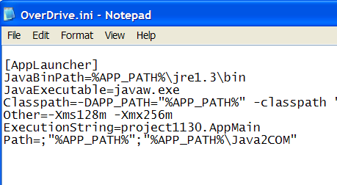

- Un-register MTJBWrapper.dll by executing the following command: regsvr32.exe /u c:\Program Files\Mettler Toledo\OverDrive\MTJBWrapper.dll
In order to successfully execute above command please follow the steps below:
- In Windows select Run command from Start menu.
- Click the Browse button.
- Select MTJBWrapper.dll by navigating to the following directory c:\Program Files\Mettler Toledo\OverDrive.
- Go to the beginning of the line in Run window and type before the starting quote the following command: regsvr32.exe /u
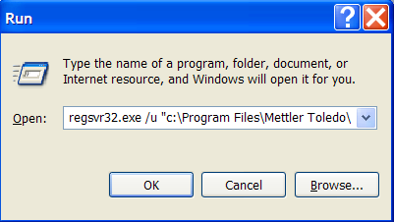

- Click the OK button to execute command. After running this command you should receive the message that the DLL was un-registered successfully.

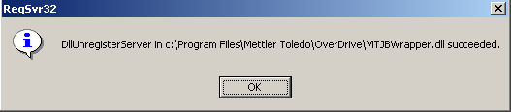

- Replace the OverDrive.jar file.
- Replace the OverDriveL.jar file.
- Replace the MTJBWrapper.dll file.
- Register MTJBWrapper.dll by executing the following command: regsvr32.exe c:\Program Files\Mettler Toledo\OverDrive\MTJBWrapper.dll
In order to successfully execute above command please follow the steps below:
- In Windows select Run command from Start menu.
- Click the Browse button.
- Select MTJBWrapper.dll by navigating to the following directory c:\Program Files\Mettler Toledo\OverDrive.
- Go to the beginning of the line in Run window and type before the starting quote the following command: regsvr32.exe

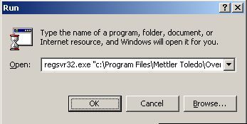

- Click the OK button to execute command. After running this command you should receive the message that the DLL was registered successfully.

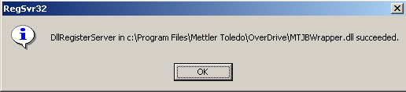

- Make necessary changes to the error.properties and app.ini files.
- Replace the application.properties file.
- Restart OverDrive v1.2.6.

OverDrive CD
The following directories and files have been added to the OverDrive v1.2.6 installation CD:

N/A

