WI-110
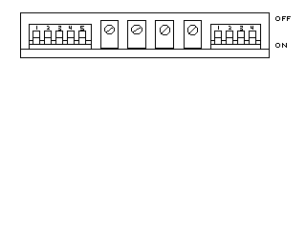

(S4) DEADLOAD ADJ
(R128) ZERO ADJ
(R115) FINE SPAN ADJ
(R114)
COARSE SPAN ADJ
(R142)
LINEARITY ADJ
(S6) SENSITIVITY
RANGE CONTROL

