RICE LAKE
INSTRUMENT OVERVIEW

All of the basic operations revolve around the interaction of the keyboard and the displays. Before starting to weigh and count, please take a minute to get familiar with the front panel and keyboard.

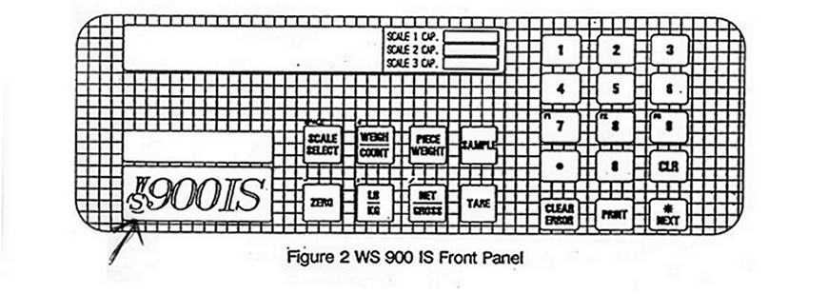
Ce sigle est une touche

2.1 THE KEYBOARD

[Scale Select] is used to switch between any remote scale bases of a multi-scale system. The active scale is indicated by a pointer in the Upper Display.

[Weigh/Count] switches the indicator between the Weigh and Count Modes once a Tare Weight has been established.

[Piece Weight] is pressed after a keyboard to define that entry as a Piece Weight or as a Piece Weight times 1000.

[Sample] is pressed after a keyboard entry to define that entry as a sample size, or is pressed when the number of parts on the selected scale equals the number of the Default Sample.

[Zero] is pressed to bring the indicator to a Center Zero at the initial entry into the Weigh Mode after power-up, and when in either the Net or Gross Weigh Mode. If pressed while in the Count Mode, it will bring the indicator to a Center Zero and clear any Tare value for the selected scale. Pressing [Zero] will NOT exit you from the Count Mode.

[lb/kg] is pressed to switch the displayed units of measure between English and Metric. The units in effect will be indicated in the Upper Display. All Keyboard entries must be made in the displayed units of measure.

