I. Recording Changes

In order to comply with FDA CFR 21 Part 11 regulations and to meet security concerns expressed by P&G, the Q.iMPACT has been enhanced to record changes to selected shared data variables. The log file “sdwrites.log” (also referred to as the “Setup Changes” log) records each shared data write by storing the shared data variable name, date, time, author, and new value. This file has a maximum size of 100,000 bytes. An example printout of this log is shown later in this document. Operator initiated changes are always recorded, however, the user has the option to record shared data writes initiated by the operating system itself as well as those initiated from FTP downloads, JagBASIC, or remote network shared data writes. The following page, accessed from Maintenance – Logging Of Setup Changes, shows how to record these other shared data writes:

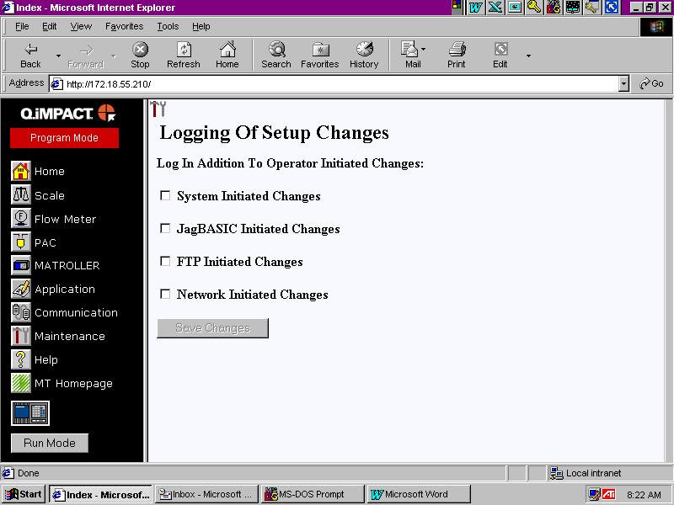
As more options are selected, the “sdwrites.log” file will fill more quickly. This is especially true for “System Initiated Changes”. A warning message will be displayed once the log is at least 80% full and will be re-displayed every 10 minutes until the log file is saved and cleared. Once the log file reaches 90% of capacity, a warning message will be displayed every 5 minutes.

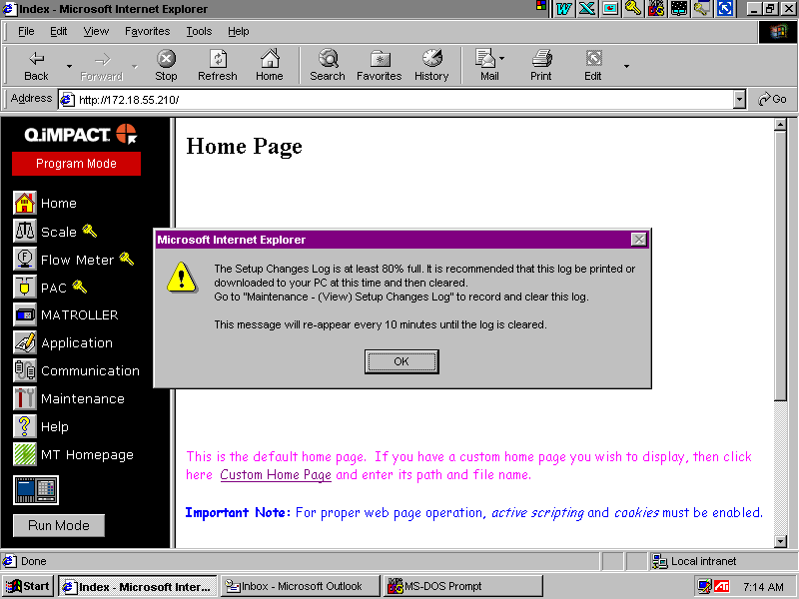

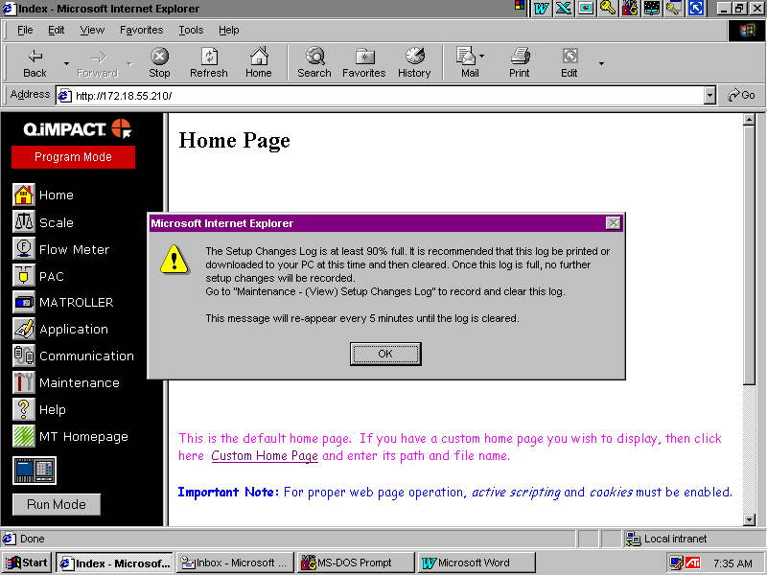
The “sdwrites.log” file needs to be copied periodically to a secure PC or a print-out made. The log file must then be cleared. The following web page, accessed from Maintenance – Setup Changes Log, shows how this is done:

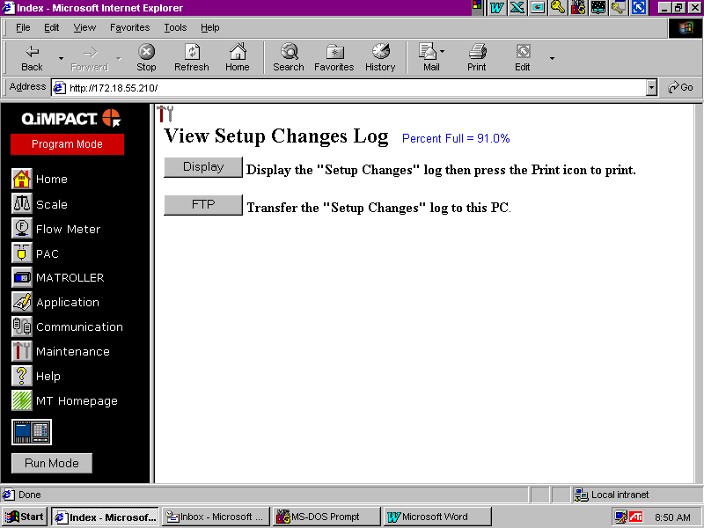
The user can either dump the log file to the screen and then print it or use FTP to transfer it to a PC. Once this is done successfully, the log file must be cleared.

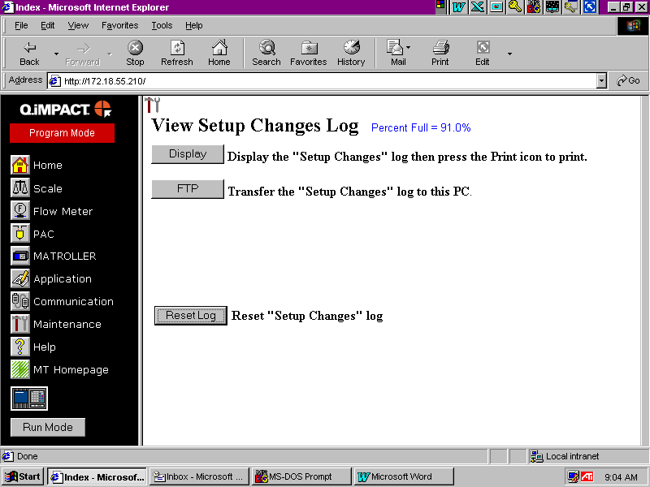
II. Forcing an Operator Name / ID entry

All web page initiated shared data writes are recorded in the “sdwrites.log” file. A shared data write record can include an author or can be anonymous. In the case that the author must be recorded, a supervisor can force the entry of an Operator Name / ID prior to saving any changes or entering into critical areas. The supervisor first needs to create a password using the MATROLLER Environment web page. Once this is done, a key symbol will appear next to all buttons or links that require an Operator Name / ID entry. Below is just one example of several web pages that require an Operator Name / ID entry to either save changes or access critical areas:

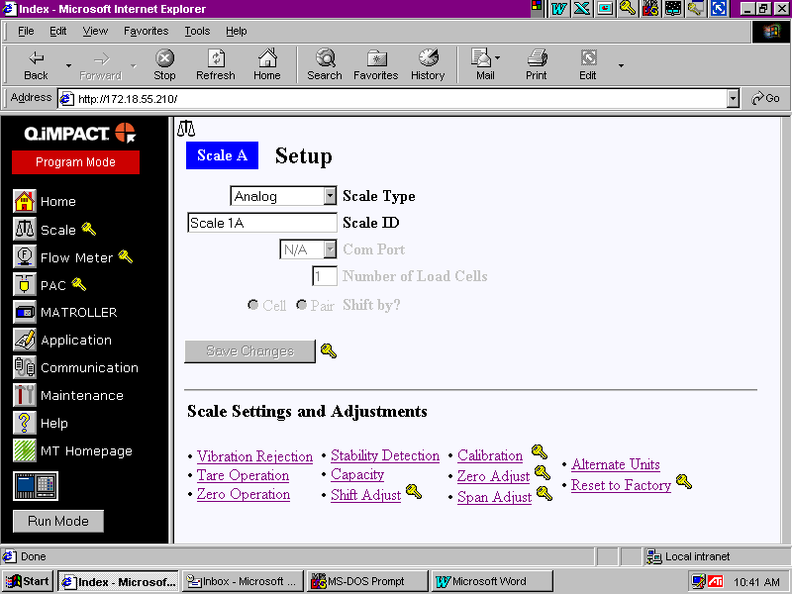
Notice the key symbol next to the Scale, Flow Meter, and PAC selections. These groups require an Operator Name / ID entry to save all changes made within the group or access critical areas, such as calibration. Other groups such as MATROLLER or Maintenance only have one or two operations within the group that require an Operator Name / ID entry and are therefore not marked with the key symbol, however, the specific operation within the group is marked with a key symbol.

To disable forced Operator Name / ID entry, the supervisor must click on the Q.iMPACT terminal graphic (just below the MT Homepage button). A separate window will appear that will permit the supervisor to disable forced Operator Name / ID entry.

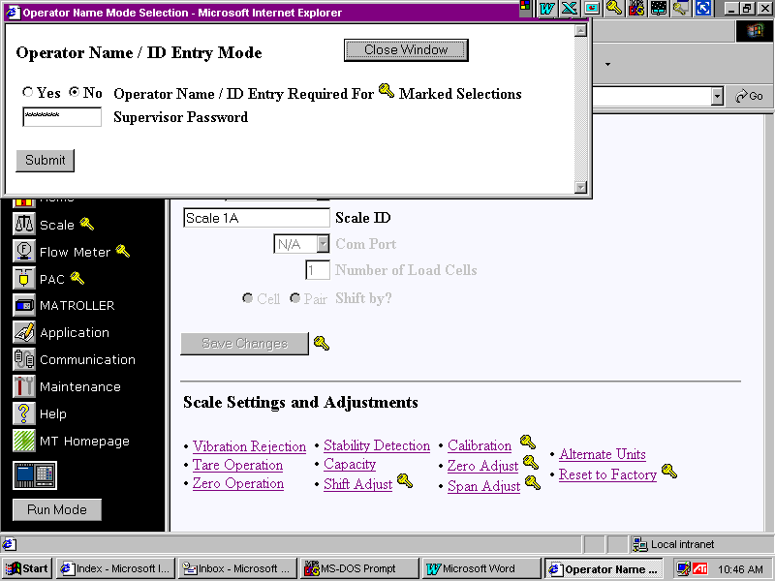

III. Recorded Shared Data Variables

ABC01 PLC address
ABC06 PLC data format
ABC85 ControlNet Media Layer
AS101 Purchased PAC channels
AS102 Purchased PAC material-paths
AS103 PAC database master
AS110 PAC weight entry method
CEn01 Address of First Load Cell
CEn02 Number of Load Cells
CEn03 Primary Units
CEn04 Primary Number of Ranges
CEn05 Primary Low Increment Size
CEn06 Primary Mid Increment Size
CEn07 Primary High Increment Size
CEn08 Primary LowMid Threshold
CEn09 Primary MidHigh Threshold
CEn10 Primary Scale Capacity
CEn11 Secondary Units
CEn12 Secondary Number of Ranges
CEn13 Secondary Low Increment Size
CEn14 Secondary Mid Increment Size
CEn15 Secondary High Increment Size
CEn16 Secondary LowMid Threshold
CEn17 Secondary MidHigh Threshold
CEn18 Secondary Scale Capacity
CEn19 Calibration Units
CEn25 Gravity Adjust
CEn26 Motion Sensitivity
CEn27 Motion Time Period
CEn85 Linearity Correction Enable
CEn88 Shift Adjust Mode
CS118 A scale ID
CS218 B scale ID
CS261 Operator Name / ID
CS318 C scale ID
CS418 D scale ID
CSn01 Auxiliary Units
CSn03 Custom Units
CSn04 Rate Time Units
CSn05 Rate Sample Time
CSn06 Rate Display Interval
CSn08 IDNET 10 Times Precision
CSn09 Power Up Timer
CSn10 Low Pass Filter
CSn11 Notch Filter
CSn12 Comb Filter
CSn17 Filter Poles
CSn19 Averaging Filter Order
CSn20 Comb Filter Order
CSn21 Scale Type
CSn22 Scale Location
CSn30 Calibration Date
CSn31 Next Calibration Date
CSn32 Calibration Days Interval
CSn33 Calibration Weightment Interval
CSn34 Calibration Expired Announcement Type
CSn36 Calibration Check Tolerance
CSn37 Calibration Check Points
CSn38 Calibration Check Failed Announcement Type
CSn40 Monitor Cell Overloads
CSn41 Cell Overload Threshold
CSn42 Monitor Platform Overload
CSn44 Monitor High Impact
CSn45 Impact Weight Threshold
CSn46 Impact Rate Threshold
CSn47 Monitor Weighments
CSn48 Weighment Trigger Type
CSn49 Weighment Threshold
CSn50 Monitor Zero Commands
CSn51 Monitor Zero Failures
CSn52 Monitor Scale IO Errors
CSn53 Weighment Reset Threshold
CSn54 Cell Overload Units
CSn55 Specified Run Flat Cell
CSn56 Percent Capacity Symmetry Start
CSn62 Cell Symmetry Check
CSn63 Cell Zero Drift Check
CSn64 Cell Zero Drift Threshold
CSn65 Cell Symmetry
CSn66 Cell Symmetry Threshold
CSn67 Predictive Fail. Announcement
CSn68 Run Flat Weight
CSn85 Fillnoise Filter Enable
CSn88 Rate Display Enable
CSn89 Auxiliary Weight Display Enable
CSn90 Units Switching Enable
CSn92 Do IDNET Tare In Q.i
CSn93 Process Application Type
DFQ01 Material-Path Assigned
DFQ02 Instrument Channel
DFQ03 Material-Path Descriptor
DFQ05 PAC Algorithm
DFQ06 Feeder Type
DFQ07 Slow Step Timer Factor
DFQ09 Minimum Open Time
DFQ10 Drain Time
DFQ11 Average Flow Rate Low Limit
DFQ12 Average Flow Rate High Limit
DFQ13 Average Spill Low Limit
DFQ14 Average Spill High Limit
DFQ15 Algorithm Update Parameter
DFQ16 Flow Rate Filter Sample Period
DFQ17 Destination Channel
DFQ18 Maximum Flow Rate Alarm Value
DFU01 Measuring Device Assigned
DFU02 Q.iMPACT Terminal
DFU03 Measuring Device
DFU04 Stable Scale Time
DFU06 Feed Override Time
DFU07 Minimum Slow Step Time
DFU09 Overlap Feed Alone Time
DFU10 Overlap Time Tolerance
DFU11 Zero Flow Threshold
DFU12 Unstable Device Flow Threshold
DFU13 Minimum Add
DFU14 Maximum Unit Size
DFU15 Dump Trip Point
DFU16 Minimum PAC Flow Rate Threshold
EMn01 Email Address
EMn02 Email Alert Messages
EMn03 Email Predictive Failures
FSn01 Flow Meter Description
FSn02 Flow Meter Increment Size
FSn03 Flow Meter Units
FSn07 Flow Meter Rate Units
FSn08 Flow Meter K Factor
FSn09 Flow Meter K Units
FSn11 Flow Meter M Factor
FWn03 Flow Meter Units
FWn07 Flow Meter Rate Units
INS01 Instrument Location (channels 1 – 20)
INS02 Instrument Location (channels 21 – 40)
INS03 Instrument Location (channels 41 – 60)
INS04 Instrument Location (channels 61 – 80)
INS05 Instrument Location (channels 81 – 100)
INS06 Instrument Location (channels 101 – 120)
INS07 Instrument Location (channels 121 – 140)
INS08 Instrument Location (channels 141 – 160)
INS09 Instrument Location (channels 161 – 180)
INS10 Instrument Location (channels 181 – 200)
JAG04 Market Region
JAG15 Number Of Internal Scales
JAG18 Consecutive Number Destination
JAG22 Consecutive Number Preset
JAG29 Monitor Log Records
JAG34 Q.iMPACT User ID
JAG35 Q.iMPACT Project,
JAG36 Q.iMPACT Description
JAG65 Battery Replacement Date
JAG88 Legal For Trade
JAG89 Consecutive Number Enable
JAG90 Consecutive Number Preset
LG801 ControlNet IP Address
LG802 ControlNet Subnet Mask
LG901 ControlNet Gateway Address
LG902 ControlNet DHCP Client Enable
LGn01 FTP User Name
LGn02 FTP User Password
NDE11 Cluster IP Address 1
NDE12 Cluster IP Address 2
NDE13 Cluster IP Address 3
NDE14 Cluster IP Address 4
NDE15 Cluster IP Address 5
NDE16 Cluster IP Address 6
NDE17 Cluster IP Address 7
NDE18 Cluster IP Address 8
NDE19 Cluster IP Address 9
NDE20 Cluster IP Address 10
NDE21 Cluster IP Address 11
NDE22 Cluster IP Address 12
NDE23 Cluster IP Address 13
NDE24 Cluster IP Address 14
NDE25 Cluster IP Address 15
NDE26 Cluster IP Address 16
NDE27 Cluster IP Address 17
NDE28 Cluster IP Address 18
NDE29 Cluster IP Address 19
NDE30 Cluster IP Address 20
NDE31 Host IP Address 1
NDE32 Host IP Address 2
NDE33 Host IP Address 3
NET02 Ethernet IP Address
NET03 Ethernet Subnet Mask
NET04 Ethernet Gateway IP Address
NET05 DNS Server 1 IP Address
NET06 DNS Server 2 IP Address
NET07 DNS Server 3 IP Address
NET10 Node Number Of Q.iMPACT
NET23 SMTP Server IP Address
NET24 Email Machine Name
NET25 Sender Email Address
NET26 Email Subject
NET28 SMTP Server TCP Port
NET30 Web Server Home Page
NET31 Web Server Document Page
NET32 Web Server Help Page
NET87 Enable Web Server
NET88 Enable FTP Server
NET89 Enable Email Alert
NET91 Enable Network Console
Qnn00 Material-Path Table Block
RM101 Node 1 Enabled
RM102 Node 2 Enabled
RM103 Node 3 Enabled
RM104 Node 4 Enabled
RM105 Node 5 Enabled
RM106 Node 6 Enabled
RM107 Node 7 Enabled
RM108 Node 8 Enabled
RM109 Node 9 Enabled
RM110 Node 10 Enabled
RM111 Node 11 Enabled
RM112 Node 12 Enabled
RM113 Node 13 Enabled
RM114 Node 14 Enabled
RM115 Node 15 Enabled
RM116 Node 16 Enabled
RM117 Node 17 Enabled
RM118 Node 18 Enabled
RM119 Node 19 Enabled
RM120 Node 20 Enabled
RM121 Host 1 Enabled
RM122 Host 2 Enabled
RM123 Host 3 Enabled
TRn01 Autotare Threshold
TRn02 Autotare Reset
TRn03 Autotare Clear
TRn85 Tare Enabled
TRn86 Pushbutton Tare Enabled
TRn87 Keyboard Tare Enabled
TRn88 Autotare Enabled
TRn89 Autotare Motion
TRn90 Autoclear Tare
TRn91 Autoclear After Print
TRn92 Autoclear Motion
TRn93 Tare Interlock Enable
TRn94 Display Tare
TRn96 Net Sign Correction
Unn00 Measuring Device Channel Table Block
ZRn01 Power Up Zero +
ZRn02 Power Up Zero -
ZRn03 Pushbutton Zero +
ZRn04 Pushbutton Zero -
ZRn05 Autozero Window
ZRn06 Under Zero Divisions
ZRn87 Autozero Gross-Net
ZRn88 Zero Gross
ZRn89 Zero Gross-Net

IV. Example Printout of Setup Changes Log – sdwrites.log

Below is a very short printout of the sdwrites.log. It contains the five character shared data variable name, followed by the date, time, and author of the change. The next line contains the new value. An anonymous entry would have “- - - -“ (four dashes) for the author.

CS261 27 Sep 2002 09:49:29 William Smith
William Smith
FS102 27 Sep 2002 09:49:29 William Smith
0.01
FS103 27 Sep 2002 09:49:29 William Smith
2
FS107 27 Sep 2002 09:49:29 William Smith
S
FS108 27 Sep 2002 09:49:29 William Smith
2400
FS109 27 Sep 2002 09:49:29 William Smith
4

V. How it all works

The current shared data structure does not contain an element (or the room to add an element) that can be used as a flag to control logging of a write to a shared data variable. Fortunately the root process used to create the shared data structure contains an unused security bit for each shared data variable. By setting this bit, the shared data variable is marked for logging every time it is written. The outputted structure does not have a security bit, so the upper bit of the length field is used to mark for logging. This required modifying the operating system at several points to mask off this bit whenever the field length was used. The Q.iMPACT has several entry points for saving shared data writes. This presented a major problem that required modifying two lower level functions for recording a write operation. Since there was no way to write to a RAM disk based file within a shared data write function, another solution needed to be found. The solution involved creating two small ring buffers that hold the shared data variable index number or block number and the author type (‘O’ – operator entry, ‘S’ – system entry, ‘R’ – remote network entry , ‘F’ – FTP download, ‘J’ – JagBASIC entry). Another function was created to read the ring buffers and convert the index or block number to a shared data name and store this along with the data, time, author, and new value in a RAM disk file. This function is called periodically within the control panel thread. In the case of a web page initiated write the control panel thread is awoken immediately after the write operation. Shared data writes from the front panel are logged very quickly since a display update awakens the control panel thread, thus calling the logging function. The operator name / ID (author) is always the first shared data variable (CS261) to be posted from the web page. This guarantees that any following shared data writes posted contain the correct author. Special comparison functions were also written to prevent logging shared data writes that did not change in value. This is common to web page posting since a group of shared data variables is always posted. Only the ones that change in value are logged. Another change to the operating system required creating new shared data write functions that contained the author type so that changes made from the control panel or from other threads (such as JagBASIC) could be logged with the correct author.

VI. Additional Security

The MATROLLER Environment web page has been enhanced with a selection that allows the supervisor to disable the MATROLLER keypad. This locks the keypad to prevent unauthorized tampering. If a key is pressed on the keypad, the message “KEYPAD DISABLED” is displayed on the lower display for one second. Note: Cycling power on the MATROLLER will re-enable the keypad.

