Application Note – Upgrading the Qi ControlNet Board Firmware

You will need:
- An RS232 cable with DB9 connector and open wires on the other
- The ControlNet Hex file
- E-Flash, firmware download software.

Upgrade sequence
- Remove power to Qi
- Remove Control Net board
- Connect RS232 cable to ControlNet board (note:1)
- Connect RS232 cable to PC RS232 port (com1 or com2)
- Start E-Flash software
- Click on the “OPEN” button. (A)
- Select the supplied ControlNet Hex file

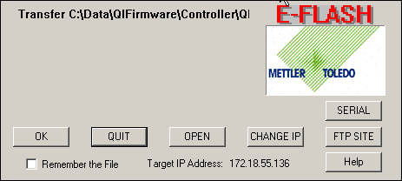
A

- Click on “SERIAL” button.
- Select the COM port that has the RS232 cable connected to it. Do not change any other parameters

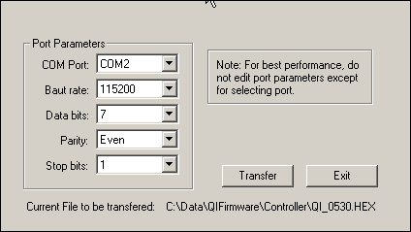
B

- At the rear of the ControlNet board is a “load” pushbutton
- Push and hold the “load” pushbutton.
- Switch power on to the Qi, keeping the button pressed.
- Keep button pressed for at least 10 seconds after power up.
- Let the button go and then click on the “Transfer” button on the displayed E-Flash window (B)
- After a brief pause a progress line will appear, wait until the download is 100% complete.
- Cycle power to the Qi.
- Transfer is complete

Note:1
There is normally no space/gaps for the RS232 cable to exit the Qi. The solution is to remove the board directly above the ControlNet board. This creates an empty slot above the ControlNet board for the RS232 cable to exit.

After the download is complete replace the removed board.

RS232 connections for DB9 connector

Receive data Rx 2
Transmit data Tx 3
Zero volts 0V 5

ControlNet board RS232 connections
ControlNet board plan view
0v Rx Tx
Load button

RS232 port

Interconnecting the two pieces of equipment
Connect 0v to 0v, Rx to Tx and Tx to Rx

Possible problems
One of the most common problems is the Com Port already in use by either hardware or software such as RSLinx. If you suspect that this might be the case, try using another ComPort or shutting down the offending application.

