

Parts Catalog

DIGITAL INDICATOR

DI-10

4th EDITION – Sept 2001

TERAOKA WEIGH-SYSTEM PTE LTD
3A, TUAS AVENUE 8. SINGAPORE 639218
TEL: +65 8613911 FAX: +65 8612242
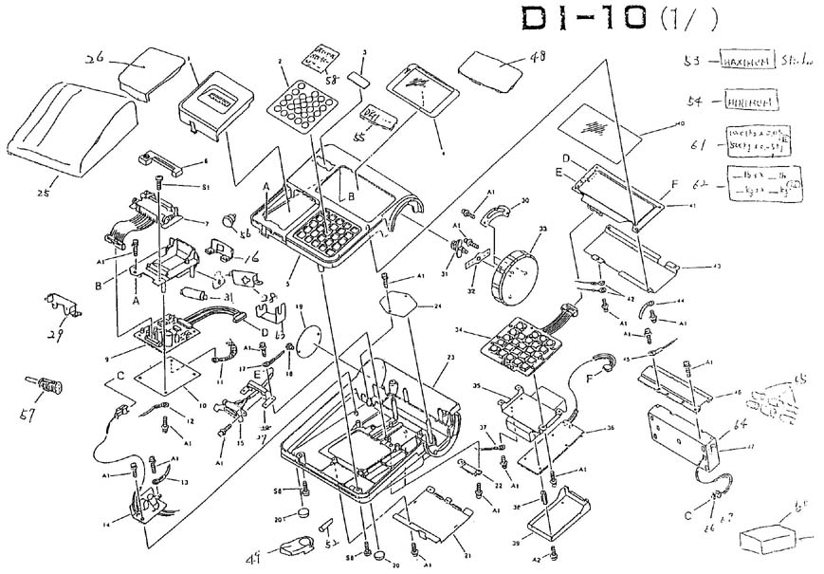

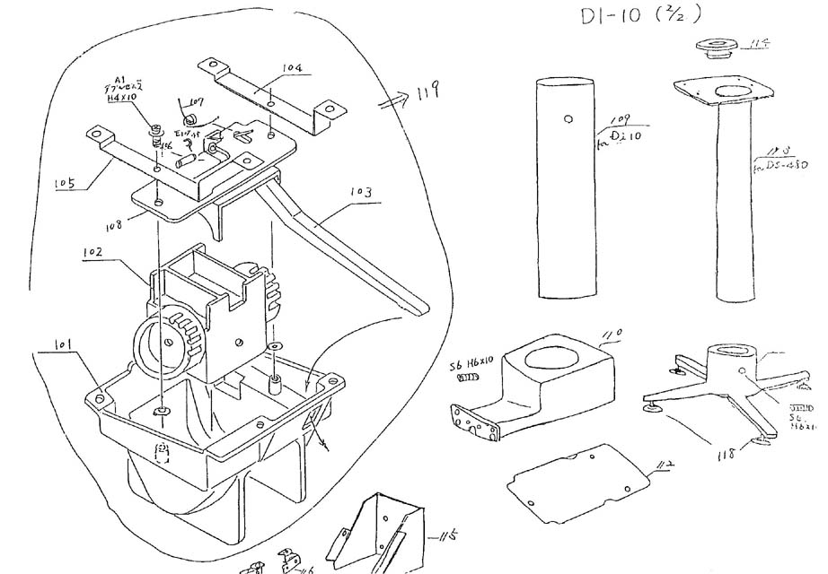

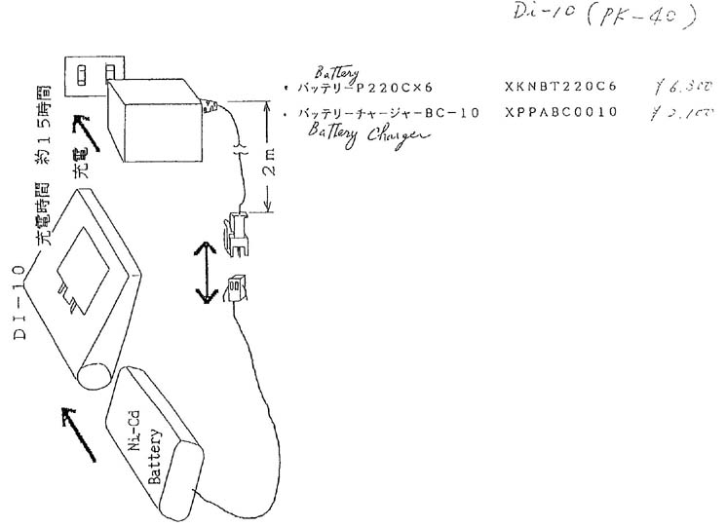

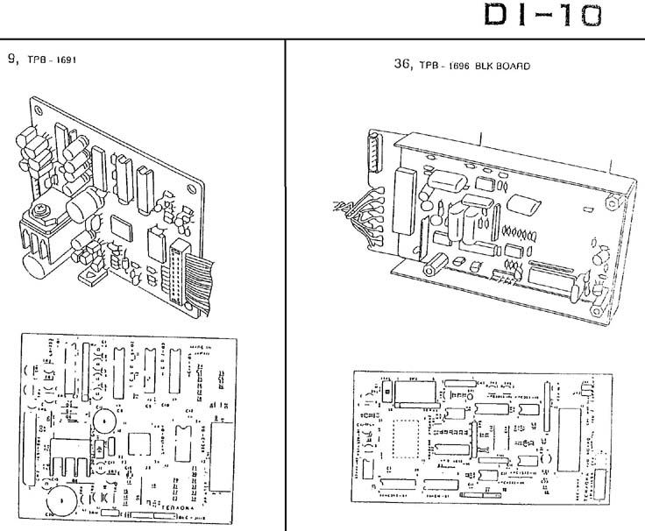

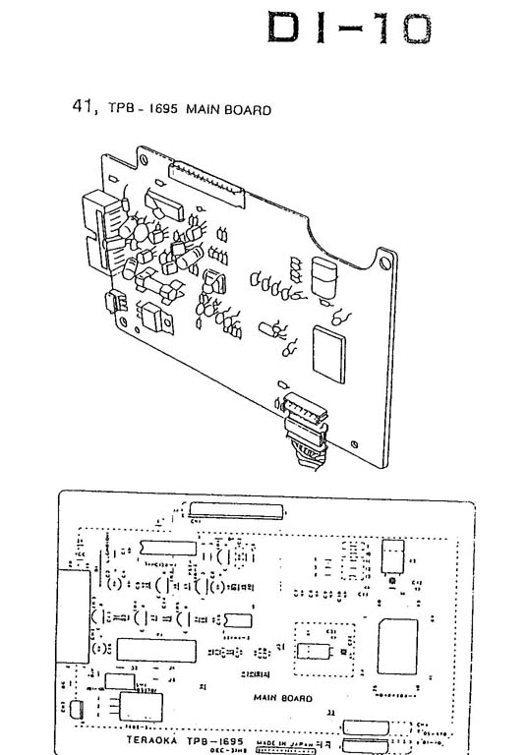

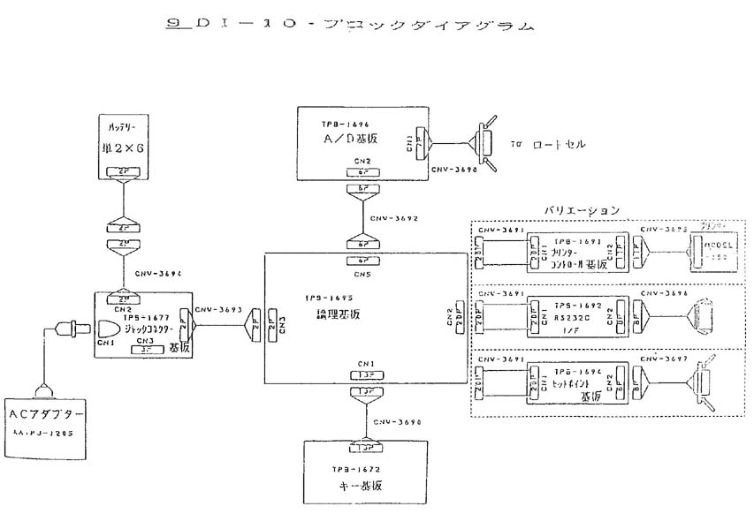

Model Name | Key Code | Index No | Product Name | Product Code | Unit Price US$
DI-10 | 1 |  | CASE (PRINTER COVER,A) | 40017400010320 | $7.92
DI-10 | 2 | AR | KEYSHEET (DI-10 AR.A) | 40017400080330 | $6.84
DI-10 | 2 | CA,U6 | KEYSHEET (DI-10,U6,A) | 40017400080230 | $6.84
DI-10 | 2 | EXP | KEYSHEET (DI-10,AA,A) | 40017400080130 | $6.84
DI-10 | 4 | AR | SHEET (DISPLAY, AR.A) | 40017400062830 | $2.88
DI-10 | 4 | EXP | SHEET (DISPLAY EXP,A) | 40017400060230 | $2.88
DI-10 | 5 |  | CASE (UP A) | 40017400010110 | $11.88
DI-10 | 5 | UU | CASE (UP, A, UL) | 40017400011120 | $11.88
DI-10 | 6 |  | RIBBON ERC-05 | 000RIBBONERC05 | $6.30
DI-10 | 7 |  | PRINTER MODEL 150-2 ASSY (W/O WIRE) | 40017400942099 | $91.65
DI-10 | 8 |  | BASE (PRINT ASSY NO.A) | 40017400610720 | $8.82
DI-10 | 9 | 82C43-06 | IC UPDB82C43G | 10I1SUA082C430 | $4.86
DI-10 | 9 | C1-3,5 | CAPACITOR SM25VB-4R7 | 10CNE1ESM00475 | $0.15
DI-10 | 9 | C11 | CAPACITOR SM16VB-220 | 10CNE1CSM00227 | $0.15
DI-10 | 9 | C14,16 | CAPACITOR DD106-63F103Z50 | 10CMD1HFOZ0103 | $0.15
DI-10 | 9 | C15 | CAPACITOR CSC300K | 10CMD1HCOK0300 | $1.14
DI-10 | 9 | C17 | CAPACITOR SM50VB-R47 | 10CNE1HSM00474 | $0.15
DI-10 | 9 | C19 | CAPACITOR SM50VB-2R2 | 10CNE1HSM00225 | $0.15
DI-10 | 9 | C20 | CAPACITOR SME16VB-470 | 10CNE1CSM00477 | $1.14
DI-10 | 9 | C4,6 | CAPACITOR HE40TJYB471K | 10CMD1HB0K0471 | $0.15
DI-10 | 9 | C7-10,12,13,18,21 | CAPACITOR RPE122F104Z50V | 10CMK1HFOZA104 | $0.58
DI-10 | 9 | CN1 | WIRE CNW-3691-1 | 20CNW000369100 | $6.48
DI-10 | 9 | CN2 | CONNECTOR SD5267-11A | 10HMSTS0526711 | $1.14
DI-10 | 9 | D1,2,7 | DIODE 1SS270TA | 10D2SCA01SS270 | $0.15
DI-10 | 9 | D3-6 | DIODE RD20EB.B3 | 10D1ZDA0020EB3 | $0.15
DI-10 | 9 | D8,9 | DIODE S5277B (1N4002) | 10D7SDA0S5277B | $0.15
DI-10 | 9 | HC02-03 | IC HD74HC02 | 10I2HC10000020 | $1.14
DI-10 | 9 | HC14-05 | IC HD74HIC14 | 10I2HC10000140 | $1.14
DI-10 | 9 | LA-170-04 | IC LA-170 | 10I5MCE0LA1700 | $48.62
DI-10 | 9 | LB1253-01 | IC LB1253 | 10I8DR1LB12530 | $3.24
DI-10 | 9 | Obsolete | TPB-1691 PRINTER BLK OPTION | 40017400948090 | $97.05
DI-10 | 9 | R1-8 | RESISTOR RA1/8 100K OHM 8A | 10RKA2BK870104 | $1.14
DI-10 | 9 | R10,17 | RESISTOR RD1/6 2K OHM J-33 | 10RKD2CJ040202 | $0.15
DI-10 | 9 | R14,26 | RESISTOR RD1/6 1K OHM J-33 | 10RKD2CJ040102 | $0.15
DI-10 | 9 | R15,20,23,30,32-34 | RESISTOR RD1/6 10K OHM J-33 | 10RKD2CJ040103 | $0.15
DI-10 | 9 | R16 | RESISTOR RD1/6 5.1K OHM J-33 | 10RKD2CJ040512 | $0.15
DI-10 | 9 | R19 | RESISTOR RD1/6 510 OHM J-33 | 10RKD2CJ040511 | $0.15
DI-10 | 9 | R25,29 | RESISTOR RD1/6 220 OHM J-33 | 10RKD2CJ040221 | $0.15
DI-10 | 9 | R35 | JUMPER JPW01-FC01 | 10GRJPW001FC01 | $0.15
DI-10 | 9 | R36 | RESISTOR RD1/6 4.7K OHM J-33 | 10RKD2CJ040472 | $0.15
DI-10 | 9 | R9,11-13,18,22,27,28 | RESISTOR RD1/6 100K OHM J-33 | 10RKD2CJ040104 | $0.15
DI-10 | 9 | SI-3052V | HEAT SINK OSH-1625-ST | 10LYRDT0016251 | $1.14
DI-10 | 9 | SI-3052V-07 | IC SI-3052V | 10IKRE003052V0 | $8.10
DI-10 | 9 | TC5065-02 | IC TC5065BP | 10I7CM10050650 | $1.98
DI-10 | 9 | TR1-3,5 | TRANSISTOR 2SD1145 | 10T82SD0114500 | $1.14
DI-10 | 9 | TR10 | TRANSISTOR 2SA733-PQ | 10T12SA0733000 | $0.58
DI-10 | 9 | TR11 | TRANSISTOR 2SB-772 | 10T12SB0772000 | $1.33
DI-10 | 9 | TR4 | TRANSISTOR 2SD879 | 10T82SD0879000 | $1.14
DI-10 | 9 | TR6 | TRANSISTOR 2SB598 | 10T82SB0598000 | $0.58
DI-10 | 9 | TR7,9 | TRANSISTOR 2SC945-P,Q | 10T12SC0945000 | $0.58
DI-10 | 9 | TR8 | TRANSISTOR 2SB-1116 | 10T12SB0111600 | $1.14
DI-10 | 9 |  | CAP SR35 6800UFM | 10CNE1VSME0688 | $3.96
DI-10 | 9 |  | HEAT SINK T220 | 10LYRDT0016251 | $1.14
DI-10 | 9 |  | WIRE CNW-3691-1 | 20CNW000369100 | $6.48
DI-10 | 9 | C1,C2,C3,C9,C21 | CAP CHIP CE EMK316F105ZD | 12CMK1EF0Z5105 | $0.15
DI-10 | 9 | C10 | CAP-E 50V 2.2uF | 10CNE1HSM00225 | $0.15
DI-10 | 9 | C11,C13,16 | CAPACITOR SR215E104MAA | 10CMK1HF0Z0104 | $1.52
DI-10 | 9 | C12 | CAP-E 16V 220uF | 10CNE1CSM00227 | $0.15
DI-10 | 9 | C14 | CAP-E 25V 220uF | 10CNE1ESM00227 | $0.15
DI-10 | 9 | C15,C20 | CAPACITOR HE12SJYB103K | 10CMD1HB0K0103 | $0.15
DI-10 | 9 | C4,C19 | CAPACITOR HE40TJYB471K | 10CMD1HB0K0471 | $0.15
DI-10 | 9 | C5,C6 | CHIP CAP MA1206CG330 | 12CFK1HA0J5330 | $0.15
DI-10 | 9 | C7 | CAP-E 50V 0.47uF | 10CNE1HSM00474 | $0.15
DI-10 | 9 | C8 | CHIP CAP GRM42-6F104Z50 | 10CMK1HF0Z5104 | $0.15
DI-10 | 9 | CN2 | CONNECTOR SD-5267-11A | 10HMSTS0526711 | $1.14
DI-10 | 9 | D1,D2,D3,D6,D7 | DIODE 1SS270TA-Q | 10D2SCA01SS270 | $0.15
DI-10 | 9 | D4,D5 | DIODE S5277B | 10D7SDA0S5277B | $0.15
DI-10 | 9 | Q1,Q5,Q7,Q14 | TRANSISTOR H945 | 10T22SC0945000 | $0.15
DI-10 | 9 | Q2 | TRANSISOTR 2SB772 | 10T12SB0772000 | $1.33
DI-10 | 9 | Q3,Q9,Q10 to Q13 | TRANSISTOR 2SA733 | 10T12SA0733000 | $0.58
DI-10 | 9 | Q4 | TRANSISTOR 2SB-1116 | 10T12SB0111600 | $1.14
DI-10 | 9 | Q6 | TRANSISTOR 2SB598 | 10T82SB0598000 | $0.58
DI-10 | 9 | Q8 | TRANSISTOR 2SD879 | 10T82SD0879000 | $1.14
DI-10 | 9 | R1 to R7,R14,R23,R26 | CHIP RES. 1206 10K ohm | 10RKN2BJ050103 | $0.15
DI-10 | 9 | R10,12,13,18,24,25,34,39 | CHIP RES. 1206 100K ohm | 10RKN2BJ050104 | $0.15
DI-10 | 9 | R11 | RES. CHIP 1206 0 ohm | 12RXN2BJ050000 | $0.15
DI-10 | 9 | R16 | RES. CHIP 1206 1M ohm | 12RXN2BJ050105 | $0.15
DI-10 | 9 | R20,R21 | RES. CHIP 1206 2.2K ohm | 12RKN2BJ050222 | $0.15
DI-10 | 9 | R22,R29,R31,R33,R36 | RES. CHIP 1206 4.7K ohm | 12RKN2BJ050472 | $0.15
DI-10 | 9 | R28,R30 | CHIP RES. 1206 150ohm | 10RKN2BJ050151 | $0.15
DI-10 | 9 | R8,R17,R35 | CHIP RES. 1206 1K ohm | 10RKN2BJ050102 | $0.15
DI-10 | 9 | R9,R15,R27 | RES. CHIP 1206 200ohm | 12RKN2BJ050201 | $0.15
DI-10 | 9 | TPB-1691-5 | TPB-1691 ELC ASSY DI-10 PRINTER | 40017400940100 | $105.00
DI-10 | 9 | U1 | IC LA-170 | 10I5MCE0LA1700 | $48.62
DI-10 | 9 | U2,U7 | IC CD74AC14M | 12ITACB0001400 | $1.14
DI-10 | 9 | U3 | IC UPD82C43G | 10I1SUA082C430 | $4.86
DI-10 | 9 | U4 | IC HD74HC02FP | 10I1HCB0000020 | $1.14
DI-10 | 9 | U5 | REGULATOR SI-3052V | 10IKRE003052V0 | $8.10
DI-10 | 9 | U6 | RTANSISTOR ARRAY STA412 | 10TSSTA0412A00 | $4.50
DI-10 | 9 | X1 | CERAMIC OSA CST6.00MGW | 10XMCXLCST6004 | $0.58
DI-10 | 10 |  | SHEET (DI-10, OPTION A) | 40017400061740 | $1.98
DI-10 | 14 |  | TPB-1677 JACK CONNECTOR BLK | 40017400978090 | $6.30
DI-10 | 14 |  | DC JACK SDCJ-210S-2.5 | 12HXJAC1SDCJ21 | $1.14
DI-10 | 15 |  | WIRE CNW-3698 | 20CNW000369800 | $15.84
DI-10 | 16 |  | COVER (AC JACK) | 40017400020340 | $1.14
DI-10 | 18 |  | BLIND RIVET HAA3-5 | 30R012HAA03005 | $0.15
DI-10 | 19 | CV | NAME PLATE (DI-10 CV.A) | 40017400091230 | $3.96
DI-10 | 19 | EXP | NAME PLATE (DI-10 EXP.A) | 40017400090240 | $3.96
DI-10 | 19 | TW | NAME PLATE (DI-10 TW.A) | 40017400090440 | $3.96
DI-10 | 20 |  | LEG SJ-5003 | 30L207SJ500300 | $1.14
DI-10 | 21 |  | COVER (PIPE BASE B) | 40017400041830 | $1.98
DI-10 | 22 |  | CLAMP (WIRE A) | 40017400041540 | $1.14
DI-10 | 23 |  | CASE (LOW) | 40017400010210 | $14.94
DI-10 | 24 |  | COVER (CORE,A) | 40017400061240 | $1.14
DI-10 | 25 |  | WATER PROTECTION COVER | 40090100740030 | $20.23
DI-10 | 26 |  | CASE (RS COVER,A) | 40017400010420 | $9.90
DI-10 | 27 |  | BRACKET (CN. SCALE A) | 40017400040240 | $1.14
DI-10 | 28 |  | BRACKET (R,S JACK A) | 40017400040340 | $1.14
DI-10 | 29 |  | BRACKET (SET JACK A) | 40017400041140 | $1.14
DI-10 | 30 |  | SPRING (BATTERY COVER A) | 40017400041440 | $1.14
DI-10 | 31 |  | AXIS (PAPER,A) | 40017400050640 | $1.98
DI-10 | 31 |  | PUSH SPACER PS-4S | 30C201PSS04000 | $0.58
DI-10 | 32 |  | SPRING (BATTERY A) | 40017400041340 | $1.14
DI-10 | 33 |  | CASE (BATTERY COVER,A) | 40017400010630 | $7.92
DI-10 | 34 |  | TPB-1672 KEYBOARD ASSY | 40017400930090 | $16.20
DI-10 | 35 |  | COVER ASSY (RFI. AD. A) | 40017400620140 | $12.78
DI-10 | 36 |  | TPB-1696 A/D BOARD BLK (02) | 40017400950590 | $102.30
DI-10 | 36 |  | WIRE CNW-3698 | 20CNW000369800 | $15.84
DI-10 | 36 | 74HC10-07 | IC HD74HC10P | 10I2HC10000100 | $1.14
DI-10 | 36 | 74HC393-04 | IC HD74HC393P | 10I2HC10003930 | $1.98
DI-10 | 36 | C12,14 | CAPACITOR ECQ-E1225JN | 10C0F2AE0J0225 | $1.98
DI-10 | 36 | C13 | CAPACITOR DD104-989B 471K50V | 10CMD1HB0K3471 | $0.15
DI-10 | 36 | C17 | CAPACITOR ECQ-E1105JZ | 10C0F2AE0J0105 | $1.98
DI-10 | 36 | C20 | CAPACITOR RPE131F473Z50V | 10CMK1HF0Z0473 | $1.14
DI-10 | 36 | C24 | CAPACITOR DN1E3R3M1S | 10C1S1E00M0335 | $1.14
DI-10 | 36 | C4,21 | CAPACITOR SM16VB-10 | 10CNE1CSM00106 | $0.15
DI-10 | 36 | C5-7,9-11,15,16,18,19,22,23 | CAPACITOR SR215E104ZTR-1A | 10CMK1HF0ZA104 | $0.58
DI-10 | 36 | C8 | CAPACITOR FPD22D104M | 10CKF2DP0M0104 | $1.14
DI-10 | 36 | CN-2 | CONNECTOR SD5267-06A | 10HMSTS0526706 | $1.14
DI-10 | 36 | CN-3 | CONNECTOR SD-5048-05A | 10HMSIS0504805 | $0.58
DI-10 | 36 | HD404418-03 | IC HD404418A18F | 10I2MCE418A180 | $12.78
DI-10 | 36 | INDICATION | LINE FILTER R1-3-4-1 | 10FKFCR0R10401 | $1.14
DI-10 | 36 | L1,2 | LINE FILTER NFB65-2402 | 10FKNFL0652402 | $1.33
DI-10 | 36 | PST-520-01 | IC PST-600D | 12IWLN0PST600D | $1.14
DI-10 | 36 | R10,12,16,17 | RESISTOR RD1/6 2.7K OHM J-33 | 10RKD2CJ040272 | $0.15
DI-10 | 36 | R11 | RESISTOR RD1/6 1M OHM J-33 | 10RKD2CJ040105 | $0.15
DI-10 | 36 | R13 | RESISTOR RD1/6 18K OHM J-33 | 10RKD2CJ040183 | $0.15
DI-10 | 36 | R14,15,34,35 | RESISTOR RD1/6 100K OHM J-33 | 10RKD2CJ040104 | $0.15
DI-10 | 36 | R19,21,22 | RESISTOR RN1/6 470K OHM F-33 | 10RKN2CF040474 | $0.15
DI-10 | 36 | R20,23,27 | RESISTOR RN1/6 1K OHM F-33 | 10RKN2CF040102 | $0.15
DI-10 | 36 | R24 | RESISTOR RN1/6 27K OHM F-33 | 10RKN2CF040273 | $0.15
DI-10 | 36 | R25 | RESISTOR RN1/6 47K OHM F-33 | 10RKN2CF040473 | $0.15
DI-10 | 36 | R26,28 | RESISTOR RN1/6 10K OHM F-33 | 10RKN2CF040103 | $0.15
DI-10 | 36 | R30 | RESISTOR RN1/6 6.8K OHM F-33 | 10RKN2CF040682 | $0.15
DI-10 | 36 | R31 | RESISTOR RN1/6 33K OHM F-33 | 10RKN2CF040333 | $0.15
DI-10 | 36 | R32,33 | RESISTOR RN1/6 15K OHM F-33 | 10RKN2CF040153 | $0.15
DI-10 | 36 | R9,18,29 | RESISTOR RD1/6 10K OHM J-33 | 10RKD2CJ040103 | $0.15
DI-10 | 36 | RA1 | RESISTOR ARRAY RA1/8K 100K OHM 8A | 10RKA2BK860104 | $1.14
DI-10 | 36 | RM1 | RESISTOR MRP-1677 | 10RTX1A0061677 | $3.96
DI-10 | 36 | RM2 | RESISTOR MRP-1678 | 10RTX1A0061678 | $6.84
DI-10 | 36 | SW-1 | DIP SWITCH KSS-08 | 10SNDSW0100810 | $1.98
DI-10 | 36 | TR1,2 | TRANSISTOR 2SC945-P,Q | 10T12SC0945000 | $0.58
DI-10 | 36 | TR3 | TRANSISTOR 2SK389 | 10T72SK0389BL0 | $2.43
DI-10 | 36 | TR4,5 | TRANSISTOR 2SK105 | 10T12SK0105000 | $1.14
DI-10 | 36 | uPA4572-11 | IC UPC4572C | 10I1LN10045720 | $1.14
DI-10 | 36 | uPC358-10 | IC UPC358C | 10I1LN10003580 | $1.14
DI-10 | 36 | uPC4062-05,09 | IC UPC4062C | 10I1LN10040620 | $1.71
DI-10 | 36 | uPC4066-06,08 | IC UPD4066BC | 10I1CM10040660 | $1.98
DI-10 | 36 | X2444-02 | IC S-24445I10 | 10I4NV10S24440 | $7.92
DI-10 | 36 | XTAL | X'TAL OSCILLATOR HC49U 8.3886MHZ | 10XDXTL0498384 | $1.14
DI-10 | 36 |  | TPB-2202 BLK00(DI10) | 40017400950790 | $117.90
DI-10 | 36 |  | EMI-FIL DEF-24F-24P202F1-T0SI02F | 10CCT1H12FT202 | $24.99
DI-10 | 36 |  | CAPACITOR HE40TJSL300J | 10CMD1HSLD0300 | $0.15
DI-10 | 36 |  | CHIP CAP GRM42-6F104Z50 | 10CMK1HF0Z5104 | $0.15
DI-10 | 36 |  | CAPACITOR MF50FC1-B6 | 10CNE1HMF05105 | $0.58
DI-10 | 36 |  | CAPACITOR ECQ-B1H224KF | 10C0F1HB0K0224 | $0.58
DI-10 | 36 |  | CAPACIOTR ECQ-P1H104JZ | 10C0F1HP0J0104 | $0.58
DI-10 | 36 |  | DIODE 1SS270TA-Q | 10D2SCA01SS270 | $0.15
DI-10 | 36 |  | DIODE 1SS286 | 10D2SCA01SS286 | $0.58
DI-10 | 36 |  | INDUCTOR EL0909SKI-101K-2 | 10FTINL0091010 | $1.71
DI-10 | 36 |  | CONNECTOR IMSA-1068 | 10HMSIS0504805 | $0.58
DI-10 | 36 |  | CONNECTOR SD-5267-06A | 10HMSTS0526706 | $0.58
DI-10 | 36 |  | IC LT1013DN8 | 10IXLN1LT10130 | $5.04
DI-10 | 36 |  | IC UPD75104GF-J58 | 10I1MCE104J580 | $6.84
DI-10 | 36 |  | IC HD74HC4066P | 10I2HC10040660 | $0.58
DI-10 | 36 |  | BR 93LC46A | 10I4EE1093C460 | $1.52
DI-10 | 36 |  | RESISTOR ARRAY CTS-770-91-103 | 10RKA2BK860103 | $1.14
DI-10 | 36 |  | CHIP RES. 1206 1/8W 100 OHM | 10RKN2BL050101 | $0.15
DI-10 | 36 |  | CHIP RES. 1206 1/8W 1K OHM | 10RKN2BJ050102 | $0.15
DI-10 | 36 |  | CHIP RES. 1206 1/8W 10K OHM | 10RKN2BJ050103 | $0.15
DI-10 | 36 |  | CHIP RES. 1206 1/8W 100K | 10RKN2BJ050104 | $0.15
DI-10 | 36 |  | CHIP RES. 1206 1/8W 51K OHM | 10RKN2BJ050513 | $0.15
DI-10 | 36 |  | RESISTOR MRP-2348 | 10RTX1A0062348 | $6.84
DI-10 | 36 |  | DIP SW KSS-08 | 10SNDSW0100810 | $1.98
DI-10 | 36 |  | CERAMIC OSC. CSA4.19MG | 10XMCXLCSA4194 | $0.58
DI-10 | 36 |  | IC PST-600D | 12IWLN0PST600D | $1.14
DI-10 | 36 |  | IC LTC1051 CN8 | 12IXLN1LT10510 | $10.80
DI-10 | 36 |  | WIRE CNW-3698-2 | 20CNW000369800 | $15.84
DI-10 | 38 |  | AXIS (RFI.AD.A) | 40017400050140 | $1.14
DI-10 | 39 |  | COVER (RFI.UP.A) | 40017400020130 | $3.96
DI-10 | 40 |  | SHEET COVER (PLATE A) | 40017400060440 | $2.88
DI-10 | 41 |  | TPB-1695 MAIN BOARD BLK (03) | 40017400900390 | $117.90
DI-10 | 41 | 74HC138-1 | IC HD74HC138P | 10I2HC10001380 | $1.14
DI-10 | 41 | 7805-4 | IC TA78DL05P | 10I7RE078DL050 | $3.24
DI-10 | 41 | C11-14 | CAPACITOR RTHE50TKYB102K | 10CMD1HB0K0102 | $0.15
DI-10 | 41 | C19,22 | CAPACITOR RTHE40TKSL150J | 10CMD1HSLD0150 | $0.15
DI-10 | 41 | C2,9 | CAPACITOR SM16VB-10 | 10CNE1CSM00106 | $0.15
DI-10 | 41 | C20,21 | CAPACITOR DD104-63SL200J50 | 10CMD1HSLJ0200 | $0.15
DI-10 | 41 | C3,5,7,15-18 | CAPACITOR RPE122F104Z50V | 10CMK1HFOZA104 | $0.58
DI-10 | 41 | C4 | CAPACITOR DD108-63F223Z50 | 10CMD1HFOZ0223 | $0.15
DI-10 | 41 | C6 | CAPACITOR SM35VB-10 | 10CNE1VSM00106 | $0.58
DI-10 | 41 | CN1 | CONNECTOR SD5268-13A | 10HMRIS0526813 | $1.14
DI-10 | 41 | CN2 | CONNECTOR SD5342-20GS1 | 10HMRIW053422Z | $2.88
DI-10 | 41 | CN3 | CONNECTOR SD5268-02A | 10HMRIS0526802 | $0.58
DI-10 | 41 | CN4 | CONNECTOR SD5268-06A | 10HMRIS0526806 | $1.14
DI-10 | 41 | D1 | DIODE S5277B (1N4002) | 10D7SDA0S5277B | $0.15
DI-10 | 41 | D3,4 | DIODE 1SS270TA | 10D2SCA01SS270 | $0.15
DI-10 | 41 | F1 | FUSE UL TSC-1A | 10PCFUS0UL0102 | $1.14
DI-10 | 41 | HD404808-5 | IC HD40480A50FS | 10I2MCE808A500 | $27.37
DI-10 | 41 | HD4074818FS, (AR3.23) | IC HD4074808FS | 10I2MPE4748080 | $27.37
DI-10 | 41 | LCD | LCD LD-B7260AZ | 10A5LCD0726000 | $49.30
DI-10 | 41 | PST-520-2 | IC PST-600D | 12IWLN0PST600D | $1.14
DI-10 | 41 | R1,2 | RESISTOR RD1/6 1K OHM J-33 | 10RKD2CJ040102 | $0.15
DI-10 | 41 | R10 | RESISTOR RD1/6 1.8K OHM J-33 | 10RKD2CJ040182 | $0.15
DI-10 | 41 | R11,13,17,19,22,23,33,35,37 | RESISTOR RD1/6 100K OHM J-33 | 10RKD2CJ040104 | $0.15
DI-10 | 41 | R12 | RESISTOR RD1/6 20K OHM J-33 | 10RKD2CJ040203 | $0.15
DI-10 | 41 | R15 | RESISTOR RD1/6 430K OHM J-33 | 10RKD2CJ040434 | $0.15
DI-10 | 41 | R16 | RESISTOR RD1/6 470K OHM J-33 | 10RKD2CJ040474 | $0.15
DI-10 | 41 | R20 | RESISTOR RD1/6 100 OHM J-33 | 10RKD2CJ040101 | $0.15
DI-10 | 41 | R21 | RESISTOR RD1/6 33K OHM J-33 | 10RKD2CJ040333 | $0.15
DI-10 | 41 | R36 | RESISTOR RD1/6 1M OHM J-33 | 10RKD2CJ040105 | $0.15
DI-10 | 41 | R4 | RESISTOR RD1/6 3K OHM J-33 | 10RKD2CJ040302 | $0.15
DI-10 | 41 | R5,9,14,18,24-27,32 | RESISTOR RD1/6 10K OHM J-33 | 10RKD2CJ040103 | $0.15
DI-10 | 41 | R6 | RESISTOR RD1/6 4.7K OHM J-33 | 10RKD2CJ040472 | $0.15
DI-10 | 41 | R7 | RESISTOR RD1/6 51K OHM J-33 | 10RKD2CJ040513 | $0.15
DI-10 | 41 | R8 | RESISTOR RD1/6 47K OHM J-33 | 10RKD2CJ040473 | $0.15
DI-10 | 41 | TR2 | TRANSISTOR 2SA733-PQ | 10T12SA0733000 | $0.58
DI-10 | 41 | TR3-5 | TRANSISTOR 2SC945-P,Q | 10T12SC0945000 | $0.58
DI-10 | 41 | X1 | X'TAL OSCILLATOR DT-38 32.7KHZ | 10XDXTL0383272 | $1.98
DI-10 | 41 | X2 | X'TAL OSCILLATOR HC49U 4.19430MHZ | 10XDXTL0494194 | $2.88
DI-10 | 41 | X2444-3 | IC S-24445I10 | 10I4NV10S24440 | $7.92
DI-10 | 43 |  | SHEET (DI-10 MAIN A) | 40017400061630 | $2.88
DI-10 | 44 |  | COATING CLIP CS-5 (CLAMP A) | 40010200015140 | $1.14
DI-10 | 45 |  | EARTH WIRE | 40017400041740 | $1.14
DI-10 | 46 |  | GUIDE (BATTERY A) | 40017400040140 | $1.33
DI-10 | 47 |  | BATTERY HOLDER ASSY (BH 261A) | 40017400974090 | $5.04
DI-10 | 48 |  | FILTER (DISPLAY,A) | 40017400060340 | $2.88
DI-10 | 49 |  | BUSHING (WIRE A) | 40017400060640 | $1.14
DI-10 | 50 |  | TPB-1692 RS232C BLK OPTION | 40017400948190 | $43.86
DI-10 | 51 |  | TPB-1694 SET POINT BLK OPTION | 40017400948290 | $39.61
DI-10 | 51 |  | SSR P6C-202T | 10EXSSR0062020 | $5.76
DI-10 | 51 |  | WIRE TCW-3697 | 20CNW000369700 | $10.80
DI-10 | 52 |  | BUSHING (WIRE DUMMY A) | 40017400061340 | $1.14
DI-10 | 53 |  | STICKER (MAX,EXP,A) | 40017400061440 | $1.14
DI-10 | 54 |  | STICKER (MIN. EXP) A | 40017400061540 | $1.14
DI-10 | 55 |  | STICKER (DI-10. COMPO. A) | 40017400062140 | $1.14
DI-10 | 56 |  | BUSHING (AC JACK A) | 40017400062340 | $1.14
DI-10 | 58 |  | SHEET (U6. EXPL. A) | 40017400062540 | $1.98
DI-10 | 61 |  | PLATE (U6. CAP. A) | 40017400062640 | $1.98
DI-10 | 62 |  | PLATE (U6. CAP. B) | 40017400062740 | $1.98
DI-10 | 63 |  | GUIDE (PAPER. A) | 40017400041940 | $2.88
DI-10 | 64 |  | STICKER (ARROW A) | 40017400062040 | $0.15
DI-10 | 66 |  | CONNECTOR SMP-02V-BC | 10HNRLC1SMP020 | $0.15
DI-10 | 67 |  | TERMINAL SHF-001-0.8SS | 10HNTML100108S | $0.15
DI-10 | 101 |  | COVER (PIPE A) FOR EXP | 40292800000220 | $3.96
DI-10 | 101 |  | COVER (PIPE A. UL) FOR UL | 40292800001220 | $3.96
DI-10 | 102 |  | COVER (PIPE B. UL) FOR UL | 40292800001320 | $3.96
DI-10 | 103 |  | LEVER (PIPE COVER A) | 40292800000440 | $1.71
DI-10 | 104 |  | EARTH (PIPE COVER A) | 40292800002340 | $1.14
DI-10 | 105 |  | EARTH (PIPE COVER B) | 40292800002440 | $1.14
DI-10 | 106 |  | SHAFT (LEVER A) | 40292800000540 | $1.14
DI-10 | 107 |  | SPRING (LEVER A) | 40292800000640 | $3.06
DI-10 | 108 |  | BRACKET ASSY (COVER HOLDER A) | 40292800613140 | $4.68
DI-10 | 109 |  | LONG PIPE (DI-10 838A) | 40292800002140 | $34.34
DI-10 | 109 |  | SHORT PIPE (DI-10 418A) | 40292800002240 | $21.25
DI-10 | 110 |  | STAND (STAND A) FOR S-M,P,L,O SERIES | 40292800000120 | $31.45
DI-10 | 111 |  | STAND (B) | 40012500082120 | $60.86
DI-10 | 112 |  | COVER (POLE STAND A) FOR NEW TYPE | 40292800000940 | $1.33
DI-10 | 113 |  | LONG PIPE ASSY A (DS-480, I=838) | 40012500680430 | $71.06
DI-10 | 113 |  | SHORT PIPE ASSY C (DS-480, I=418) | 40012500891030 | $50.66
DI-10 | 114 |  | BUSHING A | 40012500100540 | $1.14
DI-10 | 115 |  | BRACKET (HANGING A) | 40292800010130 | $10.80
DI-10 | 116 |  | TIP (HANGING A) | 40292800010240 | $1.14
DI-10 | 117 |  | TIP (HANGING B) | 40292800010340 | $1.14
DI-10 | 118 |  | LEG (A)-2 | 40402000000240 | $0.58
DI-10 | 119 |  | COVER ASSY (DI-10) | 40922900280020 | $25.33
DI-10 | 999 |  | COVER (PIPE B) FOR EXP | 40292800000320 | $3.96
DI-10 | 999 |  | CONNECTOR 57-30140 (MALE) | 10HDIFC0030149 | $5.94
DI-10 | 999 |  | RECEIPT ROLL | 40510700000940 | $0.58
DI-10 | 999 |  | DUST COVER(DI-10,B) | 40017400023090 | $3.60
DI-10 | 999 | 8 PINS | DIN PLUG TCP0586-01-5201 | 10HQDIN0058601 | $2.52

