Retrieving Application Software from the AV6010

Telnet into the AV6010
User name: root
Password: asiroot

Positioning the application software for retrieval

Note: All these commands are case and syntax sensitive. Make sure you enter the commands exactly as they are written. If you run a putty session you can copy and paste the commands.

- Change Directory

cd /leapfrog/apache/docs/leapfrog_web/downloads
(hit enter)

- Rename the StaticFocusTarget.pdf file

mv StaticFocusTarget.pdf StaticFocusTarget~.pdf
(hit enter)

- Have the download option point to the application software

ln -s /leapfrog/images/current_version/leapfrog_cflash.tar.gz ./StaticFocusTarget.pdf
(hit enter)
Note: The leading character is the letter “l“ as in the word letter

This completes the steps for positioning the application software for retrieval.

Retrieving the application software from the AV6010

Navigate to: Diagnostics>Tools>Downloads

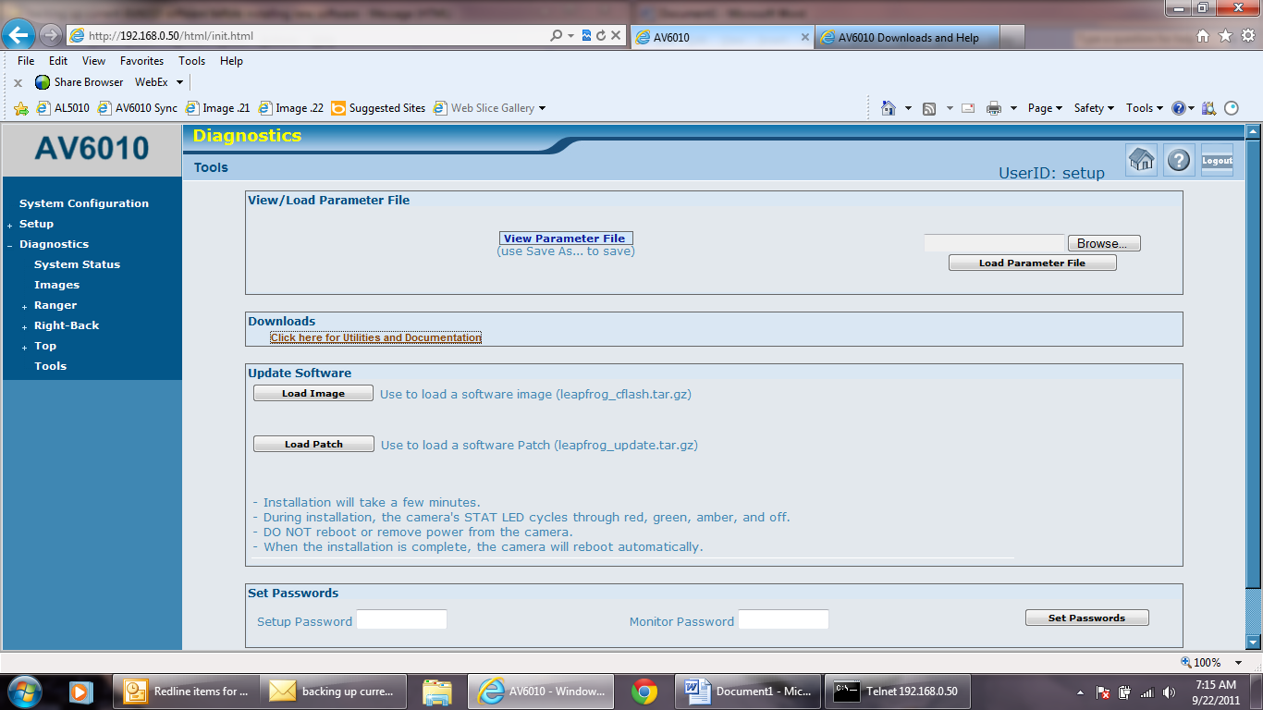

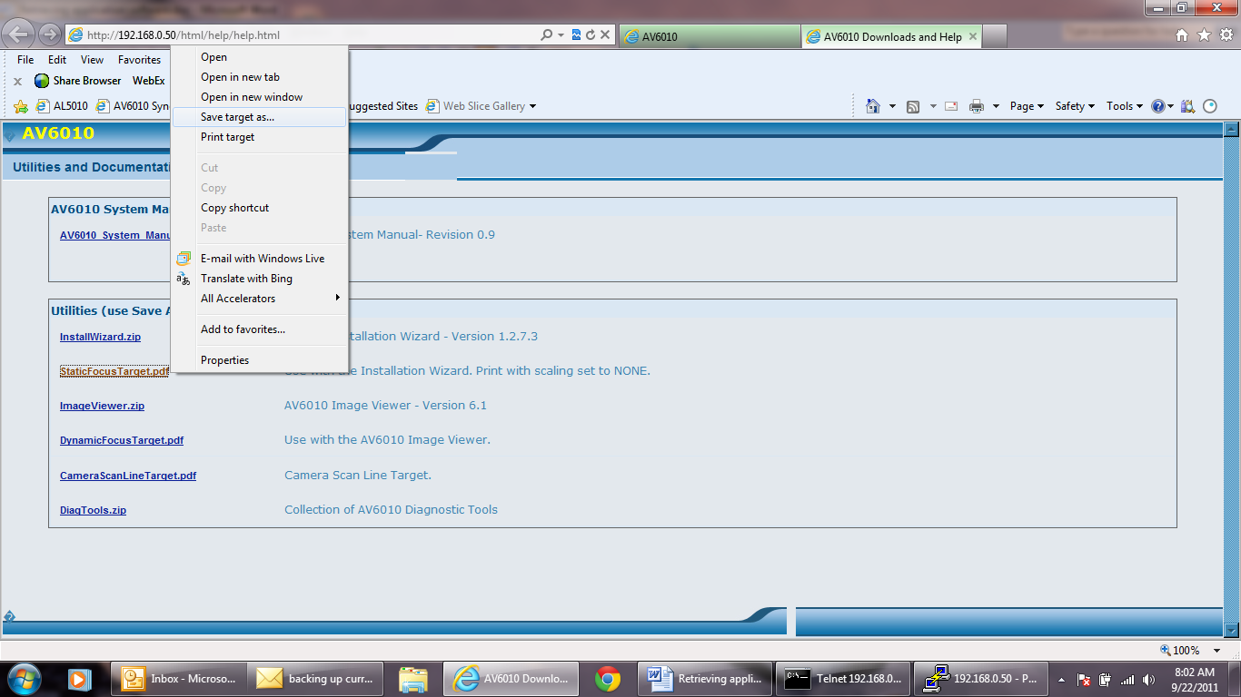
- Right click on the StaticFocusTarget.pdf file

- Select Save Target As:
  - This is a copy of the application software not the Static Focus Target.
  - Note: Rename the file with the .tar.gz extension

- Save File to your PC.

