Accu-Sort Systems

RangeFinder Calibration
Standard Work
RangeFinder calibration procedure

Tools/applications needed:

- RangerOscope (found in AV6010 under Diagnostics > tools > DiagTools.zip)
- CodeWord Viewer (found in AV6010 under Diagnostics > tools > DiagTools.zip)
- Windows command prompt
- Sync port adapter cable
- White printer paper (enough to cover the width of the conveyor, 3 pages thick)

Pre calibration steps:
- RangeFinder
  - Measure from Left laser housing to the belt (position the RangeFinder to be 75.75” above the conveyor)
  - Measure from Right laser housing to the belt (position the RangeFinder to be 75.75” above the conveyor)
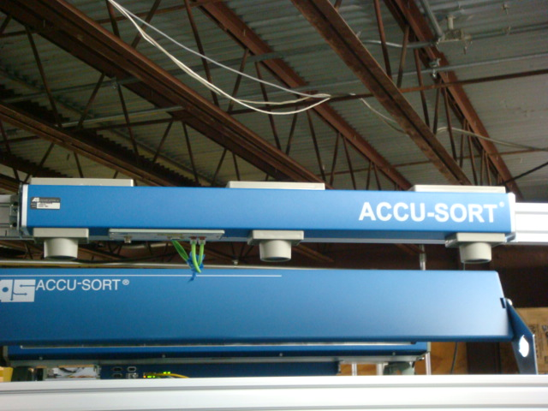

Interface panel

Measure from this surface

  - Adjust the beam blockers using a tall box at the extremes of the field of view
    - Objects outside of the conveyor that the RangeFinders beam strikes may have to be painted.
  - Connect to the AV6010 Sync port (a Sync port adapter must be used so the tach sync signal stays connected to all the AV6010 cameras)
  - Run RangerOScope
  - Run CodeWord Viewer
  - From a command prompt enter: (start>run>cmd)
  - telnet 192.168.0.40
  - Free Scale login: root
  - Password: root
  - set_gain (this command will return with the current gain setting)

Note:
The RangerOScope and CodeWord Viewer allows for turning on/off the display for each laser. The image below identifies the laser’s position on the RangeFinder as:

Interface panel
Right laser
Left laser

Calibration process

- Place white printer paper on conveyor under the RangeFinder
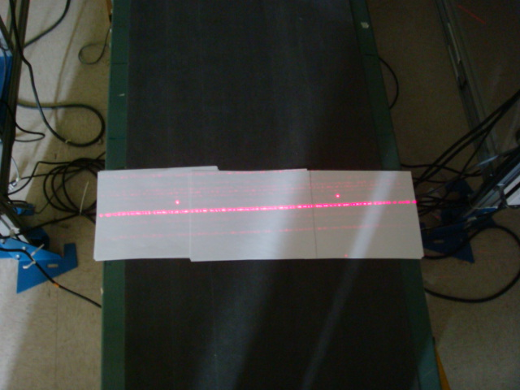
- View the signal in the RangerOScope application
- Select the left pattern generator and compare its signal to the right pattern generator
  - Both signals should be symmetrical
    - Change the RangeFinder signal gain by using
      - Setup>Mounting>RangeFinder
        - Change “offset to RF gain setting

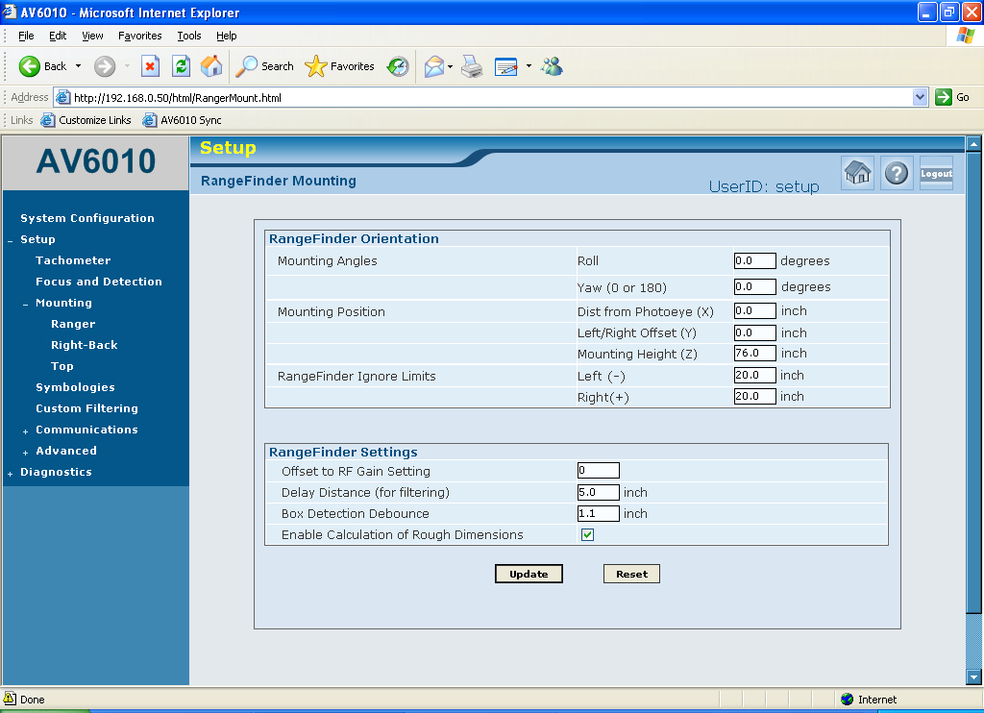

- Identify that the meat of the signal reaches inside the 192 line in the RangerOScope application program

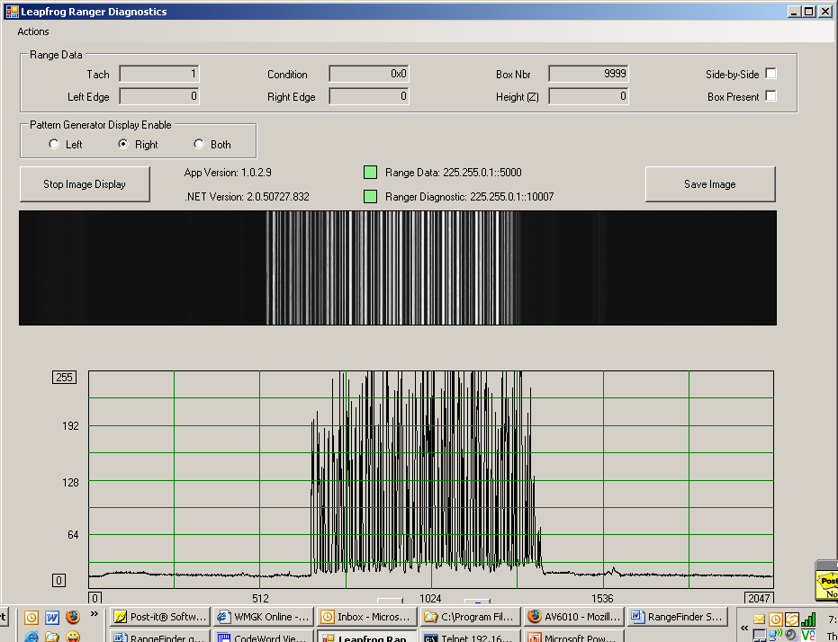
Top of the signal reaches saturation
Meat of the signal
Left/Right laser
Pattern generator display

- View the signal in the CodeWord Viewer
- Select left/right pattern generator display
- Set display to: Pixel Location
- Watch the CodeWord Viewer screen for a few moments
- Confirm that the code word signal remains solid, and none of the code words drop in and out.
- Enable the opposite side pattern (left/right) and identify that the code word signal is stable

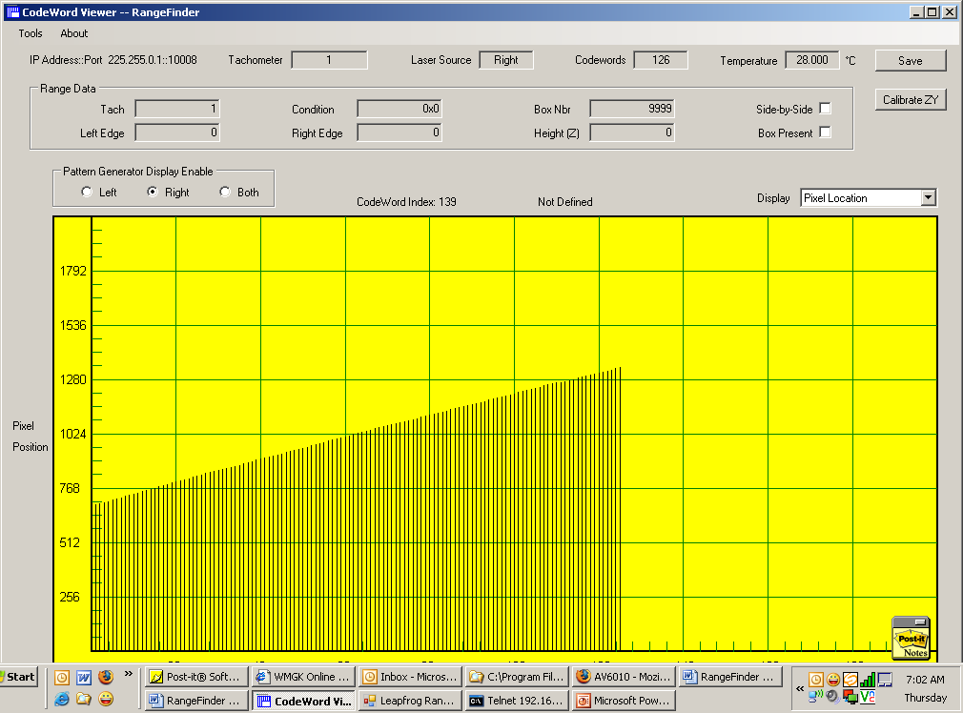
Position on sensor
Laser code word represented correctly
Good Signal

Poor CodeWord Viewer signal
- If the gain is set too high or to low some of the code words along the scan line will fall in and out

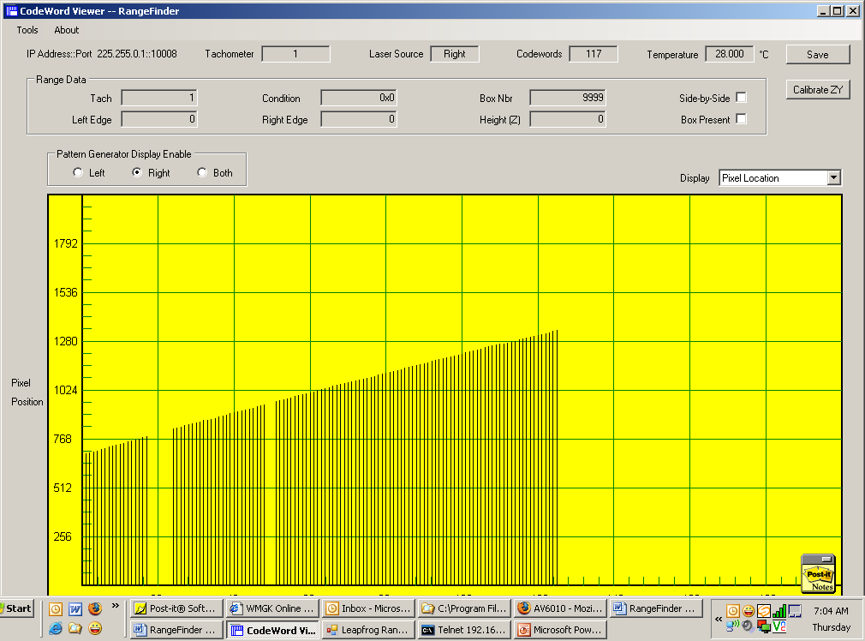
Code words are dropping out

Poor Signal

- Place white printer paper in the near of the DOF

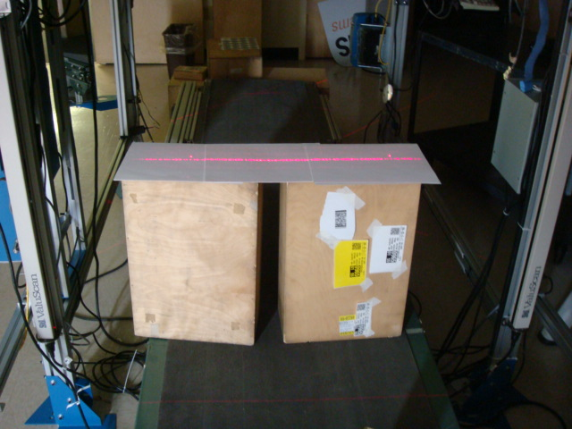

- View the signal in the CodeWord Viewer
- Select left/right pattern generator display
- Set display to: Pixel Location
- Watch the CodeWord Viewer screen for a few moments
- Confirm that the code word signal remains solid, and none of the code words drop in and out.
- Enable the opposite side pattern (left/right) and identify that the code word signal is suitable
- If the signal drops out change the rangefinder gain, and repeat the process.

Position on sensor
Laser code word represented correctly
Good Signal

Bad Code Word Viewer signal
- If the gain is set too high or to low some of the code words along the scan line will fall in and out

Code words are dropping out

Two other factors that can affect the RangeFinder signal
- Laser power
- Ambient light

Laser power test

Left or right laser looks good, but the opposite side laser code words periodically drop out.

- Select left side signal and note its signal amplitude
  - Note: The gain may have to be reduced in order to have a good representation of the signal
- Select right side laser and confirm that the signal amplitude is relatively equal to the left side signal amplitude. If there is a noticeable discrepancy, which indicates that there is a potential problem with the laser diode, then the unit could report erroneous height. Since there are no field repairable items on the RangeFinder the unit should be replaced.

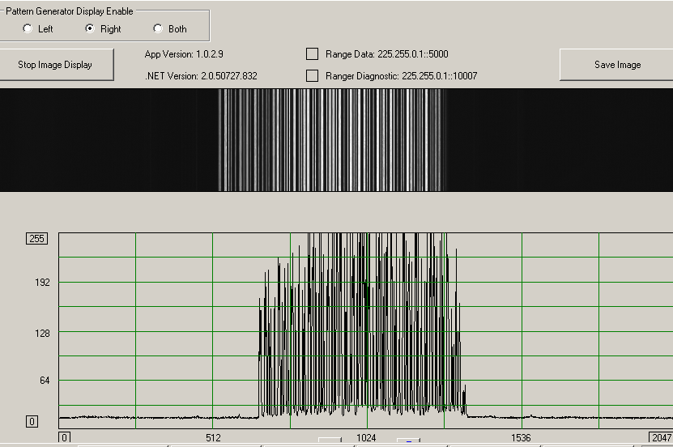
Left/Right selection
Gains set to LOW

Gains set to HIGH
Ambient light

Ambient light can influence the signal DC level
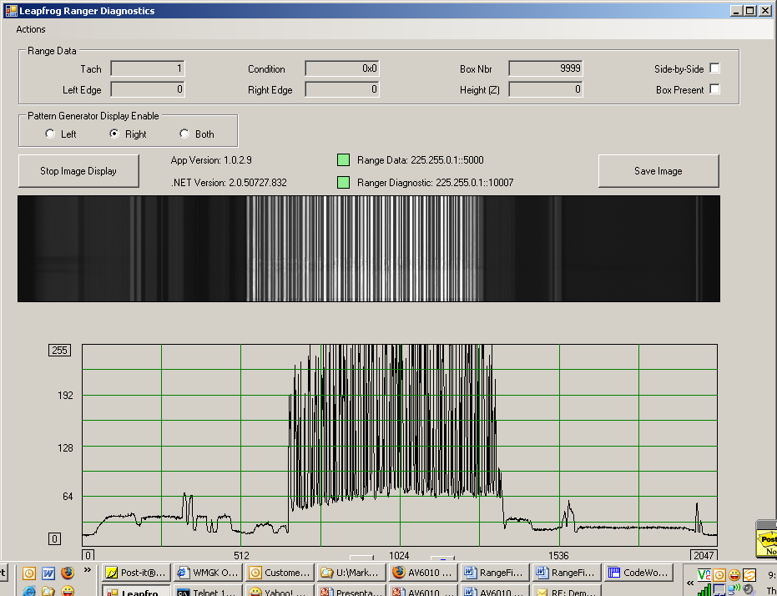

Delta in DC lever
Noisy signal

Good Signal
DC level
Clean signal
Verify

- Change the CodeWord Viewer to Z vs Y
- With now packages being inducted, confirm that there are no spikes breaking through

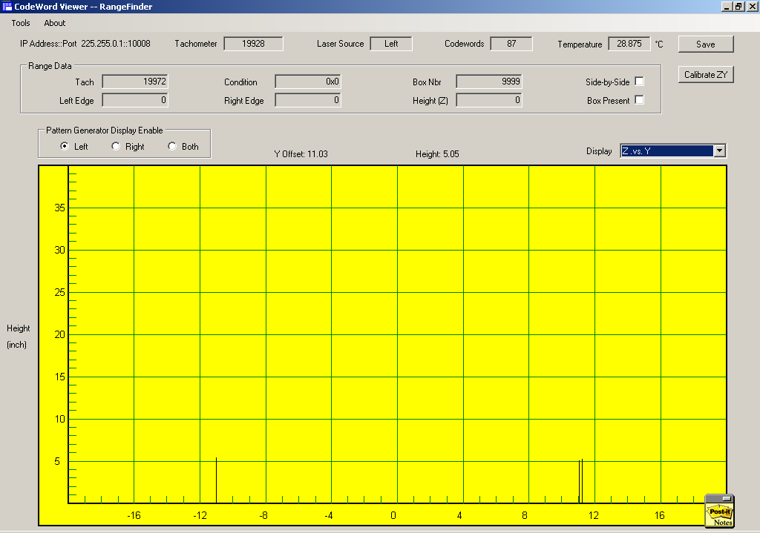
Spikes appearing with no packages being inducted.

- Place a box in the RangeFinder scan line.
- Measure the height of the box.
  - Note: This box should be square and undamaged.
- The CodeWord Viewer will identify the height of the box in relation to its mounting height.
- If the CodeWord Viewer height does not match the correct box height then adjust the RangeFinder “Mounting Height (Z)” found in the GUI

