Access Point Configuration Guide

July 18, 2000

Author:
Jeff Guadagnolo
jeff.guadagnolo@intermec.com

Table of Contents

2100 UAP 3
2.4Ghz WLIF OpenAir 3
2100 UAP 4
IEEE 802.11 High Rate w/WEP, Dual 9db 4
2100 UAP 5
IEEE 802.11 High Rate w/WEP, Single 9db 5
2101 UAP 6
2.4Ghz WLIF OpenAir 6
2101 UAP 7
IEEE 802.11 High Rate w/WEP, Dual 9db 7
2101 UAP 8
IEEE 802.11 High Rate w/WEP, Single 9db 8

2100 UAP

2.4Ghz WLIF OpenAir

Configuration Diagram

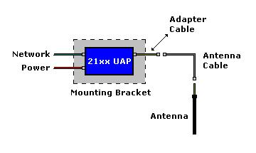

Parts List

Item | Part Number | Qty | Description
Access Point | One of the following
1 | 2100C51504000 | 1 | UAP, Standard Temp
 | 2100C52504000 | 1 | UAP, w/Heater
 | All of the following
2 | 068918 | 1 | Mounting Bracket
3 | 067265 | 1 | Adapter Cable (to Cable)
4 | 059167 | 1 | 9F-9F Null Modem Cable (Config)
Antenna Cabling | One of the following
5 | 064616 | 1 | Cable – 2.5’
 | 063245 | 1 | Cable – 5’ (Typical)
 | 063246 | 1 | Cable – 20’
Antenna | One of the following
6 | 066147 | 1 | Omni (Does not require Adapter Cable or Antenna Cable)
 | 067261 | 1 | 3db Mini Omni
 | 065349 | 1 | 9db Omni (Recommended)

2100 UAP

IEEE 802.11 High Rate w/WEP, Dual 9db

Configuration Diagram

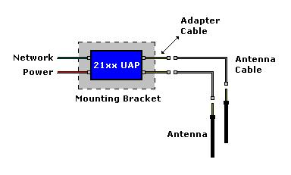

Parts List

Item | Part Number | Qty | Description
Access Point | One of the following
1 | 2100C51704000 | 1 | UAP, Standard Temp
 | 2100C52704000 | 1 | UAP, w/Heater
 | All of the following
2 | 068918 | 1 | Mounting Bracket
3 | 067265 | 2 | Adapter Cable (to Cable)
4 | 059167 | 1 | 9F-9F Null Modem Cable (Config)
Antenna Cabling | One of the following
5 | 064616 | 2 | Cable – 2.5’
 | 063245 | 2 | Cable – 5’ (Typical)
 | 063246 | 2 | Cable – 20’
Antenna | One of the following
6 | 066147 | 2 | Omni (Does not require Adapter Cable or Antenna Cable)
 | 067261 | 2 | 3db Mini Omni
 | 065349 | 2 | 9db Omni (Recommended)

2100 UAP

IEEE 802.11 High Rate w/WEP, Single 9db

Configuration Diagram

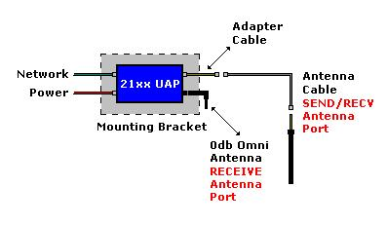

Parts List

Item | Part Number | Qty | Description
Access Point | One of the following
1 | 2100C51704000 | 1 | UAP, Standard Temp
 | 2100C52704000 | 1 | UAP, w/Heater
 | All of the following
2 | 068918 | 1 | Mounting Bracket
3 | 067265 | 1 | Adapter Cable (to Cable)
4 | 059167 | 1 | 9F-9F Null Modem Cable (Config)
Antenna Cabling | One of the following
5 | 064616 | 1 | Cable – 2.5’
 | 063245 | 1 | Cable – 5’ (Typical)
 | 063246 | 1 | Cable – 20’
Antenna | One of the following
6 | 066147 | 1 | Omni (Does not require Adapter Cable or Antenna Cable)
 | 067261 | 1 | 3db Mini Omni
 | 065349 | 1 | 9db Omni (Recommended)
Antenna | One of the following
7 | 066147 | 1 | Omni (Does not require Adapter Cable or Antenna Cable)

2101 UAP

2.4Ghz WLIF OpenAir

Configuration Diagram

Parts List

Item | Part Number | Qty | Description
Access Point
1 | 2101A51504000 | 1 | UAP, Mounting Bracket, Power Supply
 | All of the following
2 | 069893 | 1 | Kit, Power Supply Holder
3 | 069886 | 1 | Adapter Cable (MMCX to Cable)
4 | 059167 | 1 | 9F-9F Null Modem Cable (Config)
Antenna Cabling | One of the following
5 | 064616 | 1 | Cable – 2.5’
 | 063245 | 1 | Cable – 5’ (Typical)
 | 063246 | 1 | Cable – 20’
Antenna | One of the following
6 | 069753 | 1 | Omni (Does not require Adapter Cable or Antenna Cable)
 | 067261 | 1 | 3db Mini Omni
 | 065349 | 1 | 9db Omni (Recommended)

2101 UAP

IEEE 802.11 High Rate w/WEP, Dual 9db

Configuration Diagram

Parts List

Item | Part Number | Qty | Description
Access Point
1 | 2101A51704000 | 1 | UAP, Mounting Bracket, Power Supply
 | All of the following
2 | 069893 | 1 | Kit, Power Supply Holder
3 | 069887 | 2 | Adapter Cable (802.11 to Cable)
4 | 059167 | 1 | 9F-9F Null Modem Cable (Config)
Antenna Cabling | One of the following
5 | 064616 | 2 | Cable – 2.5’
 | 063245 | 2 | Cable – 5’ (Typical)
 | 063246 | 2 | Cable – 20’
Antenna | One of the following
6 | 069903 | 2 | Omni (Does not require Adapter Cable or Antenna Cable)
 | 067261 | 2 | 3db Mini Omni
 | 065349 | 2 | 9db Omni (Recommended)

2101 UAP

IEEE 802.11 High Rate w/WEP, Single 9db

Configuration Diagram

Parts List

Item | Part Number | Qty | Description
Access Point
1 | 2101A51704000 | 1 | UAP, Mounting Bracket, Power Supply
 | All of the following
2 | 069893 | 1 | Kit, Power Supply Holder
3 | 069887 | 1 | Adapter Cable (802.11 to Cable)
4 | 059167 | 1 | 9F-9F Null Modem Cable (Config)
Antenna Cabling | One of the following
5 | 064616 | 1 | Cable – 2.5’
 | 063245 | 1 | Cable – 5’ (Typical)
 | 063246 | 1 | Cable – 20’
Antenna | One of the following
6 | 069903 | 1 | Omni (Does not require Adapter Cable or Antenna Cable)
 | 067261 | 1 | 3db Mini Omni
 | 065349 | 1 | 9db Omni (Recommended)
Antenna | One of the following
7 | 069903 | 1 | Omni (Does not require Adapter Cable or Antenna Cable)

