MS-2500/MS-3800/MS-3900/MS-4600/MS-5400
Calibration Manual
Software ver. UP1911 V1.12

CONTENTS
PRECAUTIONS - 3 -
GENERAL INFORMATION - 3 -
KEY AND FUNCTIONS - 4 -
KEY FUNCTIONS - 4 -
FUNCTION SETTING DESCRIPTION - 4 -
FUNCTION FLOWS - 5 -
FULL FUNCTION FLOW - 6 -
MULTI DIVISION SETTING - 7 -
CALIBRATION - 8 -
GRADUATION SETTING(OIML CLASS III) - 9 -

PRECAUTIONS
READ this manual BEFORE operation or servicing this equipment.

FOLLOW these instructions carefully.

SAVE this manual for future reference.

DO NOT allow untrained personnel to operate, clean, inspect, maintain, service or tamper with this equipment.

ALWAYS DISCONNECT this equipment from the power source before cleaning or performing maintenance.

Note: If the unit has been stored or transported in below freezing temperatures, allow the unit to warm up to room temperature before turning on power.

PAY SPECIAL ATTEHNTION TO ALL “WARNING” SYMBOLS
 IMPORTANT  ELECTRICAL WARNING

GENERAL INFORMATION
Before connecting or disconnecting any internal electronic components or interconnecting wiring between electronic equipment, always remove power and wait at least 30 seconds. Failure to observe these precautions could damage or destruction of the equipment.

FCC COMPLIANCE STATEMENT
WARNING! This equipment generates, uses and can radiate radio frequency and if not installed and used in accordance with the instruction manual, may cause interference to radio communications. It has been tested and found to comply with the limits for a Class A computing device pursuant to Subpart J of Part 15 of FCC rules, which are designed to provide reasonable protection against such interference when operated in a commercial environment. Operation of this equipment in a residential area may cause interference in which case the user will be responsible to take whatever measures necessary to correct the interference.

KEY AND FUNCTIONS
KEY FUNCTIONS
*ON/OFF Press to switch scale on and off.
ZERO KEY Press to zero the scale.
BMI Press to enable BMI function.
*HOLD Press to lock weighing result.
*UNITS Press to select weighing units between kg,lb,st
ENTER Press to confirm the function or numeral key.
CLEAN Cleaning error input of numeral key.
Key Pad 0~9 Entering numeral 0~9
PRE-SET TARE Press to set pre-tare weight.
*SEMI AUTO TARE Press to tare the weight of current loading object.
PRINT Press to print result.
* 4key type indicator

FUNCTION SETTING DESCRIPTION
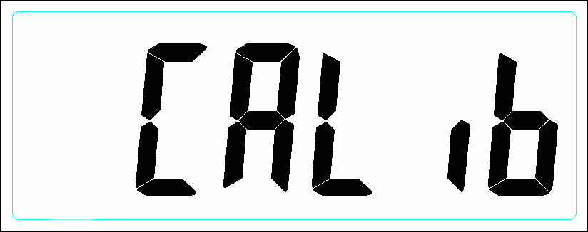

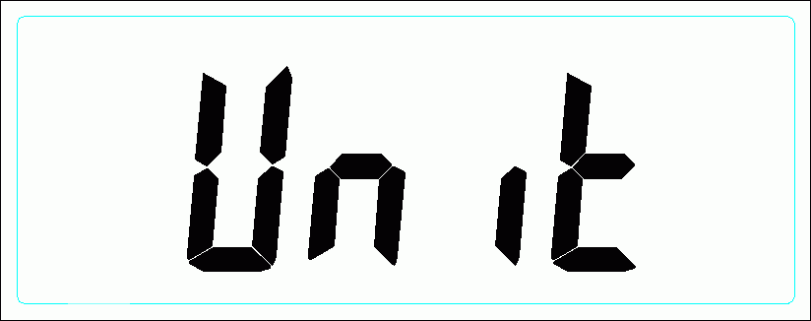
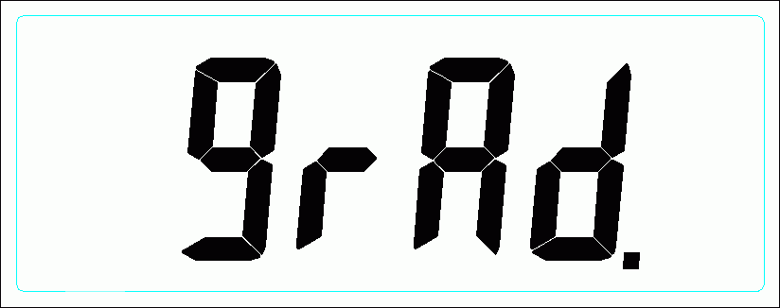

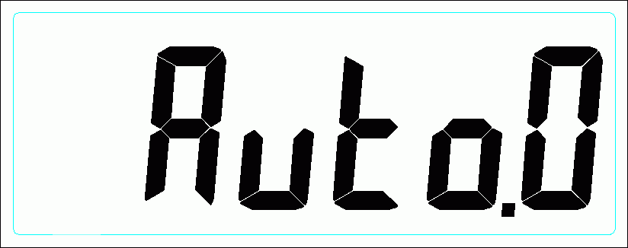
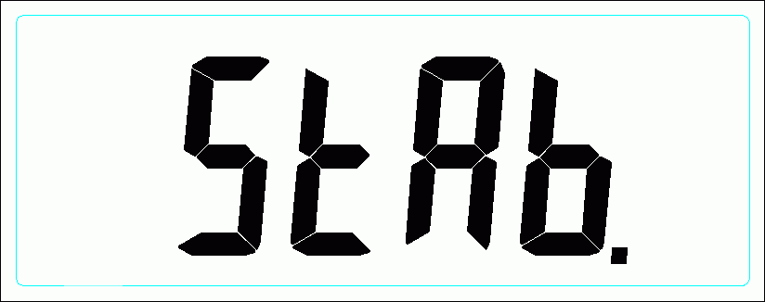
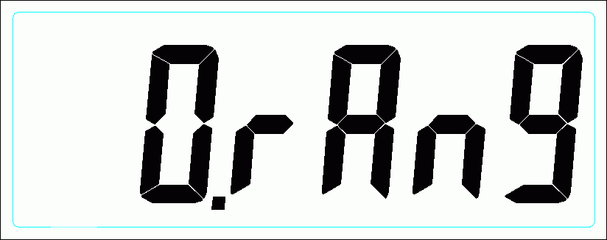
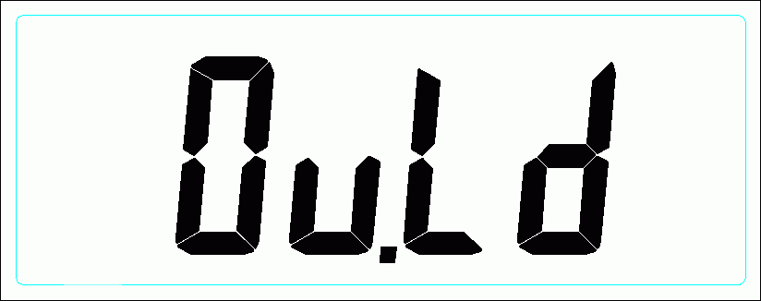
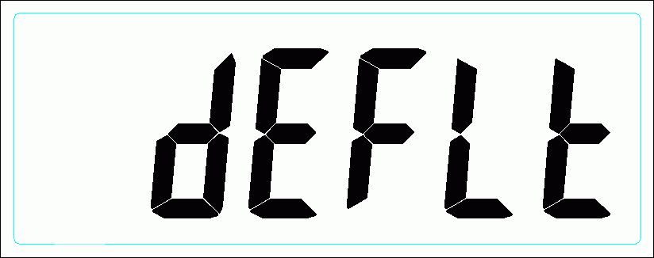

(Units) : ( Kg / Lb / St ) set up weighing unit on and off.
(Graduations ) : graduations、max capacity、division , refer to figure (1)

(Weight Section Division) : multi division set up

(Auto-Zero-Tracking-Range)：zero tracking range set up ( 0.25d/0.5d/1d/3d/OFF )
(Stable-Range)：stable range set up ( 0.25d/0.5d/1d/3d/OFF )
(Zero Range)：zero range set up ( 2% / 100% )
(Over Load Range)：overload set up ( 9d / 2% )

(Calibration Set)：calibration function set up
(Auto-Off Time)：auto off set up (120 SEC. / 180 SEC. / 240 SEC. / 300 SEC. / OFF)

(Buzzer)：beeper (ON / OFF)
(Defult Setup)：restore default setting

FUNCTION FLOWS

Press ZERO (4 key indicator: UNIT) for three seconds when LCD show then, release the button. LCD now is showing (unit) first function in function setting mode. Following are mainstream of function flow.
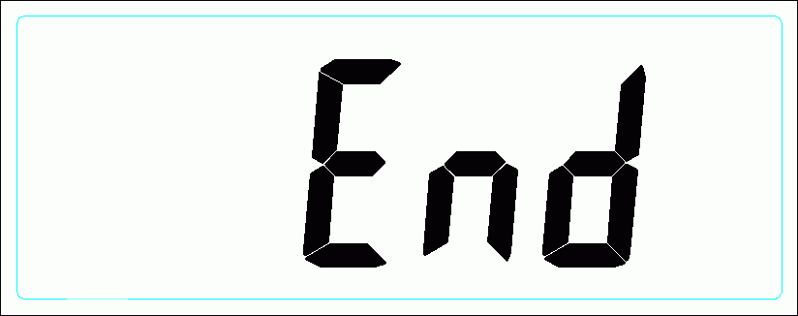

Press SEMI AUTO TARE to select function.
Press HOLD to confirm selection.

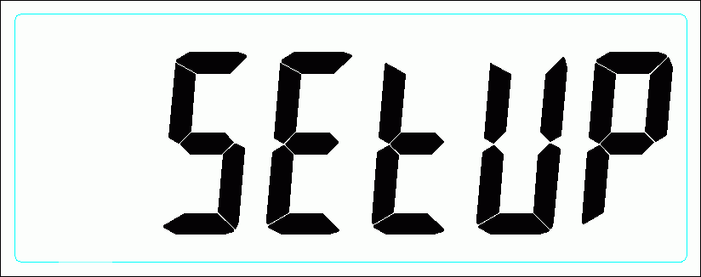
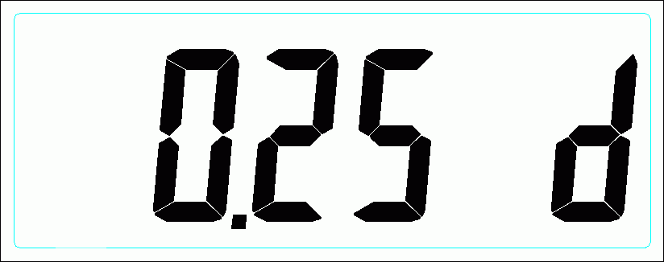
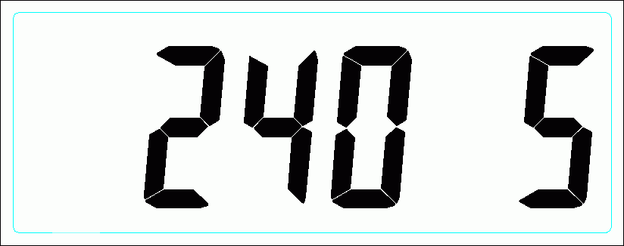
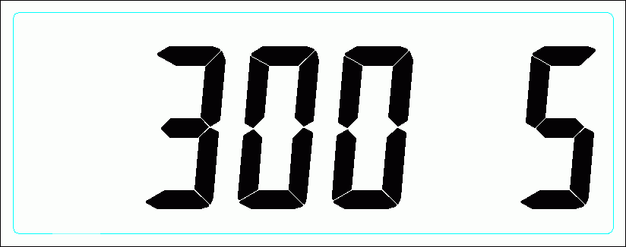

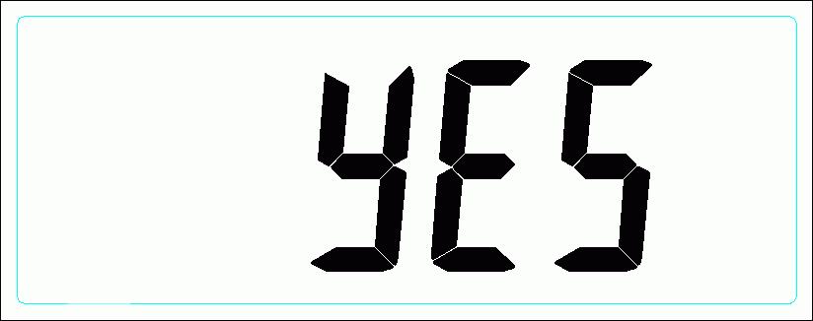

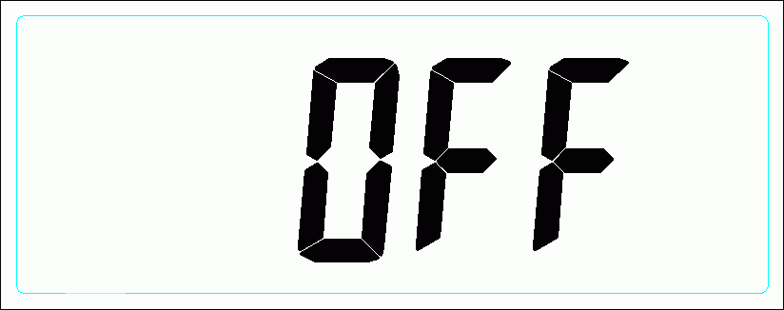
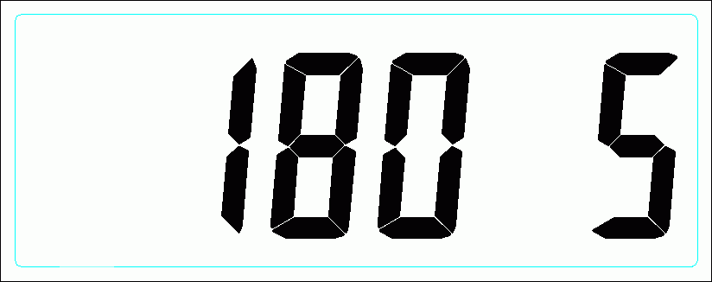

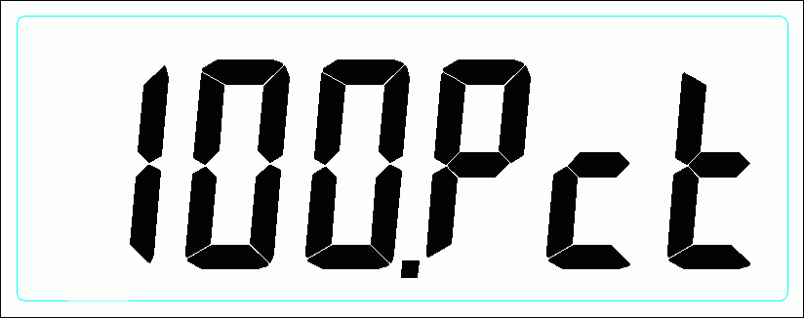
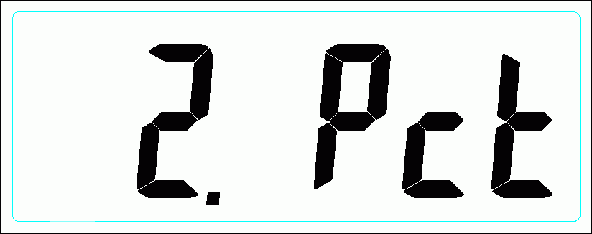
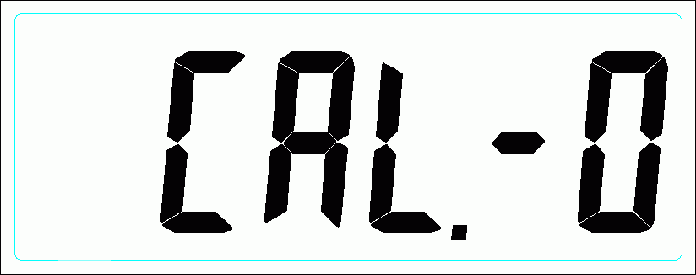
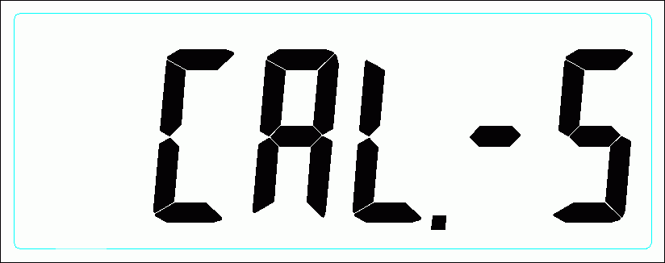
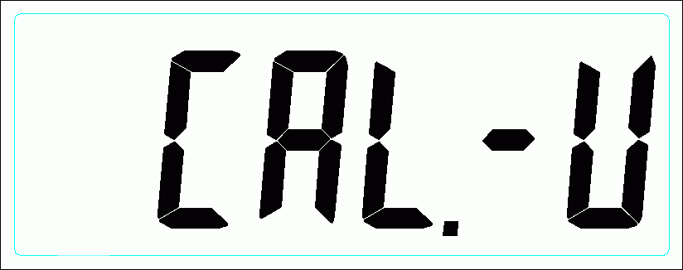

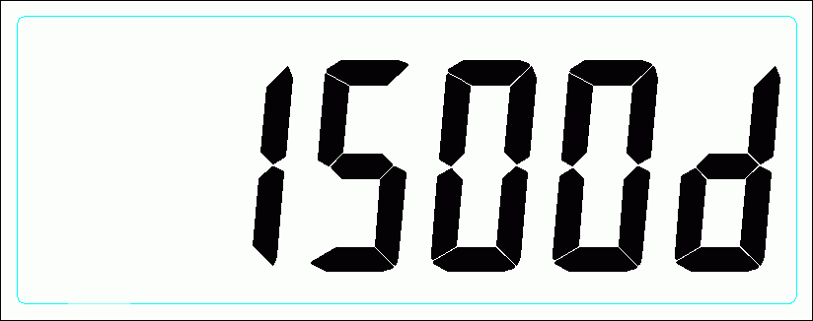
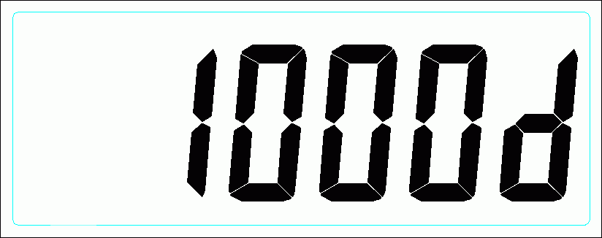
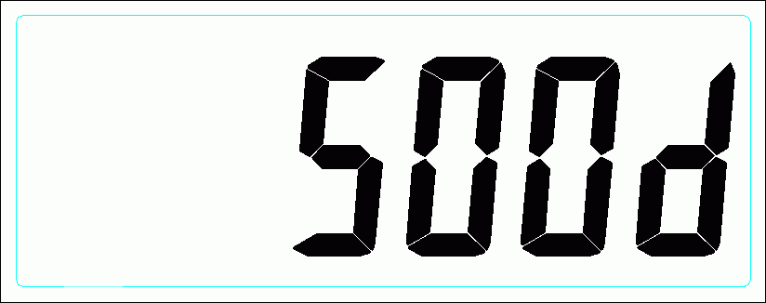
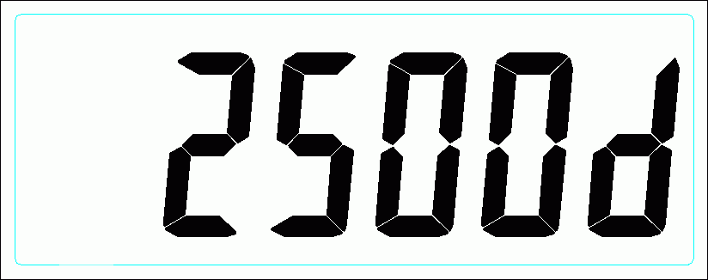
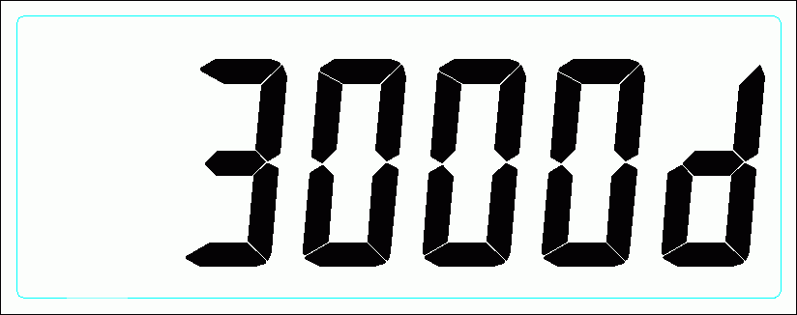


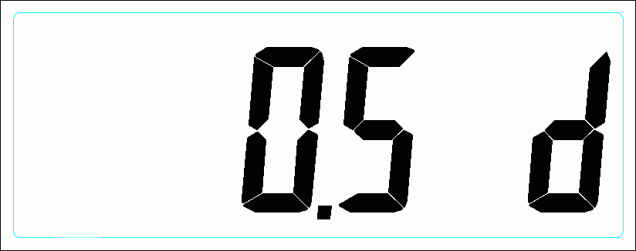
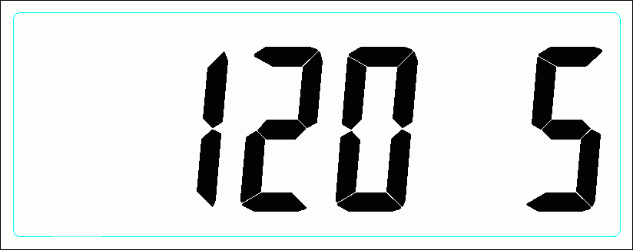
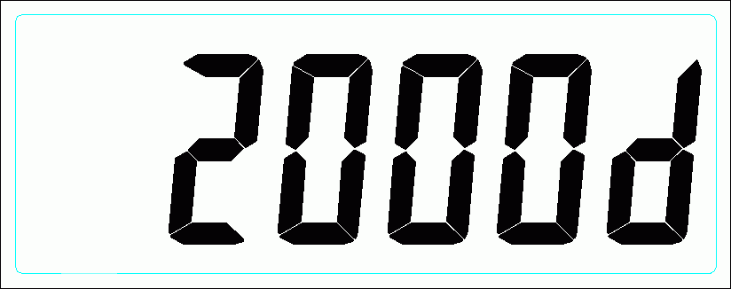


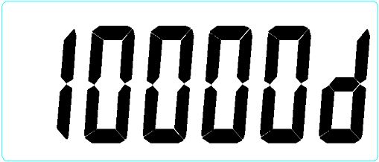
FULL FUNCTION FLOW

MULTI DIVISION SETTING

Press ENTER to confirm setting.
For 20key indicator:
input target division in kg.
For 4key indicator:
TARE to reduce numeral
UNIT to clear input
HOLD to move to next digit.
***To confirm setting by moving to “Wt-d”.
Full capacity
multi capacity & division

***NOTE***
-Only two divisions are accepted. For example: Max capacity 300kg, multi capacity can be 0~200kgx100g and 201~300kgx200kg. It depends on loadcell capability and standard restriction.
-Multi division setting can’t be lower than 0kg. When it is at 0kg means it is full capacity now.

CALIBRATION


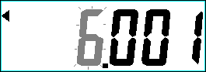

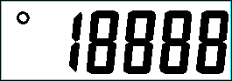


calibrating unit kg
calibratingunit lb
LCD shows span count
Entering calibrating point and store span count
Zero the span count
Loading dead weight to calibrate scale.

：Press HOLD key
：Press SEMI AUTO TARE to select.
Select between kg and lb for calibration
When LCD shows span count press ENTER (4Key indicator: UNIT ) to store span count.
First, set up calibrating point( how many kg(lb). Then press ENTER to zero span count. Loading dead weight up to calibrating point. Press ENTER to calibrate and store the result. You will back to normal mode.
For 4key indicator,
HOLD means to move to next digit and final confirm the result.
UNIT means to zero span count.

GRADUATION SETTING(OIML CLASS III)

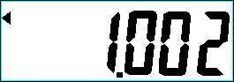


press HOLD to select
please refer to table below.

NO. | 500d | 1000d | 1500d | 2000d | 2500d | 3000d | 6000d | 10000d
1 | 1.002 kg | 1.001 kg | 1.501 kg | 1.0005 kg | 1.2505 kg | 1.5005 kg | 1.2002 kg | 1.0001 kg
2 | 2.505 kg | 2.002 kg | 3.002 kg | 2.001 kg | 2.501 kg | 3.001 kg | 3.0005 kg | 2.0002 kg
3 | 5.01 kg | 5.005 kg | 7.505 kg | 4.002 kg | 5.002 kg | 6.002 kg | 6.001 kg | 5.0005 kg
4 | 10.02 kg | 10.01 kg | 15.01 kg | 10.005 kg | 12.505 kg | 15.005 kg | 12.002 kg | 10.001 kg
5 | 25.05 kg | 20.02 kg | 30.02 kg | 20.01 kg | 25.01 kg | 30.01 kg | 30.005 kg | 20.002 kg
6 | 50.1 kg | 50.05 kg | 75.05 kg | 40.02 kg | 50.02 kg | 60.02 kg | 60.01 kg | 50.005 kg
7 | 100.2 kg | 100.1 kg | 150.1 kg | 100.05 kg | 125.05 kg | 150.05 kg | 120.02 kg | 100.01 kg
8 | 250.5 kg | 200.2 kg | 300.2 kg | 200.1 kg | 250.1 kg | 300.1 kg | 300.05 kg | 200.02 kg
9 | 501 kg | 500.5 kg | 750.5 kg | 400.2 kg | 500.2 kg | 600.2 kg | 600.1 kg | 500.05 kg
10 | 1002 kg | 1001 kg | 1501 kg | 1000.5 kg | 1250.5 kg | 1500.5 kg | 1200.2 kg | 1000.1 kg
11 | 2505 kg | 2002 kg | 3002 kg | 2001 kg | 2501 kg | 3001 kg | 3000.5 kg | 2000.2 kg
12 | 5010 kg | 5005 kg | 7505 kg | 4002 kg | 5002 kg | 6002 kg | 6001 kg | 5000.5 kg
13 | 10020 kg | 10010 kg | 15010 kg | 10005 kg | 12505 kg | 15005 kg | 12002 kg | 10001 kg

