LP-1000N (US)
LABEL EDITOR USER MANUAL
1. Label Format Files
● User Defined Label
The user defined label is saved in LABEL folder ( LP-Works App. Installed Folder\Label)
Ex) C:\Program Files\CAS\LP-Works\Label

● Sample Label
The sample label is stored in SampleLabel folder under the LABEL folder
Ex) C:\Program Files\CAS\LP-Works\Label\SampleLabel

2. Open Sample Label
File – Open - Find Sample Label Folder – Open a sample label,
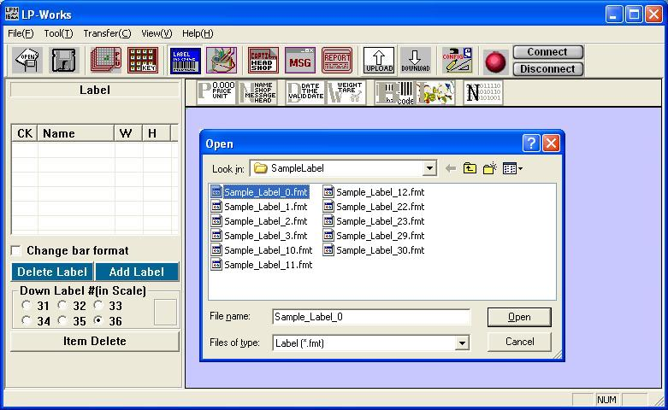
And User can find the Sample label which is opened on the Labe List
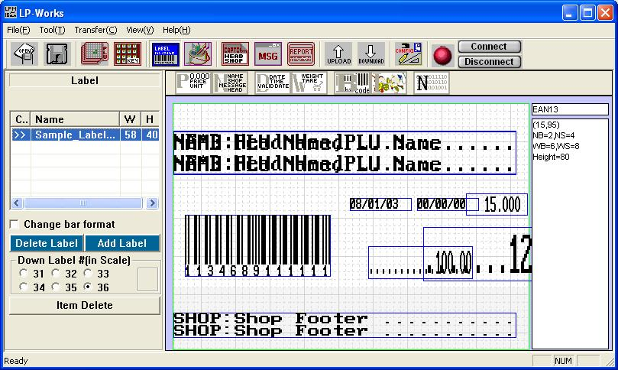
Also, User can fine the opened label file in LABEL folder because the opened sample label file is copied to LABEL folder from SampleLabel folder automatically.
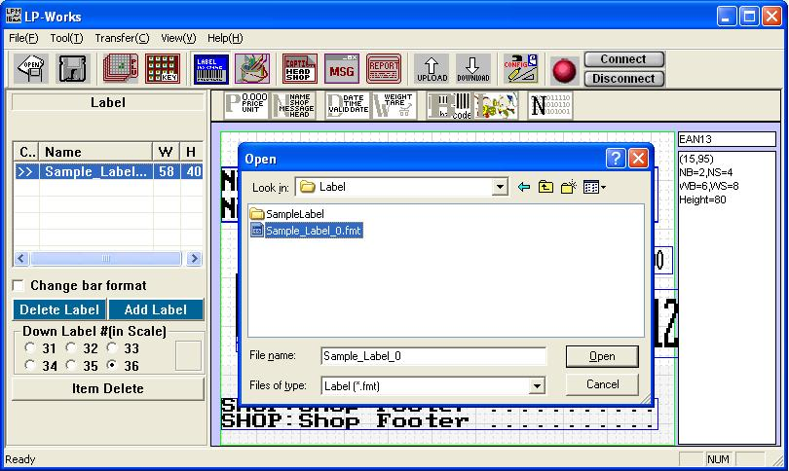

3. ADD LABEL
To add label, just click “Add Label” button and the New Window is opened as follows.
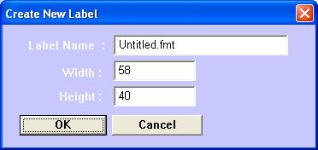
Put a Name, Width, Height of the New Label and then click “OK” button. User also can change width and height of the label by double click a label on label list.

4. Label Items
● Item Icons
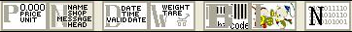
User can customize a label form with the label items
- Total Price, Unit Price, Currency Total Price, Currency Unit Price
- Name, Shop, Message, Head, Caption, Currency Rate
- Packed Date, Sell Date, Time
- Weight, Tare
- Barcode Type
- Images
- PLU Number, Department Number, Item Number
● Settings Item Properties
To change Item’s properties, click the right mouse button on each item. Then, its properties windows will be opened. (Example of the Name Item’s property)
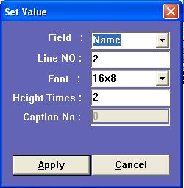
In here, user can change the item types, string line number, font size, item height, etc.

5. Barcode Format Change
If users want to change the barcode format, open its property setting windows with right button click.
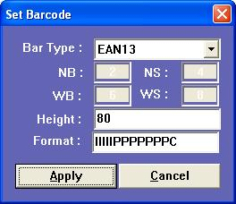
In here, user can select a bar type among 4 kinds of type (EAN13, EAN13A2, EAN13A5, Intereaved 2 of 5) and NB, NS, WB, WS, Height of label. Also, user can change the string of format. Please, look at LP-1000N user manual, page 40.

Last step, user most check “Change bar format”. This is one of the most important to change barcode format. Please, don’t forget this check.

6. Add Image
There are two kinds of image size (512 and 1024) you can add to the label. Before download the label which includes Image, User must download the Image on Image editor.
With a right button click on the image item, user can select image number and size.
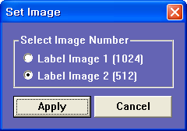

7. Label Download/Upload
User can see a number panel on left side of LP-Works as follows picture
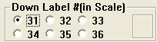.
These numbers indicate the down/upload label umber. If users try to down or upload a label, user can see a follows picture. Then, select the label number and click “OK” button to down/upload. In case of upload, user can select the label size.
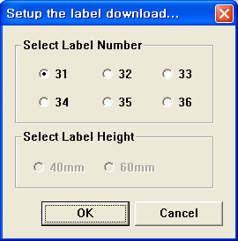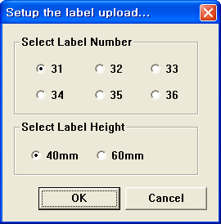

8. Others
● Using Caption Items
If user uses the empty label, user can print item’s caption (these captions must be predefined). Locate the caption items (Name, Shop,...) and set field name to caption and a caption number.
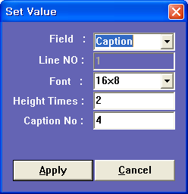
● Delete Items
If user wants to delete items, select (click) a item to be deleted and just click “Item delete” button.
