LP-1000N

Software Manual
PLU Management
Label Editor

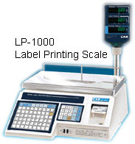

Date: 13-Apr-2007
Support Model

Introduction
This chapter explains the installation of LP-Works. The installation program will start automatically when you insert this CD.

The installation programs should self start when you insert the CD. If it doesn’t start click on the CD-Rom drive and double-click Setup.exe.

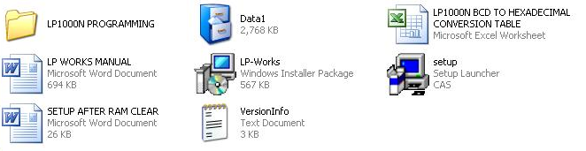

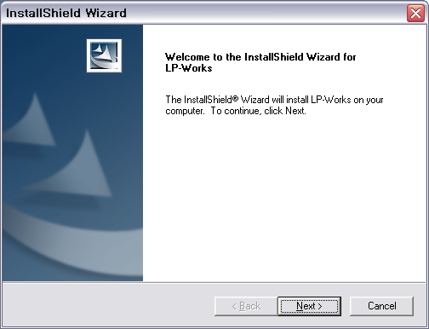

Click next button to continue

Choose Destination Location
You will not have to choose your destination folder LP Works does it for you. The Program will create a folder under.
< C:/program files/CAS/LP Works >

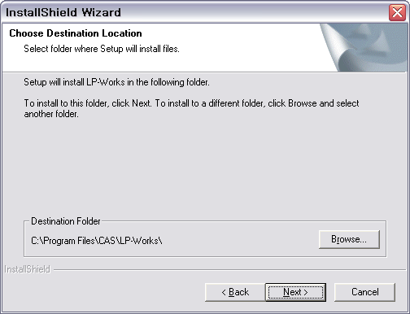

Click next button to continue

Setup Type will be the next screen. Please select (USA). This is the USA version.

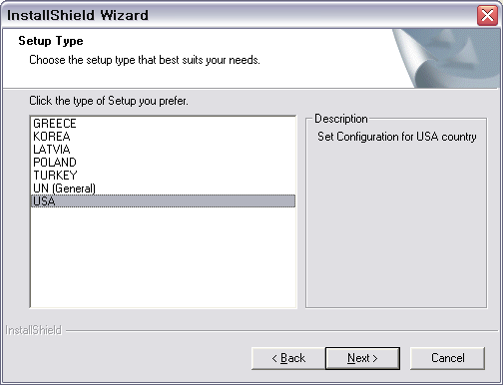
Click next button to continue

Program Installation
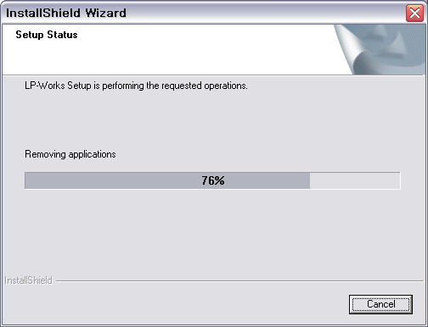

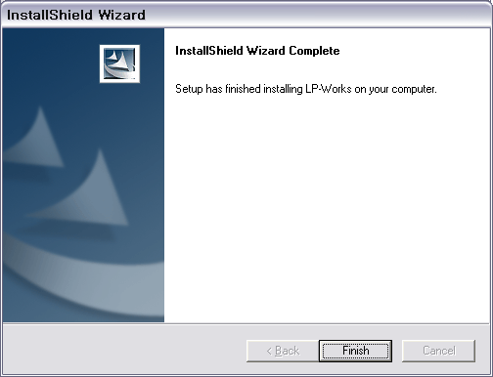
Click Finish Button on the Install Wizard

To run the program click LP-Works icon on you’re Desktop or click on the START button, ALL Programs and then look for LP-Works icon.

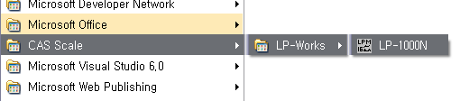

Basic setting
You have to set the basic settings to use this program. If not, you may have communication problems.

Communication setting
To set communication click Config Icon on the Tool Bar and then you will see the screen, click Communication Tab. Select RS-232 and use the black serial cable provided with the scale. Also go to Device Manager in your computer and see what com port your PC is using, com1. (19200 Baud/8/n/1 scale default)

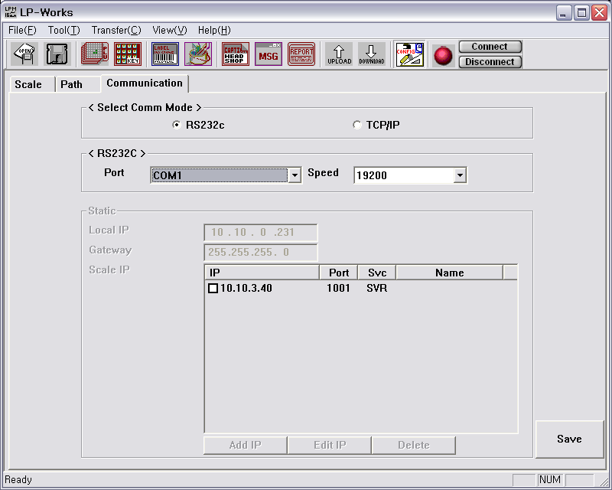

Basic Scale Parameters
You can set parameter information by clicking the Scale tab. You can then set your desired weighing unit, the method of price and date display. (Remember that 15.000kg is the 30lb. type)

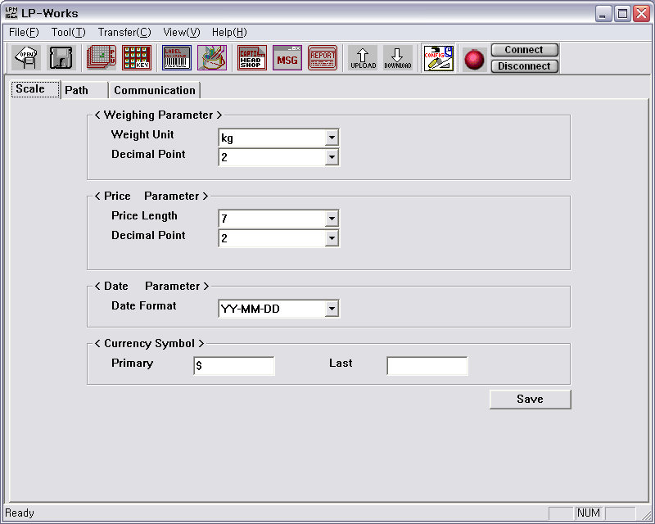

PLU Editor

Introduction of PLU Editor
You can program or edit PLU data with the PLU editor. Also you can vopen programmed data or an Excel file to manage PLU data depending on your needs so now click the PLU Icon (3rd one in from left).

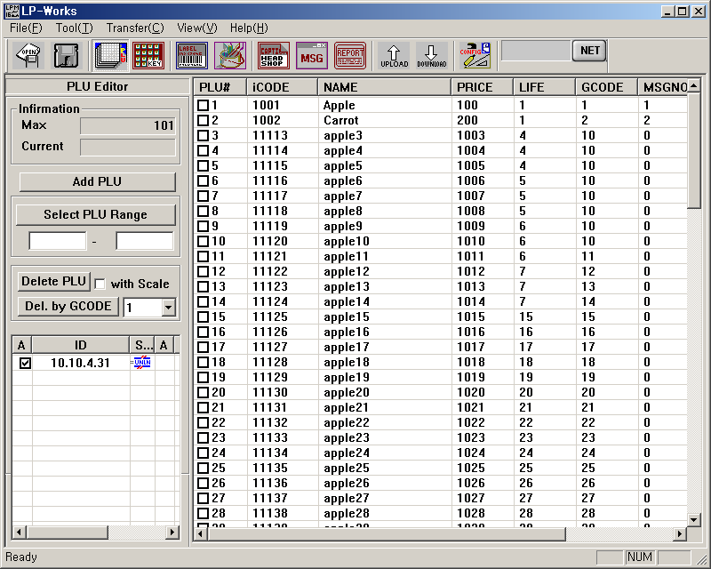
A
B
C
D
E
F
G

Name and Description
(A) Max – Total number of existing PLU.
(B) Plu Range and Delete
(C) Not used at this time
(D) Upload and Download
(E) Plu File
(F) Number Plu
(G) Save/Open Icon

(1) Select PLU Range – You can select PLU range that you wish to check.
(Note: It is convenient to delete or download using PLU Range.)
(2) Delete PLU – Delete PLU that is checked.
(3) With scale – If it is checked, data in scale is deleted.
(If it is not checked, only listed PLU data is deleted in the program.)
(4) Del by Gcode – All PLU data of selected group code is deleted.
(5) Upload – You can upload the data from the scale.
(6) Download – You can download the data to the scale.

How to use PLU Editor

How to run PLU Editor

1. Click the LP-Works Icon on your desktop
Create a new file
2. Select File menu.
3. Select New. Previous screen is cleared and ready to create a new PLU list.

How to add or edit PLU

1. How to add PLU
a. Click Add PLU button. The new data is added.
b. Double-click blued area.
c. You can add or edit PLU.
Note : It is possible to add up to 4000 PLU.
: When programming Tare us 20 format for 0.20.

2. How to edit PLU
a. Double-click item that you wish to edit.
b. Edit Window is displayed. Edit data and then click OK button.

How to save data

1. Edit data.
2. Click second icon of G box which is the little Floppy Disc, Data is saved.
3. First time saving asks you to name it.
Note: If you select current file, data is saved to current file.

How to open data

1. Click File on the Menu Bar.
2. Click Open.
3. Select data file or enter file name that you wish to open.
4. Click open button.

How to transmit data

1. Click the box next to the PLU’s (ALL Plu’s click the word PLU#)
2. Click connect button and see if the ball turns green.
3. Click Start.
4. Transmission is completed when screen says End.

How to receive data

1. Click upload icon.
2. You will receive data.

How to delete PLU

1. Delete PLU.
a. Run the program.
b. Open a file or PLU program.
c. Select PLU you wish to delete by clicking the check-box.
d. Click Delete PLU button
e. PLU is deleted.
2. Delete PLU of the scale
a. Click with scale check-box.
b. Click Delete PLU button.
c. PLU data of the scale is deleted.

Reference
PLU (Price Look Up) is the name of the individual items that the scale stores. Each PLU consists of a variety of fields and options. Following table shows input range of the individual items.

No. | Item | Input range
1 | iCode | 999999
2 | Name | 28
3 | MSG No | 9999
4 | Price | 99999
5 | Life | 99
6 | Tare | 999999
7 | GCode | 99

Importing Database using the Import feature
Click the PLU Icon then Click on FILE then DATA IMPORT then Import *.XLS type file or Import PLU type file from older CAS Database (LP-1000 A, B, C.)

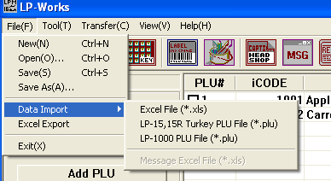

This next screen shows the first line in your Excel Spread Sheet (Row A)

PLU No, Item code, name 1, name 2, UPrice, ValidDate, GCode Tare and message, these Names SHOULD BE IN LINE A of your *.xls file.

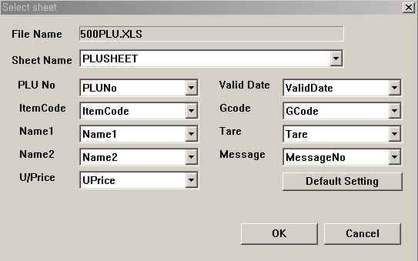

Click ok then the database will open up in LP Works and now you can modify it and resend back to scale!

Speed key programming
You can program speed key easily by using LP-Works.

Configuration of Speed Key Screen
. 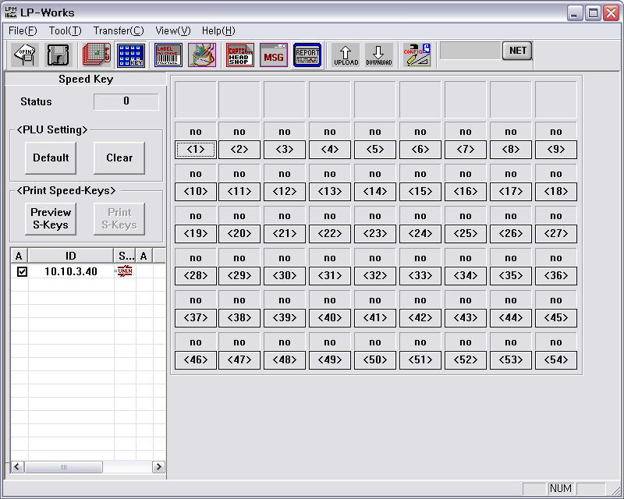
A
B
C
D
Name and description
(A) Speed Key Number
(B) Print Speed Keys
(C) Upload-Download
(D) Actual Speed Keys

How to use Speed key
Default setting

Click Default button and Speed key will be set to default which is 1 to 54 left to right.

How to clear Speed key

Click Clear button and all information of Speed keys are deleted.

SPEED KEY SETTING
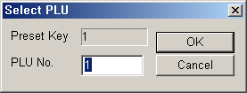
Click on button that you wish to edit speed key.

When Select PLU Window is open, enter PLU number and click OK button.

How to send Speed key to the scale

1. Click Download Button.
2. Speed keys are sent to scale.

How to print Speed Key
You can print Speed Keys and see the preview of the Speed keys with click Preview S-Keys button. In preview mode, click Print S-Keys to print the Speed Keys.

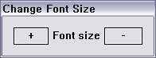
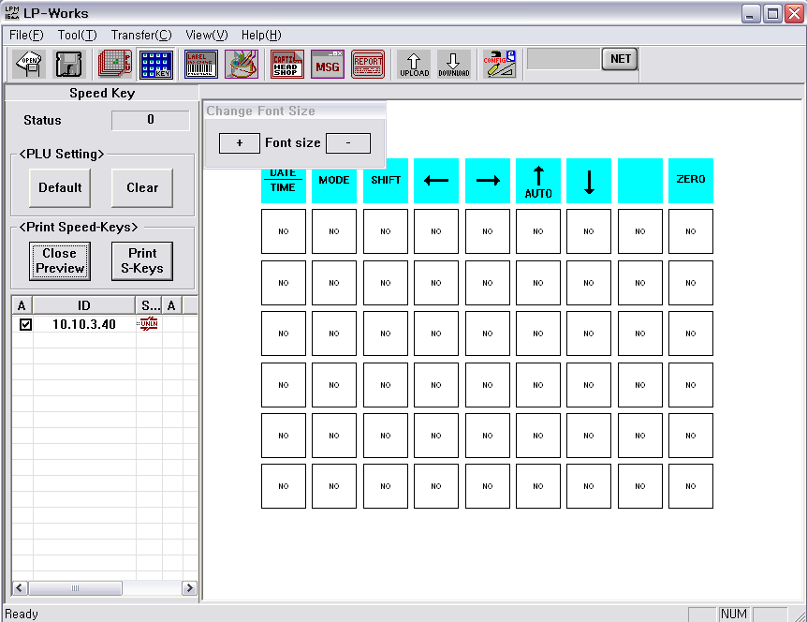
A
B
C

Name and Description
(A) Print Speed-keys and Close Button to close Preview
(B) Control button to the change font seize
(C) Main window of the speed keys preview

Select option

If you click Print S-Keys, you can select a print option. Here, you can print the speed key with Function keys or not.

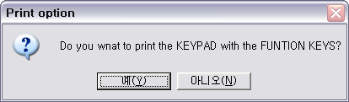

Font Size

To change the font size of the speed-key, just click the plus(+) or minus(-) button.

Label Editor
This chapter explains about label editor.

Configuration of Label Editor Screen
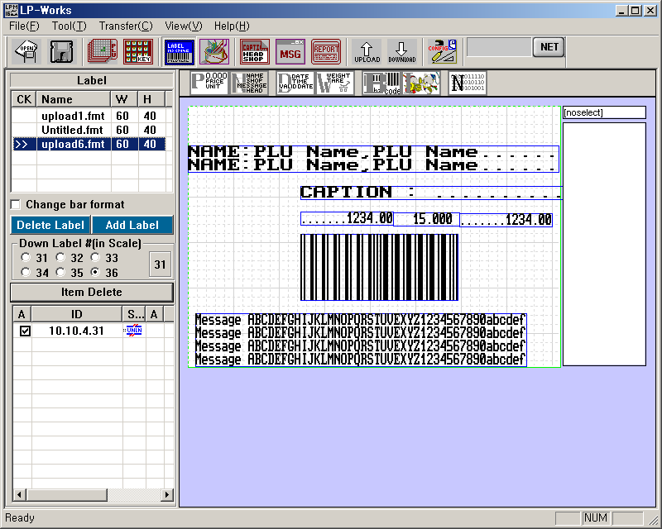
A
B
C
D
E
G
H
F
Name and Description
(A) Open-Save
(B) Formats Saved
(C) Format Numbers
(D) Not needed (For TcPip Connection)
(E) Upload-Download
(F) Label Quick Set Icons
(G) Actual Label Format
(H) Coordinance of X and Y parameters of fields

How to use label editor

Starting label editor
1. Run LPWorks program by clicking LP-Works icon.
2. Click Label editor on toolbar. Label editor is opened up.
3. You can use label editor.

Adding a new label format
1. Click Label editor which is the 5th Icon from the left (has a barcode pic on it) toolbar. Label editor is open up.
2. Click Add Label button you will see following screen.
3. Enter Label Name and Height.
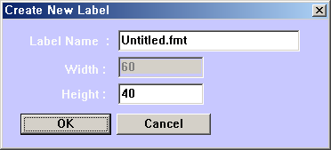

Adding field
1. Click on a certain field (icon) that you wish to add. (Box will appear in upper left corne of label)
2. Point mouse on a field and drag to desired position.

Deleting field
1. Select label format and click the field that you wish to delete.
2. Click Item Delete button.
3. Field is deleted

Saving label format
1. Add or edit label format
2. Click 2nd icon which is the Floppy Disk.
3. Click label on a label list.
4. Saving is performed
5. Editing label format
6. Run label editor.
7. Click label to edit
8. Right-click a field to edit.
9. Edit field.
10. Click OK button.
11. Click second icon (Floppy Disk)
12. Editing is saved.

Sending label format to the scale
1. Run label editor.
2. Click label to edit or open label
3. Click label number (31 to 36).
4. Click Download icon
5. Download is starting.
6. Label format is being sent to the scale.
7. Download is completed.
8. Now select label format in scale to use.
9. Now you have to select format in the scale
(Format 31 – 36 in the scale)

Receiving label format from the scale
1. Run label editor.
2. Click Upload icon.
3. Upload is completed.
4. Received label format appears.

Reference/Terms

Item | Description
Total Price | Total price
Unit Price | Unit price
Currency Total Price | What kind of Currency you wish Total Price field
Currency Unit Price | What kind of Currency you wish Unit Price Field

Item | Description
Name | Product name
Shop | Shop name
Message | Message (Ingredient)
Head | Label head
Caption | Fixed Text
Currency Rate | What Currency used for Price Calculations

Item | Description
Packed/Date | Packed on date
Sell/Date | Sell by date
Time | Time

Item | Description
Weight | Weight
Tare | Weight of container

Item | Description
PLU No | PLU Number
Group No | Group number of PLU
Item No | Item number in Barcode

Image Editor
You can open image from the file and change it to print image of the scale by using image editor.

Configuration of Image Editor Screen

Configuration of image editor is same as figure below.

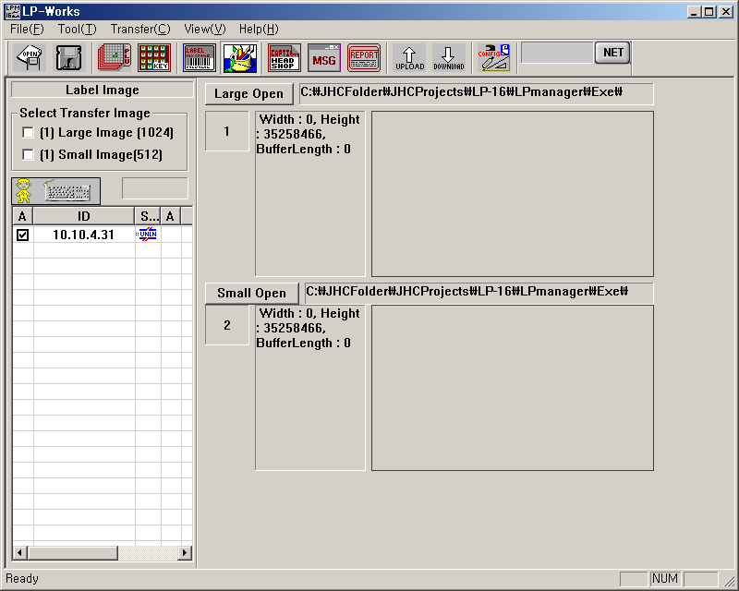
A
B
C
D
E

Name and Description
(A) Select Size
(B) N/A
(C) UP/DOWNLOAD Icons
(D) Large BMP file open and adjust
(E) Small BMP files open and adjust

(1) Large image (1024) – Select image of 1024 byte to transfer.
(2) Small Image (512) – Select image of 512 byte to transfer.
(3) First icon (Upload) – Used to receive image data from the scale.
(4) Second icon (Download) – Used to send image data to the scale.
(5) Large Open Button – Open image of 1024 byte.
(6) Image Information – Shows image informatio
(7) Small Open Button – Open image of 512 byte.
(8) Image Information – Shows image information
(9) Path window –Shows path of file.
(10) File Name editor – Shows file name.
(11) File Size window– Shows file size of image.
(12) Size on Rect (for large) check-box – If the file size of image is greater than the display Window, you will see reduced scale view when editing.
(13)File type selection button– You can select file type. (JPG, BMP, GIF)

Configuration of Dailog Screen for Image

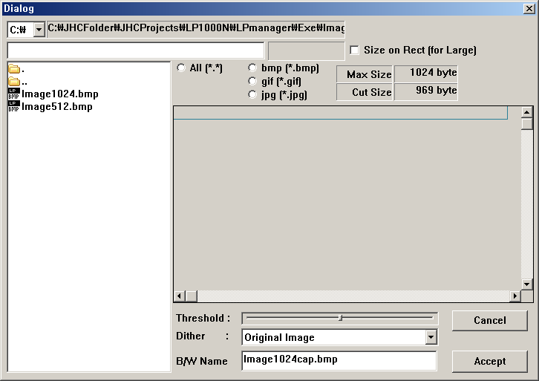

Name and Description
(1) Image view window – Shows image.
(2) Threshold – You have to set Threshold item in Dither Box to use Threshold.
(3) Dither Box – Changes color image to BMP to fit format of the scale.
(4) B/W Name – File name of print image.
(5) Cancel button – Cancel image open.
(6) Accept button – Accept image open.

Caption and Shop Name

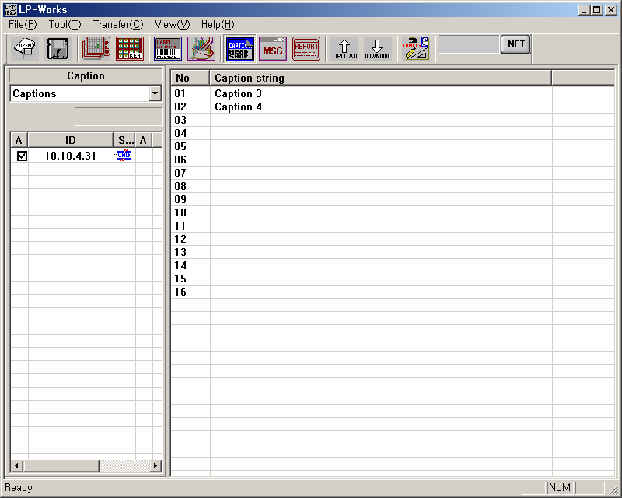
A
C
B
D

Name and Description
(A) Caption or Shop Name selection
(B) N/A
(C) Captions Available
(D) UP/DOWNLOAD Icons

Starting Caption/Shop Name

1. Click Caption/Head&Shop Icon.
2. Editing caption
3. Select caption by double clicking the number and you will
4. See this screen
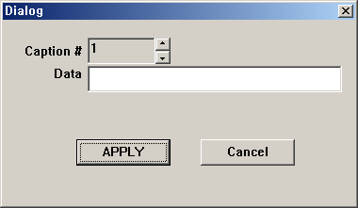
Note: Caption and Shop Name are use in conjunction with label editor.

Upload/download of caption

1. Click Upload icon to receive caption data from the scale.
2. Click Download icon to send caption data to the scale.
MSG (Message/Ingredients)

MESSAGE/Ingredients

This chapter explains message/Ingredient programming. (MSG’s are Ingredients!)

Configuration of MESSAGE/Ingredients

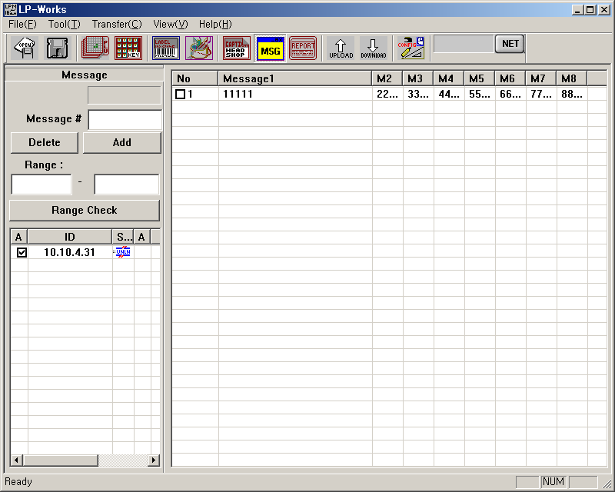
A
C
B
D

Name and Description
(A) Adding, Deleting Messages
(B) Not Available
(C) Actual Messages

How to use MESSAGE/Ingredients

Click MSG icon on the Tool Bar.

Adding MESSAGE/Ingredients

1. Enter Message/Ingredient number in Message# box.
2. Click Add button.
3. Message is added.

Editing MESSAGE/Ingredient

1. Click MSG icon on the Tool Bar.
2. Double-click message that you wish to edit on the list.

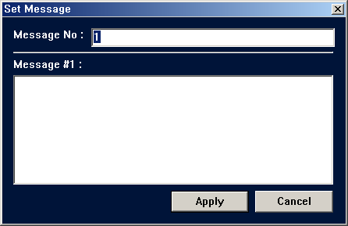

3. When Set Message Window is appears type message.
4. To save message, click Apply button.
5. Message is saved. (8 lines of text with 50 characters per line max.)

Selecting MESSAGE/Ingredient range

1. Click MSG icon on the Tool Bar.
2. Enter message range.
3. Click Range Check button.
4. Check-box of message within the range is checked.

Deleting MESSAGE/Ingredient

1. Click MSG icon on the Tool Bar.
2. Check the check-box of message that you wish to clear.
3. Click Delete button.

Download/upload of MESSAGE/Ingredient

1. Click Upload icon to receive message data from the scale.
2. Click Download icon to send message data to the scale.
3. Check the check-box of message that you wish to send.

Configuration of Report and Totalling
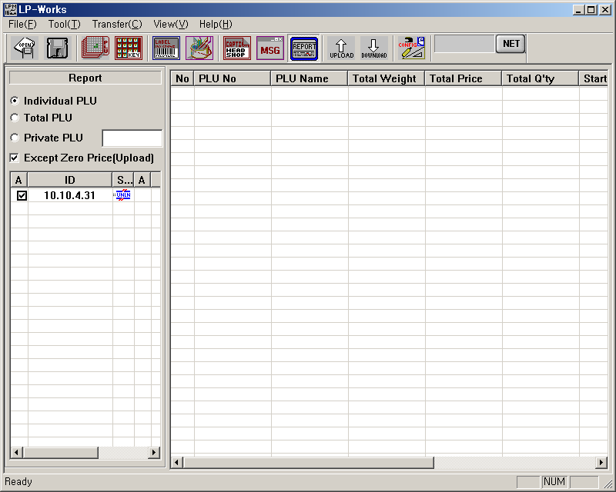
A
B

How to use Report and Totalling

Starting report

1. Run LP works program by clicking LP-Works icon.
2. Click Report.

Receiving PLU report

1. Click Report.
2. Select Indivisual PLU.
3. Click Upload icon on Tool Bar.
4. PLU report is appeared.

Receiving Total PLU report

1. Click Report
2. Select Total PLU.
3. Click Upload icon on Tool Bar.
4. Total PLU report appears

Receiving Private PLU report

1. Click Report.
2. Select Private PLU.
3. Enter PLU number to receive.
4. Click Upload icon on Tool Bar.
5. Report is appeared.

Exception of zero price

1. Click Report.
2. Select Except zero price (upload). If the total price is zero, it is not displayed. If you want to see it, do not check.
Speed Sheets for Hand Programming the LP-1000N

PLU Programming- first go to Program Mode which is the 1 key then the mode key and this will bring you to the PLU. Pull down overlay keysheet on left hand keyboard for letters and numbers and special characters. The shift key will let you program the special characters on the keyboard plus capitol letters for the regular characters.

1. Press PRT/* (you will see how many PLU’S are left of open space in memory) then PLU Number then PRT*
2. Press PRT* -ICODE/ enter the Commodity Code in the Barcode(5 digit) PRT/*
3. Press PRT* -Name-Program text for product description. (Use the up and down 4. arrow to go from first row to second row of commodity description).
5. Press PRT* MSGno- used for ingredients (Links reference # with PLU)
6. Press PRT* Price- Unit/Price per lb. PRT*
7. Press PRT* Life- Shelf Life in number of days PRT*
8. Press PRT* GCODE- For Group Code PRT*
9. Press PRT* Save- Press PRT* to save changes.

